François Laflamme

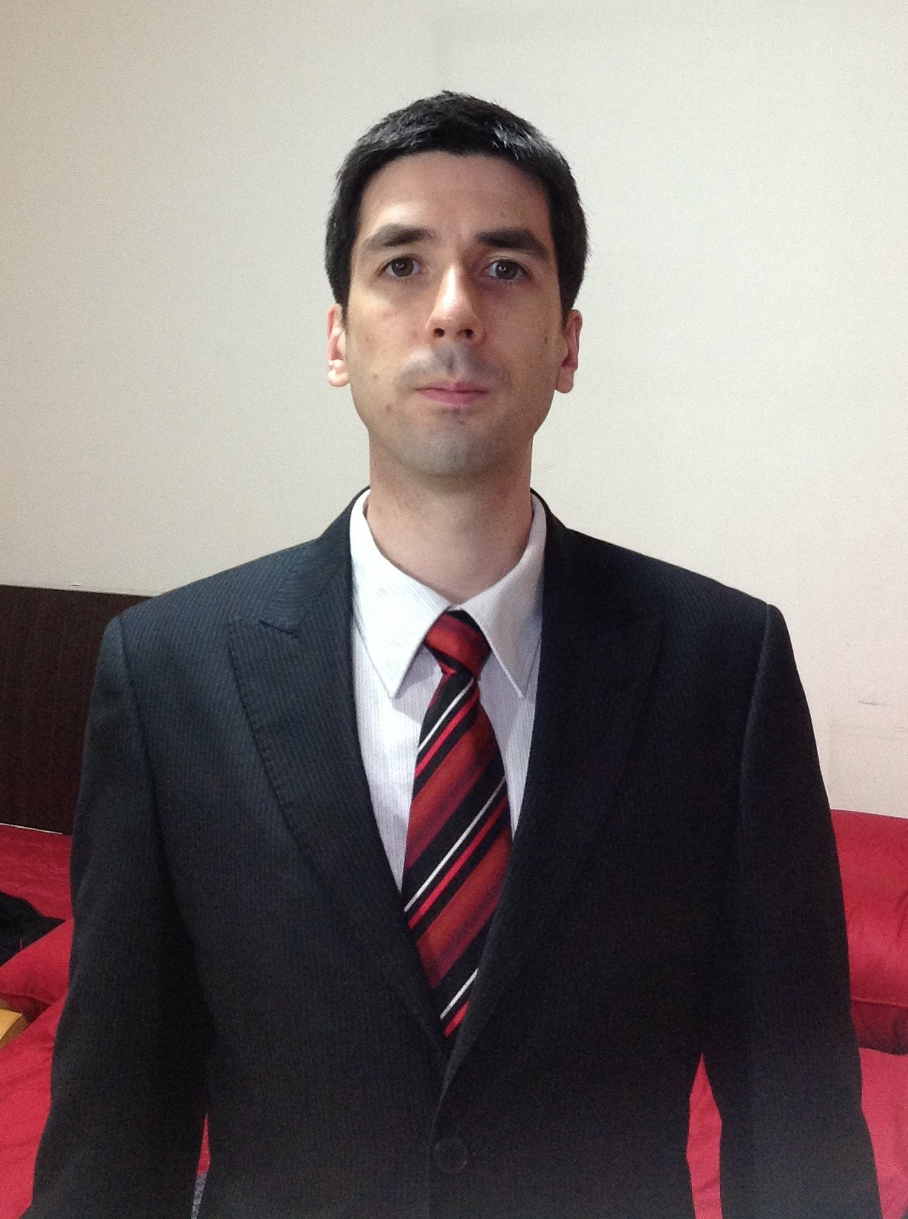

EMPLOYMENT OBJECTIVE

One-year TESL/TEFL contract starting as soon as possible.

PERSONAL DETAILS

Sex : Male Date of Birth : September 25th, 1979
Age : 33 Place of Birth : Canada
Marital Status : Single Citizenship : Canadian
Mother Tongue Fluency : English & French Korean Ability : Intermediate Level

EDUCATION (SUMMARY)

2008 MA (Economics) Carleton University, Ottawa, ON, Canada.

2005 TESL/TEFL (60-hour) Certificate Oxford Seminars, Ottawa, ON, Canada.

2004 BA (Economics) Carleton University, Ottawa, ON, Canada.

WORK HISTORY (SUMMARY)

2008-2010 English Teacher Sung-Il Middle School, Jegi-dong, Seoul, Korea.

2005-2007 English Teacher BR English Jr, Geumjung Branch, Busan, Korea.

2005 U.S. Trade Advocacy Officer Agriculture and Agri-Food Canada
Ottawa, ON, Canada.
2004 Trade Policy Analyst AAFC, Ottawa, ON, Canada.

INTERESTS AND HOBBIES

Education. Technology. Policy.
Computers. Programming. Educational Technologies.
Languages. Language Learning. Linguistics.
Social Sciences. Economics. Politics. Philosophy. Religions.
Stocks. Tech-Sector Economics. Business Management.
Anime. Korean Drama. Science-Fiction. Fantasy.

REFERENCES

Mrs. PARK EUN SOOK (박은숙 선생님, aka HELEN)
LINK: She was Head Teacher at the Geumjung (금정) branch of BR English Jr where I worked from December 2005 to June 2007. As such, she was my direct supervisor during most of my time there.
PHONE: 010-4285-8874
EMAIL: sook8874@daum.net
MAILING ADDRESS: 부산시 기장군 이지더원 1차 아파트 113동 103호
NOTES: Please call between 10AM and 2:30PM Monday to Friday. Leave a text message if she does not pick up and she will call you back as soon as possible.

Mrs. KIM HEE JUNG (김희정 선생님)
LINK: She was one of my co-teachers as well as my direct supervisor at Sung-Il Middle School (성일중학교) where I worked from September 2008 to August 2010.
PHONE: 010-3575-0634
EMAIL: inos88@naver.com
MAILING ADDRESS: 대전광역시 서구 둔산동 대전탄방중학교 제1교무실
NOTES: If she does not pick up, please leave a message and she will call you back as soon as possible.

Mrs. JUNG DAM ON (정담온 선생님)
LINK: She was my direct supervisor for the English Excellence Program (EEP) at Hwi-Kyung Middle School (휘경중학교) where I taught after-school classes during my time at Sung-Il Middle School.
PHONE: 010-8945-0213 / 02-780-2380
EMAIL: damon0213@gmail.com
MAILING ADDRESS: 서울시 금천구 가산동 60-25번지 에이스하이엔드타워 6차 19층 1903호
NOTES: You can call her anytime. If she does not pick up, please leave a message and she will call you back as soon as possible.

Mrs. KANG BO RA (강보라 선생님)
LINK: She was the Special Education teacher at Sung-Il Middle School. Although not officially part of my duties, I gave her students English classes semi-regularly, whenever our schedules matched, classes that addressed her students' needs and English level. She was my co-teacher during those lessons.
PHONE: 010-6803-3350 / 02-303-9294
EMAIL: kr335see@gmail.com
MAILING ADDRESS: 서울시 은평구 증산동 산24 증산중학교
NOTES: From February 1st to February 6th, you can contact her at her work phone number between 3:30 and 4:30PM. You can also contact her at 010-6803-3350 instead, if need be.

Mrs. PARK HYE JUNG (박혜정 선생님)
LINK: She was the receptionist at BR English Jr and one of my adult students at the time, so I believe that she can be a good judge of my teaching skills and character.
PHONE: 010-9305-2167
EMAIL: chunghajang@naver.com
MAILING ADDRESS: 부산시 금정구 장전동 225-71번지 우남빌딩 2층 비알잉글리쉬
NOTES: Please call after 9PM on weekdays or 4:30PM during weekends.

DETAILED EDUCATION HISTORY

March 2012 to Dec. 2012 KOREAN LANGUAGE
(Levels 2, 3 and 4 of the Regular Program)
Korean Language Institute, Yonsei University, Seoul, Korea

Sept. 2008 to (End of 2013) INFORMATIQUE APPLIQUÉE À L'ORGANISATION
(i.e. Applied Computer Science)
Certificat (completion expected by the end of 2013)
(One-year distance education undergraduate program.)
TÉLUQ, Québec, Québec, Canada

July 2007 to April 2008 ECONOMICS
Master of Arts (completed in April 2008)
Carleton University, Ottawa, Ontario, Canada

Sept. 2005 to Nov. 2005 SELF-DIRECTED STUDY OF THE STOCK MARKET & INVESTMENT PORTFOLIO MANAGEMENT
(I earned tens of thousands of dollars on the stock market since, which I have been using for the last two years to fund the continuation of my university studies.)

May 2005 TEACHING ENGLISH AS A SECOND/FOREIGN LANGUAGE (Intensive 60-hour TESL/TEFL Certificate) (completed in May 2005)
Oxford Seminars, Ottawa, Ontario, Canada

Sept. 2004 to Aug. 2005 ECONOMICS
Graduate Studies
Carleton University, Ottawa, Ontario, Canada

Sept. 2003 to Aug. 2004 ECONOMICS
Bachelor of Arts, Honours (completed in August 2004)
Carleton University, Ottawa, Ontario, Canada

Sept. 2001 to Aug. 2003 PUBLIC AFFAIRS & POLICY MANAGEMENT
Undergraduate Studies
Arthur Kroeger College of Public Affairs
Carleton University, Ottawa, Ontario, Canada

Sept. 1999 to April 2001 PHILOSOPHIE (i.e. Philosophy)
Diplôme (completed in April 2001)
(Two-year undergraduate program.)
Université Laval, Québec, Québec, Canada

Sept. 1998 to April 1999 CRÉATION LITTÉRAIRE (i.e. Creative Writing)
Undergraduate Studies
Université Laval, Québec, Québec, Canada

Sept. 1996 to May 1998 SCIENCES DE LA NATURE (i.e. Natural Science)
Diplôme d'études collégiales (completed in May 1998)
(Two-year, pre-university college program in my home province.)
Collège de Lévis, Lévis, Québec, Canada

DETAILED WORK EXPERIENCE / COMMUNITY INVOLVEMENT

Sept. 2008 to Aug. 2010 ENGLISH TEACHER
Sung-Il Middle School (성일중학교), Seoul, South Korea
Phone (행정실): 02-926-7401
Teach middle-school students with my Korean co-teachers. Create lesson plans conducive to student engagement and learning. Prepare Powerpoint presentations, videos, handouts and other learning materials for use in the classroom. Assemble a picture dictionary for student use during lessons. Organize and teach after-school lessons, as well as summer and winter English camp activities. Teach English to a group of teachers. Teach English to a group of special-education students.

Dec. 2005 to June 2007 ENGLISH TEACHER
BR English Jr, Geumjung (금정) Branch, Busan, South Korea
Phone: 051-512-5300
Teach English to Korean students aged 5 to 45. Create a class atmosphere that is both comfortable and stimulating. Coordinate my lessons with those of Korean teachers. Maintain effective communication with the students’ parents, who are important partners in the students’ learning. Organize cultural activities for Halloween and Christmas.

May 2005 to Aug. 2005 U.S. TRADE ADVOCACY OFFICER
Agriculture and Agri-Food Canada
Ottawa, Ontario, Canada
Research various aspects of agricultural trade between Canada and the United States. Identify the benefits of liberalizing agricultural trade between the two countries, as well as the industries where greater trade liberalization would be beneficial. Write and update various trade advocacy and trade policy documents for AAFC’s website. Work with a graphic designer of the department to ensure a professional presentation of the information.

July 2004 to Aug. 2004 TRADE POLICY ANALYST
Agriculture and Agri-Food Canada
Ottawa, Ontario, Canada
Find the official texts of all the free-trade agreements signed by the United States and Mexico. Build comparative tables presenting the differences, for trade in agricultural products, between those agreements and NAFTA. Identify, in NAFTA, liberalization opportunities that would benefit Canada. Formulate new rules of origin (ROO) to be proposed to our trade partners in future NAFTA negotiations.

Sept. 2002 to Apr. 2003 FOUNDER AND PRESIDENT
Carleton University Interfaith Club
Ottawa, Ontario, Canada
Plan and chair meetings. Ensure respectful and fruitful dialogue among members. Manage communications with the members and with other clubs on campus. Advertise the club’s activities. Manage and moderate the club’s message board.

Jan. 2000 to Apr. 2001 SECRÉTAIRE (i.e. Secretary)
Comité des programmes de premier cycle en philosophie
(i.e. Undergraduate Philosophy Programs Committee)
Université Laval, Québec, Québec, Canada
Write minutes of the meetings. Review and approve course outlines. Select summer courses. Reconfigure undergraduate philosophy degrees in compliance with the university’s new academic regulations. Analyze the Faculty’s course evaluations. Report to the Dean.

Sept. 1999 to Apr. 2001 VICE-PRÉSIDENT (i.e. Vice-President)
AGÉÉPP (i.e. Undergraduate Philosophy Student Association)
Université Laval, Québec, Québec, Canada
Co-chair and plan meetings of the representatives and of the regular members. Present relevant issues to the members as well as the course of action suggested by the representatives. Write minutes. Defend the association’s interests and present its positions in various committees. Organize social events. Conduct and analyze the association’s own course evaluations.

Summers 1987 to 2002 AGRICULTURAL LABOURER / SALESMAN
Ferme Laflam, Enr. (i.e. the family farm)
Saint-Henri-de-Lévis, Québec, Canada
Harvest, sort and deliver sweet corn and exotic mushrooms. Supervise workers during harvesting and sorting operations. Serve clients and handle payment. Present the product and answer clients’ questions. Deliver seeds and fertilizers to local farmers.

