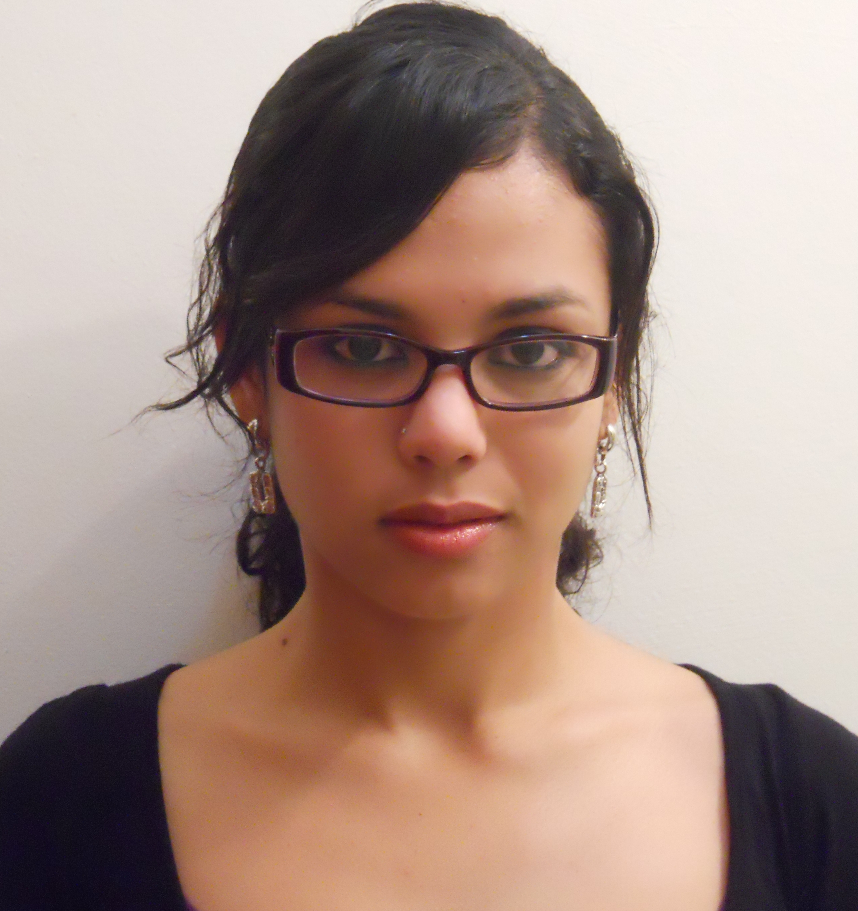
Gabriela López Zerón

Citizenship: Honduran

Availability: August 1st 2010

Contact: Gabriela.lopez85@gmail.com

(+504) 958 05491

Education:

- Bachelor of Arts, Psychology and International Relations, May 2007, Webster University, St Louis.
- High School Diploma, Escuela International Sampedrana, Honduras [American accreditation by SACS (Southern Association of Colleges and Schools) CASI (Council on Accreditation and School Improvement), a division of Advanced ED.]
Related Coursework: Social Psychology, Psychology of Adjustment, Brain and Behavior
Study Abroad: San Pedro Sula, Honduras: Summer 2005, Leiden, Holland: Fall 2005, Cha-am, Thailand: Spring 2006
GPA: 3.83
Additional Skills: Computer: Proficient in MS Word, Excel, PowerPoint, and Mac OS
Languages: Fluent in Spanish, Familiar with French and Japanese

Relevant Experience:

Pre- Algebra Teacher, Escuela Internacional Sampedrana, San Pedro Sula, Honduras, November 2008 to present
-Teach Pre Algebra and Algebra I to eighth grade students.
-Act as the eighth grade team leader by coordinating projects and activities and coordinate parent-teacher conferences for the team.
-Coach students in Math Counts, Math Relay and Math Olympics competition.

Math Tutor, San Pedro Sula, Honduras, August 2009 to present
-Tutor students with math difficulties on an individual basis
-Prepare students for unit and term exams on an individual basis

Peer Tutor, Academic Resource Center, Webster University, St Louis, MO, USA August 2003 to May 2007
-Tutor college-aged students in Spanish, International Relations and Psychology courses on an individual basis.

English Fluency Tutor, Student Literacy Corps, Webster University, St Louis, MO, USA
January 2004 to May 2005
-Tutor second grade students with reading fluency problems at St. Cecilia’s School three times a week on an individual basis.

Work History:

Staff Member Psychology Department, Medical and Psychological Center, San Pedro Sula, Honduras, August 2008 to August 2009
-Assist with implementation of a cognitive behavioral treatment for clients diagnosed with panic disorders.
-Assist with the development of a cognitive behavioral treatment for clients diagnosed with Major Depression.
-Teach a yoga class and a corporal expression and relaxation class tailored for clients who suffer with anxiety, depression or panic disorders.

Administrative Assistant, Accion Social Comunitaria, St. Louis, MO, USA, October 2007 to April 2008
-Manage front office by answering phones, writing emails, translating documents, greeting clients and visitors.
-Write, edit and proofread information for organization’s developing website.
-Assist with the management of After School and Health Care programs.
-Assist with the management of organization’s general accounting paperwork.

Help Desk Assistant, Health Services, Webster University, St Louis, MO, August 2006 to May 2007
-Assist students when visiting health services
-Assist with managing the front office by answering phones, greeting, retrieving and filing charts.

Volunteer Experience:

Youth Conference Planning Assistant, La Cosecha Ministries, San Pedro Sula, Honduras
July 2002 to March 2003
-Coordinate accommodation and transportation for speakers.
-Design and implement efforts to publicize event around the city and online.

Volunteer, African Refugee Center, St Louis, MO, USA, January 2004 to December 2004
-Provide assistance to new members of the community with child care and transportation to institution where individuals would learn a trade.

Volunteer Translator, Youth for Christ, San Pedro Sula, Honduras, Summers 2004 and 2005
-English- Spanish translator for medical brigades visiting the country

References:

Dr. Allan MacNeill
Chair of International Relations Department and Professor
Webster University
470 East Lockwood Ave
St Louis, MO 63119
314-968-7489
macneiam@webster.edu

Professor Kate Northcott
Director of Literacy Corps
Webster University
470 E. Lockwood Ave
St. Louis, MO 63119
northcot@webster.edu

Mrs. Ximena Silva
Middle School Principal
Escuela Internacional Sampedrana
San Pedro Sula, Honduras
xsilva@seishn.com

