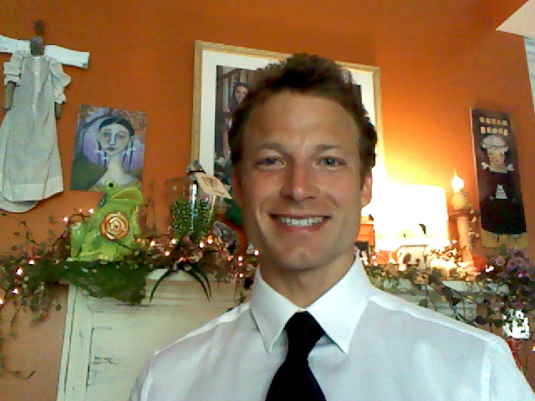

Gary D. Young
MA English (Dual Degree)
579 Rocky Step Road Winfield, WV 25213
garyyoungii@hotmail.com / 304-586-2940
_____________________________________________________
Education:
Northern Michigan University MA Literature May, 2007
MA English Pedagogy, GPA: 3.77

Liberty University BS English December, 2002
_____________________________________________________
Certificates:
Pennsylvania Board of Education English Teaching Certificate April, 2010

American Red Cross CPR / AED July, 2011
_____________________________________________________
Career Positions:
Beijing Normal University Foreign Expert of English 2012
Zhuhai, China Director Kathy Wang: 011-86-75-6612-6501

Marymount College Adjunct Instructor English Composition 2011
Los Angeles, CA Dr. Patrick McMahon: 310-303-7245

Northeastern University Foreign Expert of English 2010 - 2011
Shenyang, China Dean Yan Kang: 011-86-1-394-047-2926

Kyungwon University Foreign Visiting Professor 2008 - 2010
Seoul, South Korea Director M. Song: 011-82-19-9721-7224

TOPIA Academy Language Arts Teacher: Elementary and Middle 2007
Seoul, South Korea Director Kim Mu Seng: 011-822-2052-0505

Northern Michigan University Adjunct Instructor English Composition 2006 - 2007
Marquette, Michigan Dr. Mark Smith: 906-227-2676

Sichuan Normal University ESL Instructor (Practicum) 2006
Sichuan, China Director Wendy Wei: 011-86-1-300-815-7849

Basalt Middle School Teacher: Elementary and Middle 2003 - 2004
Glenwood Springs, Colorado Manager, Mary Jay: 970-384-6011

Plugged In Magazine Writer / Editor Intern 2001
Colorado Springs, Colorado Senior Editor Bob Smithouser: 719-531-5181

Winfield High School Student Body President 1996 - 1998
Winfield, West Virginia Principal William Hughes: 304-586-3279
_____________________________________________________
Professional References:
Dr. Patrick McMahon Head of English, Marymount College, 310-303-7245 pmcmahon@marymountpv.edu
Dr. Paul Lehmberg Professor of English, N. Michigan University 906-227-2009 plehmber@nmu.edu
Dr. Thomas Martin Professor of English, Florida Atlantic University 561-667-1559 tmartin@fau.edu

