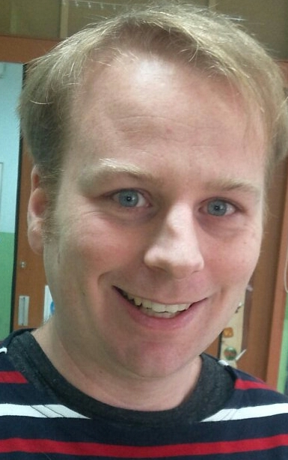

Geoff Gaudet
Seoul si, Mapo gu
-----------------------------------------------------------------
Education:
Oxford seminaries
--Certified ESL Instructor, January 2008
Humber College post secondary school
--Graduated with a degree in Comedy: performance and script writing. May 2005
Pine Ridge secondary school
--Graduated OAC level high school with studies in Performance arts and English, June 2000.

Work experiences:
Kids’ republic childrens' café, mokdong
Role: English activity coordinator- December 2011 on going
Responsibilities- planning and organizing games or activities for the children to play in the café. Encouraging group activities for all children at the café to participate in. Teaching cooking classes to groups of children. Mc’ing birthday parties or special events for groups.

Nobel After school academy, Naebalsan elementary school
Role: English teacher- March 2012 to February 2013
Responsibilities- teaching English to elementary school students. Assigning, editing and discussion short story homework. Creating tests based on classroom studied lessons.

Guil language academy, Seoul., tel: 02-838-9191
Role: English teacher- May 2009 to May 2011
Responsibilities- teaching English to students elementary level to High school level. Creating test based on classroom studies, school listening and speaking test preparation for students, conduction speaking and conversation classes. Editing essays and homework .

ICI Korea, Seoul., tel: 010-9992-8029
Role: Korean history and culture instructor –January 2009 to present
Responsibilities- Guiding students through Korean historical sites and museums, lecturing the history of Korean sites and events. Transportation monitoring, teaching history classes, teaching essay writing classes, Supervising student history speeches, material writing and editing

Kids College kindergarten, Seoul., tel: 02-716-7373
Role: English teacher -May 2008 to April 2009
Responsibilities- creating daily lesson plans, English lecturing and teaching of students in a kindergarten institutes, assigning and marking daily homework assignments, writing and coaching ESL student English presentations, writing monthly progress reports for students. Creating tests and worksheets covering school’s teaching themes.

Well English Institute and Well English Kindergarten, South Korea
Role: English teacher -June 2006 to September 2007
Responsibilities- creating daily lesson plans, English lecturing and teaching of students’ kindergarten to adults in English institutes, assigning and marking daily homework assignments, writing and coaching ESL student English presentations, writing monthly progress reports for students.

CIBC International banking development project
Role: Bank software Tester - May 2005 to December 2005
Responsibilities- recording daily notes from project management conference calls . Beta testing global banking software. Creating fake banking trades to monitor and contacting third outside sources for results, compiling spreadsheets of daily project progress, documenting testing results on project forums.

Hobbies and leisure activities
I enjoy sports, music, board games, watching movies or TV, Cooking and reading. I currently studying Korean at Sogang university and in my spare time. As well, I have begun to study French with a language exchange.
I like to travel within Korea and learn more about its culture and life-style. I also like to draw and write when I think of creative ideas.

