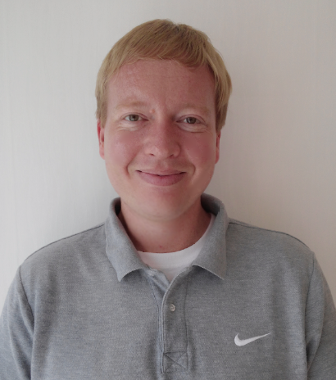
George Robert Kramer III

Personal Statement

I have recently gotten married here in Korea and have moved to Chuncheon with my wife and I am currently getting an F-6 visa. I would like to find a job here in Chuncheon, either full time or part time.
Teaching English in Korea has developed to be a passion of mine that I wish to continue. The greatest pleasure and enjoyment I get is seeing young students improve in English and take enjoyment from learning. I have been teaching for 3 years, for the TaLK after school program. I did a month Teacher training in Jochiwon and a week training course on-line provided by the TaLK program. I have taught all grades in Elementary at two different schools in the city of Nonsan. While teaching in Korea I have had many responsibilities: such as making books for English camps, assisting other Korean teachers in their classes, recording speaking for the schools listening part of their English tests, and also taking part and being MC for English competitions.
My Korean is basic to average; I studied level 3 Korean at the University of Kongyang in Nonsan. Though I have not gotten my degree yet from college I think I have enough experience here in Korea to teach English to students here in Korea. For I have a passion for teaching them and have fun playing with students and making them happy with learning.
I am looking forward to helping many more students in their pursuit in learning English here in Korea.

Work Experience

English Teacher Jan-2012 – July 31st 2013
Banwol Elementary school, ChungCheon Nam-do Nonsan

- After School English Classes.
- Making and assisting for English Tests.
- Winter and Summer English camps.
- Making camp work books.
- Being MC at English Golden bell competitions.

English Teacher
Geumgang University Winter Camp Jan – 2013 – Jan 2013
Geumgang University, ChunCheon Nam-do Nonsan.

- English Classes
- Making Camp lessons
- Camp Book

English Teacher Aug-2010 – Jan-2012
Dung-Sung Elementary School, ChunCheon Nam-do Nonsan

- After School English Classes.
- Assisting in English Tests.
- Assisting in normal English classes.
- Winter and Summer English Camps.

Japanese Assistant Teacher Aug-2010 – Aug-2010
University of Texas at San Antonio, San Antonio Texas.

- Helping Elementary students learn basic Japanese.
- Playing games and activities.
- Introducing Japanese culture such as the art of Bonsai making.

Education

2 years of College Jan-1999 - Present
University of Texas of San Antonio, San Antonio Texas
- GPA 3.1
- Deans’ List 2009
- Currently studying.

TEFL/TESOL Certified
- 150 hours TEFL/TESOL certification course T
- 10 hours teaching to young learners
- 30 hours Grammar Awareness
- 20 hours lesson presentation practice

