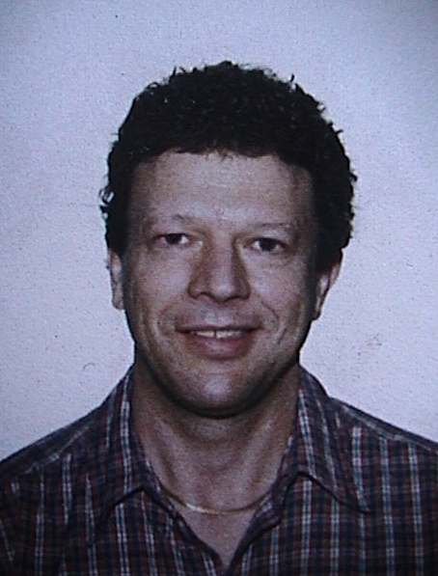

RESUMÉ
of
George Kullmann

EDUCATIONAL BACKGROUND

1968 - 1972 NORTH TORONTO COLLEGIATE INSTITUTE
Toronto, Ontario, Canada

‘Secondary School Honor Graduation Diploma’ (‘A’ Average)

1972 - 1976 UNIVERSITY of TORONTO
Faculty of Arts and Science
Toronto, Ontario, Canada

Bachelor of Arts (4-Year Honor’s Degree)
Majored in Linguistics

June - September 1974 GOETHE INSTITUTE
Munich, Germany

Certificate of Proficiency in German
German Government Scholarship

May - August 1975 Université de Paris (La Sorbonne)
Paris, France

Participant in the Canada-France Student Exchange Program
Advance course in simultaneous translation from French to English

September 1997 - GEORGE BROWN COLLEGE
April 1998 Toronto, Ontario, Canada

Intensive 2-semester academic program in teaching English as a second language, including courses in T.E.S.L. methodology, phonetics and phonology, pedagogical grammar, teaching skills, and practicum.

T.E.S.L. Certificate

EMPLOYMENT BACKGROUND

June - August 1976 ORGANIZING COMMITTEE of the MONTREAL OLYMPIC GAMES
Montreal, Québec, Canada

Liaison and Protocol Guide

Organizing and coordinating arrival and departure of international
Olympic delegations to and from the Olympic Village.

September 1976 - École International de Langues Étrangères
June 1977 Nice, France

Teaching Assistant for English

Position offered by the Selection Committee for the French
Government teaching posts

Providing English language instruction in grammar, writing, and conversation to French students specializing in foreign languages.

September 1978 - ONTARIO MINISTRY of REVENUE
November 1979 Toronto, Ontario, Canada

Tax Information Officer

Providing information to the general public regarding various Ontario government provincial tax programs.

November 1979 - CANADA EMPLOYMENT CENTER (Government of Canada)
June 1981 Toronto, Ontario, Canada

Employment counselor
Evaluating employment occupational skills of job seekers and referring them to matching available employment positions.

June 1981 – May 1996 GOVERNMENT of CANADA
Toronto, Ontario, Canada

Program Administrator

Administering and enforcing various government programs vis-à-vis existing legislation. Served in Canada and at Canadian diplomatic posts abroad.

July 1998 - April 2001 UNIVERSITY of HOCHIMINH CITY
Vietnam

Teacher of English

Providing English instruction and lessons to students in grammar, conversation, pronunciation, writing. Assisting in setting up and implementing a curriculum in various teaching disciplines, e.g. writing and conversation.

May 2001- February 2004 BROADWAY ENGLISH ACADEMY
Toronto, Ontario, Canada

Teacher of English as a Second language

Provided instruction to overseas students, mostly Koreans, in all disciplines of academic English, including essay writing as well as TOEIC and TOEFL preparation.

June 2004 – May 2006 Teacher of English Conversation and Writing

KIM HYO JUNG ENGLISH ACADEMY
Anyang, Gyeonggi-do, RoK.

- Provided instruction to elementary, middle-and high school students in conversation,
including phonics, and writing: from basic grammar and sentence structure to essay writing (TOEFL level). The aim has been to prepare students of all levels for the CBT and IBT TOEFL formats, namely, writing and oral expression.
- Held English conversation classes for the school’s Korean English teachers the purpose of which was to create an informal where they could practice their oral expression in English.
- Organized and held special classes of public speaking, presentation, and essay writing for advanced-level students.

June 2006 – May 2009 Toefl (IBT) Teacher

GULMAEK EDUCATIONAL INSTITUTE / SANG SANG DO-JEON (English Language Section)
Anyang, Gyeonggi-do

- Provided instruction to elementary and middle school students in conversation,
including phonics, and writing: from basic grammar and sentence structure to essay writing (TOEFL – various levels). The aim has been to prepare students of all levels for the TOEFL IBT Independent and Integrated speaking and writing tasks by enhancing their oral and writing expression skills.
- Instructed students in Reading and Listening Comprehension for TOEFL IBT.
- Taught academic skills (note-taking, summarizing, restating, and synthesizing) for TOEFL IBT.
- Authored a book on enhancing skills for TOEFL essay writing.
- Compiled material in book format for developing academic skills as well as oral and writing expression skills for the TOEFL IBT.
- Instructed students in problem solving (grammar, vocabulary, reading, and listening) for TEPS.

June 2009 – present Assistant English Conversation Teacher
(contract renewed to June 2011)
DAEPYEONG HIGH SCHOOL
Suwon, Gyeonggi-do

- Provided instruction to first and second grade students in English conversation using visual tools and devising educational games and interactive activities to encourage group and individual class participation.
- Conducted pronunciation drills and open discussions on various relevant topics with the aim of stimulating and encouraging students’ verbal expression.
- Co-authored a textbook for Daepyeong High School students on writing effective sentences in English. Textbook was used for writing classes.
- Organized and conducted ‘open classes’ for observation by other English teachers from within and outside the school.
- Assisted in editing and proofreading the school’s annual English newspaper.
- Organized and conducted classes for summer and winter camps.

- Supporting documentation provided on request

