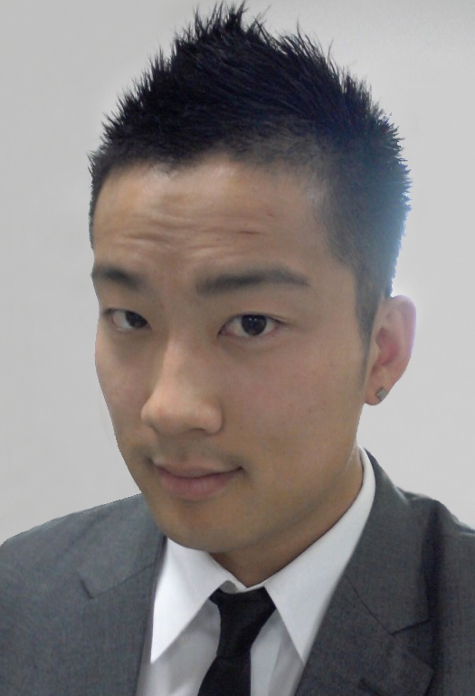

Glen Lee

OBJECTIVE To be a Native English Teacher in Korea

EDUCATION

San Francisco State University, Graduated: B.A. in Sociology – Spring 2011
City University of Hong Kong, Study Abroad Program in Language Studies – Spring 2011
TEFLONLINE.COM, Teach English in Foreign Language Certification (120 hours) – January 2012

Academic Awards: Mosaic Scholarship 2006, Osher Foundation Scholarship 2006, APASS Scholarship 2007, Goldman’s Scholarship 2008, and Music Teacher’s Association of California, Dean's List College of Behavioral and Social Sciences Fall 2009, Spring 2010, Fall 2010, Gilman Scholarship 2010, EPIK Pre- Orientation Award, EPIK In-Training Award, TEFL 120 Hour Course Award

WORK
EXPERIENCE
Yugang Elementary School, Pohang, Gyeongsangbuk-do, South Korea
English Teacher, February 2012 – February 2013
- Managed and facilitated 19 classes per week with 26 students per class (students age 10-13)
- Worked collaboratively with three Korean co-teachers to translate language effectively
- Lesson planned with the Korean National Curriculum and created own curriculum for after school classes
- Facilitated two English summer camps by making learning fun, engaging and motivating
- Supported students with various learning styles and to those with special disabilities
- Promoted prosocial behavior and prevented student bullying

City College of San Francisco Outreach & Recruitment, San Francisco, CA
Student Ambassador, September 2011 – December 2011
- Facilitated campus tours to new prospective students (middle and high schools, and individuals)
- Front desk Administrative Assisting in Multi-Use Building for the Gateway to College Program
- Provided informative college presentations to high school students (9-12th grade) such as Burton, Washington, and El Camino High School
- Tabled and represented CCSF at non-profit organizations and college fairs throughout San Francisco Bay Area. (7 Tepees, SF Promise, Women's Building Mission SF, Community Youth Center)
- Motivated students to attain higher education

San Francisco State University, New Student Programs, San Francisco, CA
Peer Advisor, January 2009 – July 2010
- Facilitated summer orientations for incoming Freshmen and transfer students
- Checked-in students and family members, worked as an usher, organized orientation information packets with graduation requirements for new students
- Academically advised students by planning class schedules, presenting keynotes and registration workshops
- Worked exclusively with a diverse group of students and a team oriented environment
- Advised a cohort of 10 undeclared freshmen and sophomores with educational planning, major exploration, and all academic resources

SKILLS Proficient with Microsoft Excel, PowerPoint, and Word. Stellar communication and interpersonal skills, verbal and written skills, motivational and team building skills, time-management, multi-tasking, productive skills, public speaking, detail-oriented, adaptive to all environments

LANGUAGES Conversational Taishanese, Cantonese, Mandarin, and Korean

REFERENCES Available upon request

