Margaret Gould, B.A. (Adv.) (Winnipeg), Cert. TESL
Email: Mag.Gould@hotmail.com
Phone: 010-2661-0533
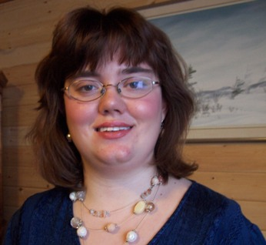
#1604-7, No. 205
Jeongwang-Dong, Siheung City
Gyeonggi-Do, South Korea

Personal Details
Date of Birth: 12/03/1982
Mother Tongue: English
Citizenship: Canadian
Marital Status: Single
Health: Excellent

Education
2008 Oxford Seminars Winnipeg, MB
Teaching English to Children certification

2007 Oxford Seminars Winnipeg, MB
TESOL/TESL certification

2000 - 2006 University of Manitoba/Winnipeg Winnipeg, MB
Bachelor of Arts Advanced
- English and Native Studies

Work/Volunteer Experience
September 2008- Kim’s Language Institute Siheung City, South Korea September 2009
English Teacher
- Taught adults how to speak, read and write in English.
- Taught English to children between the ages of 10-13.
- Prepared lessons from the available textbooks and the daily newspapers.
- Prepared and marked report cards and homework.

April-August 2008 Nowon SLP Seoul, South Korea
English Teacher
- Taught how to speak, read and write in English to children from Kindergarten to High School level.
- Prepared and marked homework, tests and exams.
- Assigned schoolwork from the required textbooks.
- Accompanied the students on field trips.

2007 University of Manitoba Winnipeg. MB
Volunteer Tutor
- Assisted a special needs University student with daily tasks and social interactions and tutored in him in English and Fine Arts.

2002 – 2004 St. Andrew’s College Winnipeg. MB
Resident Assistant
- Assisted students by reporting all safety concerns at the college to the Principal.
- Helped students solve problems concerning each other or the college.
- Patrolled the resident section of the college in the evenings.

Relevant Skills and Experience
Professional Associations: Canadian Library Association and the Ontario Library Association
Interests: Writing, reading, current issues, Native issues, theatre and visiting museums
Travel: South Korea, United States, within Canada

References:
Available upon request

