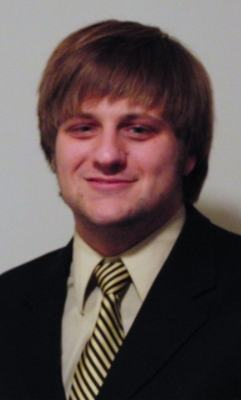

Greg Behn
Use my strong academic skills and command of the English language to teach English abroad and gain valuable international experience.
Education
Bachelor of Science, Physics  Bob Jones University | May 2009
- Major: Physics
- Minor: Mathematics
Skills & Abilities
Telescope Observation
- Managed every aspect of data collection on a 31” refractor telescope in 3 one-week-long observing runs at Lowell Observatory in Flagstaff, AZ.
- Collected scientific data in multiple single-night observing runs using SARA’s remote observing software.
- Performed data analysis for several binary star systems.
Communication
- Presented a talk to the Meeting of South Carolina Astronomers on our observations and data analysis on an eclipsing binary star system.
- Explained all aspects of our observations and conclusions to a room full of professional astronomers.
- Published an article in the Astronomical Journal. Article Title: “Photometric Analysis and 60-Year Period Study of the Detached But Near Contact System VV Virginis” The Astronomical Journal, 136:1667-1676, 2008 October.
Teaching
- Taught a Wednesday night children’s club for 2 years at my local church for kids aged 5-11 years, which involved creating, designing, preparing, and presenting the lesson, along with all learning aids; also designed and directed games.
- Improved other students grades by tutoring numerous college and high school students in math, science, and English courses, both on a regular basis and as single lessons throughout my college career.
- Traveled with the Bob Jones University Science Team for two weeks after graduation, visiting 12 schools and presenting a Science demonstration to all age groups from kindergarten to 12th grade. Presentation was tailored for each age group.
Physics and Astronomy Lab Assistant
- Prepared all equipment for General Physics, Physical Science, and Astronomy labs.
- Managed the entire lab class, improving student comprehension by assisting them in their experiment and answering their questions.
- Assisted the professor in equipment management, lab design (when necessary), and problem solving.

