Hannah McDonald
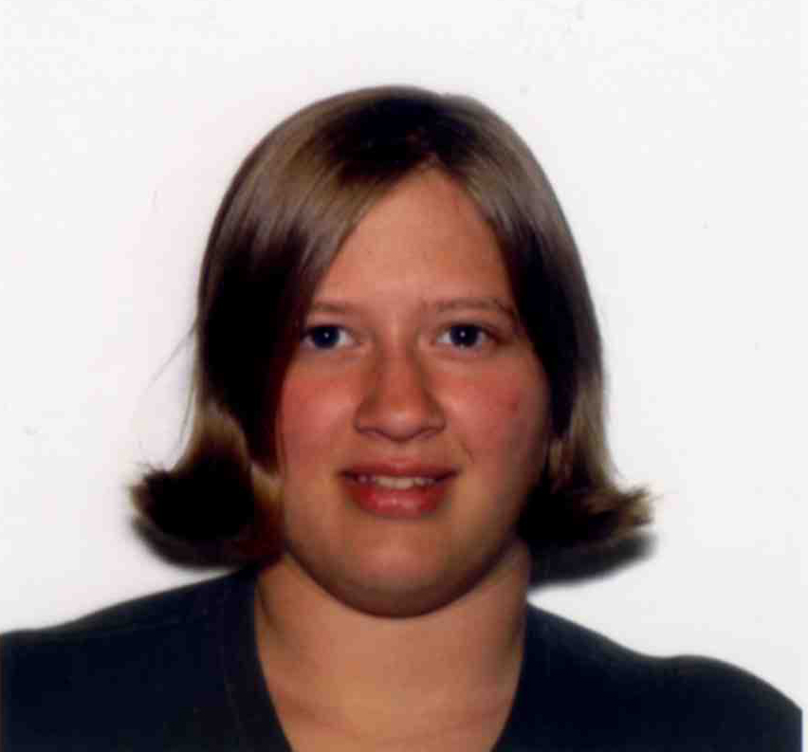
E-mail: ohannahmcdonald@gmail.com
Skype: traveljunkie1
Phone: 5025175630

Personal
Details Name: Hannah McDonald
Date of Birth: 18 June 1988
Sex: Female
Passport Origin: United States of America

Education August 2010, Phnom Penh, Cambodia
144 Hour TESOL
Language Corps Asia

May 2010, Danville, Kentucky, USA
Centre College
Bachelor of Arts

May 2006, Lawrenceburg, Kentucky, USA
Anderson County High School
High School Diploma

Employment
Details Camp Albrecht Acres, Sherrill, Iowa, USA, June 2012-August 2012
Assisted as a counselor for 8 weeks at a residential summer camp for children and adults with special needs and disabilities. Took charge as the Art Director during the last two weeks of daytime camp for children with and without autism between the ages of 4-13.

Aston English Foreign Teacher, Yulin Aston English, Yulin City, Shaanxi Province, China, August 2010-March 2012
Full time foreign teacher of English to students between the ages of 5-16. Create lesson plans, grade homework, administer regular exams to test students’ language proficiency, regularly meet with parents, and attend promotional school events.

Executive Leader of Alpha Phi Omega (volunteer organization) Centre College Chapter, Danville, KY, September 2006-May 2010
Average over 200 hours of volunteer service per year with institutions such as Sadie’s Animal Rescue Shelter, Kentucky School for the Deaf, Relay for Life, and the Red Cross.

Psychiatric Hospital Intern, Psiquiátrico Yucatán, Merida, Mexico,
January, 2009
Studied with psychiatrists during appointments with in-hospital patients. Reported observations from group sessions with suicidal patients, and helped collect data for schizophrenic research.

Other Skills
    - Previous International Study: Spain, January, 2008; Centre-in-Strasbourg, France, Fall 2008; Costa Rica, January, 2010
    - Languages Spoken: English and Spanish
    - Computer: Microsoft Word, PowerPoint, and Excel

