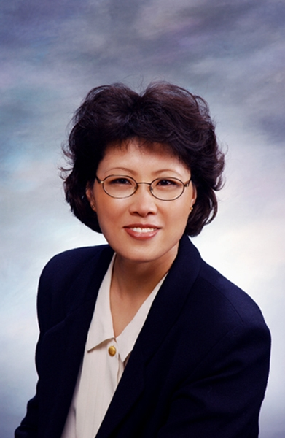
Heather Seo
206-150 The Donway West,
Toronto, Ontario, Canada, M3C 2G2.
1-416-441-9161 seo.heather@gmail.com
Personal Information
 | Birth: Republic of South Korea, 1956 |  |  | Marital Status: Single
 | Citizenship: Canadian, 28 years |  |  | Health: Excellent
Mother Tongue: Korean
Education
 | 2010 | TESOL/TESL Certification, Toronto, Ontario
 | 2008 | Introduction to Public Relations Workshop, Humber College, Toronto, Ontario
 | 2005 | Mortgage Financing, Seneca College, Toronto, Ontario
 | 2002 | Property Management Certification, Humber College, Toronto, Ontario  - Communicating for Effectiveness  - Business Planning and Strategic Management  - Human Relations for Managers
 | 2001 | Social Science Program, University of Toronto, Toronto, Ontario
 | 1996 | Real Estate Broker License, Ontario Real Estate College, Toronto, Ontario
 | 1987 | Ontario Secondary School Diploma, Saint Albert Collegiate Institute, Toronto, Ontario
 | 1978 | Nursing Diploma, Hallym University, Republic of South Korea
Work Experience
 | 2009 | Workshop Assistant, Thornhill Community center, Markham, Ontario  - Play a supportive role in a non-English speakers' newcomer workshop
 | 1996 | Real Estate Broker (self-employed), Toronto, Ontario  - Represent clients’ best interests in the real estate market
 | 1978 - 1982 | - Maryknoll Hospital  - Participated as an integral part of the Planning and Management Office team
Credentials
 | TESOL/TESL Certification, Toronto, Ontario
 | Real Estate Broker, Toronto, Ontario
 | Certified Property Manager, Toronto, Ontario
 | Registered Nurse, Republic of South Korea
Skills / Interests
 | Reference available upon request

