RESUME
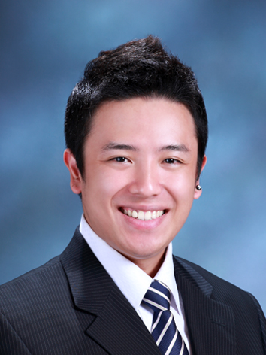

PERSONAL INFORMATION

Name : Holly Andrade Calilung
D.O.B : 8 October, 1986
Address : 346-8 Seogyo-dong Mapo-gu Seoul
South Korea, 121-837
Mobile : +82-10-8477-3444
Email : quassiha@gmail.com

Interests : Studying Languages/Foreign Cultures, Digital Painting, Travelling, Music
Qualities : I'm a very outgoing person and I get along very well with others. I'm kind and respectful towards my colleagues and superiors. I'm very enthusiastic, creative and energetic about working. I'm always happy to help out anyone who needs help. I am a fast learner, and I enjoy challenges. I love experiencing new locations and meeting new people.
Career Objective : I want to work overseas and gain a broader understanding of different cultures and ways of living, especially in north-east Asia. I have a large interest in Japanese and Korean culture, and studied their languages and learnt about their cultures while in University. I think working with school students is a very good way to begin working overseas. I intended to gain some experience teaching overseas before I return to University and complete an education and teaching degree.

EDUCATION
MacGregor State High School 1999-2003 MacGregor, QLD
Completed to a Grade 12 level, graduating 2003.

QANTM College 2004-2006 Brisbane CBD, QLD
Diploma of Screen, major in
- 2D Animation (3D Animation Minor)
Griffith University 2006-2009 (Graduating in December) Nathan, QLD
Bachelor of Arts, major in
- Japanese Language
- Japanese Culture
Akita International University (国際教養大学) Mar. 2008-Dec. 2008 Akita, JAPAN
Completed Study Abroad Exchange Programme at this institution.

WORK EXPERIENCE

BEST Fitness Sunnybank Hills, QLD
January 2009 – any time they need website update
Position: Graphic Designer for their website and advertisements
Duties:
- Create banners and logos for BEST Fitness website
- Design web page templates for future use

Kumon Learning Centre, Inc, Sunnybank Hills, QLD
March 2009 – June 2009
Position: Assistant Tutor
Duties:
- Responsible for elementary students
- Motivate students to do their homework and class work
- Record student work progression

OFFICE SKILLS
- Microsoft Office (Word, Powerpoint, Excel)
- Adobe Photoshop CS3, Corel Painter
- Adobe Flash
- Basic web design skills

REFERENCES
Dr. Leigh Kirwan – (Griffith University – Head of Japanese Language) (Australia)
- (07) 555 28612
- l.kirwan@griffith.edu.au

