Julie (Hui-yeon) KIM

Unit 702/ 15 Atchison Street
St Leonards, 2065 Australia
E-mail: huiyeonkim82@gmail.com
Contact no. +61 433 222 166

- NSW Government Accredited Teacher
- Permanent Resident Visa Holder of Australia
(Teacher No. 1193802)
12th January 2010

To whom it may concern,

Thank you for considering my application for the Foreign Language Teaching Assistant position for the Gyeonggi Province in South Korea.

I have high admiration to the teachers in Korea who are devoting their profession to the talented and young students. This has led me to a deep passion for education and I am eager to bring my professional assets to be contributed to the students and staff in the Gyunggi Province of South Korea.

Since I was 7 years of age, due to my father’s work transfer, I had started Elementary School in Toronto, Canada and after 4 years of receiving primary education, this has led me to continue my middle school, high school and University degrees in Sydney, Australia (14 years). During those important years as a young student, I clearly remember till this day, how greatly teachers have influenced my attitude towards studying and my acceptance of the unfamiliar culture.

As my teaching philosophy states, engagement is the essential key for effective learning. And with my experience and competence in teaching and deep passion for education, I believe my qualifications will match your requirements.

To highlight some of my personal attributes, I have had the opportunity to function in a variety of educational settings making it easy to adapt to new situations and faculty concepts. I am a creative thinker and with my background in Visual Arts and Photo Media, I have achieved numerous ways to approach students with creative and interesting activities for class work. With this, students have discovered and learned ways to appreciate class work in another level.

Confidence and experience is the core essence to quality teaching and integral part to develop relationship with staff and students. More importantly, I am an enthusiastic team member who can enhance productivity of the group that I belong to and I am a good communicator who is always willing to resolve problems through quality discussions.

Please accept this letter as an expression of my genuine interest in pursuing my teaching career at Gyunggi Province of South Korea. I will produce an energising and creative learning environment that will bring best in students.
If you are interested in a dedicated teaching professional with the required credentials, patience and positive attitude, please contact me via mobile phone number or e-mail given above.

Thank you for your time.

Sincerely,

Julie (Hui-yeon) KIM

Julie (Hui-yeon) KIM Huiyeonkim82@gmail.com
Professional Teaching Philosophy

Everyone can learn. I believe all students are gifted in their own individual way and it is the teacher’s job to support and show how special individuality is to the student.
To support students and my beliefs, it is important to build motivation.

I will find ways to incorporate students’ personal experiences, social concerns and different cultures into the classroom and plan effective lessons by having quality discussions with students as well with the staff in the department. By this, I will motivate students towards higher goals and achievements.

As for personal development, it is crucial to revise and reflect every lesson for higher achievement and results of class. Improvement in professional practice such as upgrading myself and adapting to upcoming technologies and popular culture is the key to gain common grounds with the students to understand their perspective in life experience.

I am an enthusiastic, bright, caring teacher who values students’ autonomy. I believe motivation is a very important part of education but maintaining motivation will be the core task for all teachers including myself through this journey.

Curriculum Vitae Julie (Hui-yeon) KIM

Address: 702/15 Atchison Street
St Leonards, NSW, 2065 Australia
Mobile: +61 433 222 166
E-mail: huiyeonkim82@gmail.com

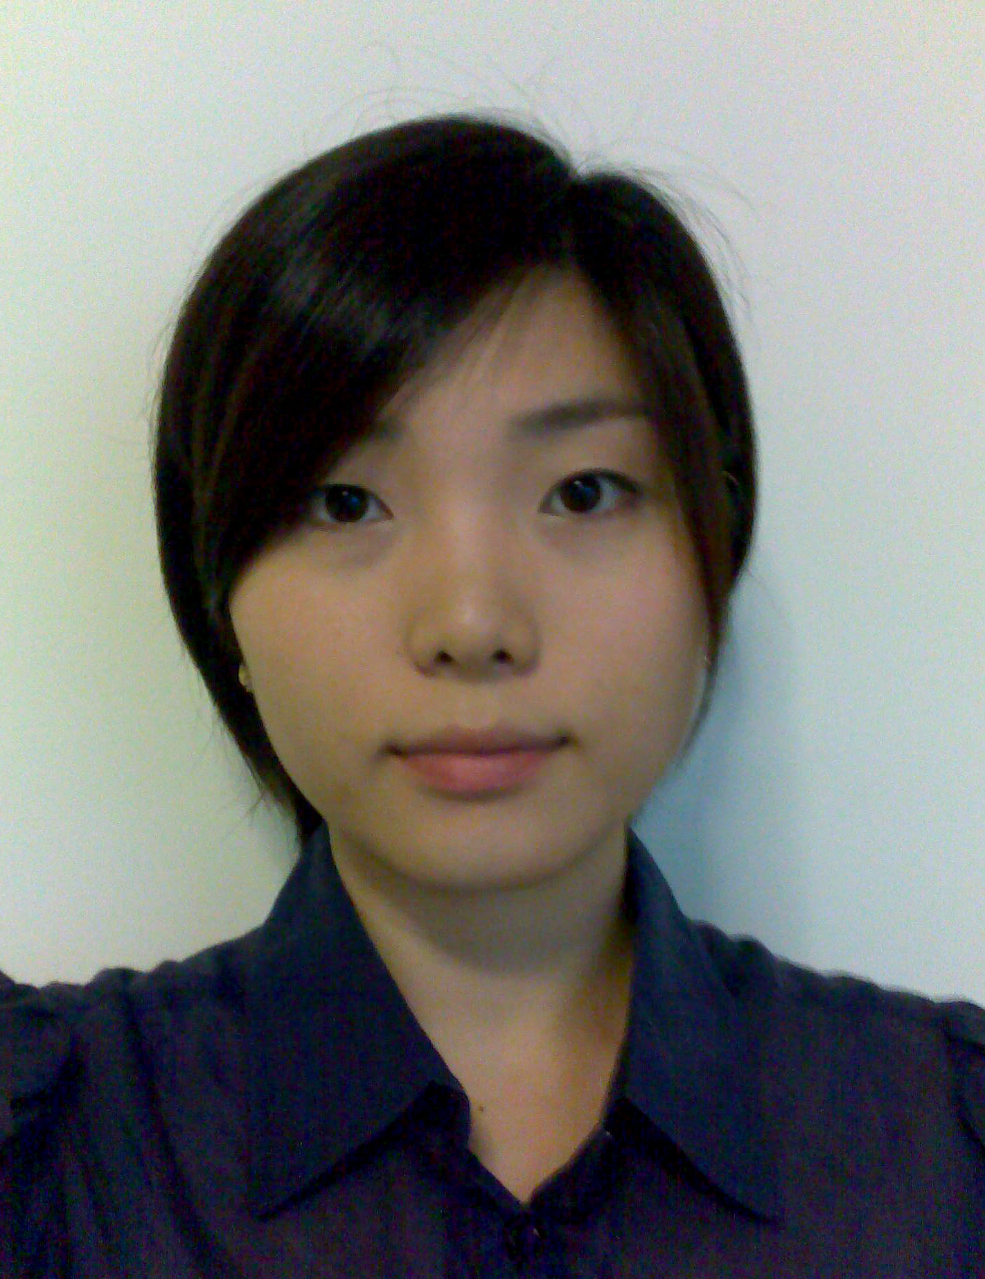
PERSONAL PROFILE
I am currently working in the early childhood education sector with passion for education. My passion for education has led me to Bachelor of Teaching after completing an Honours Degree in Masters of Studio Art and a Bachelors Degree in Visual Arts.
I am a qualified teacher accredited by the Australian New South Wales government with the Department of Education and Training for Visual Arts and Photography (DET No. 1193802).
With the extensive experience I have obtained from the early childhood education and my 2 degrees, I am currently seeking for an opportunity in South Korea for a primary and secondary level education. I am fully prepared and ready to give guidance to the young and talented students and to assist staff in the school community in need.

EDUCATION
Bachelor of Teaching, Secondary Art Curriculum (2006 - Nov, 2008)
University Of Sydney

Practicum Placement (1) Mosman High School
Military Road Mosman
NSW 2088
Phone: (02) 9968 1006

Practicum Placement (2) Ryde Secondary College
5 Malvina Street Ryde
NSW 2112
Phone: (02) 9809 4894

Master of Studio Art (Photo Media) with Honours (2004)
University Of Sydney

Bachelor of Visual Arts, Fine Arts with Photo Media (2001 – Dec, 2003)
University Of Sydney

Higher School Certificate (1996 – Dec, 2000)
Meriden Girls School (Private Anglican School for girls)
QUALIFICATIONS/AWARDS

DET Accreditation for Visual Arts and Photography (yr7-12)
DET Approval Number: 1193802

Adobe In Design CS2 (2009)
Eastern Suburbs Community College
Certified in successful completion of course for graphics program in Adobe In Design CS2

Small works (2009)
BSG Fitzroy – Small works 09 exhibition
4 major artworks (photography) have been selected to be part of an exhibition at Brunswick Street Gallery in Melbourne, Australia.

Senior First Aid Certificate including CPR (2009)
St. John Ambulance, Australia
Certificate No. 589273

Professional Development Workshop (2007)
Camp Australia (Children education services)
Workshop1. Duty of care
Workshop2. Occupational Health & Safety in the workplace
Workshop3. Quality Assurance
Workshop4. Child protection

Westmead Children’s Hospital photo selection prize (2003)
Artwork (photography) was selected as the main image for the calendar of Westmead children’s hospital. Theme of the photo selection was CHILDREN.

KEY SKILLS

- Native speaker in both languages - English and Korean
- Proficient with computer software including Microsoft Word(90wpm), PowerPoint, Adobe In Design and Photoshop
- Computer literate (both MAC and PC)
- Proficient with wet photography including high resolution scanning negatives and positives
- Extensive experience with manual and digital cameras
- Creative, hard working, proactive and responsible with given work
- Great team worker and leader
- Quick adapter in challenging environments
- Handling children
- Great communication skills

KEY EXPERIENCES

2009 – Current Expect a Star
Child Education (Education Services)

Casual Assistant
- Childcare specialists in early childhood sector
      - Facilitating indoor and outdoor activities
      - Assist preparation of lunch, morning tea and afternoon snacks
      - Developing skills to handle difficult situations when handling young children

2008 Camp Australia
Child Education (Education Services)

After School care Assistant
- Leading provider of Outside School Hours care in Australia
- After school care services for children aged between 7 to 12
- Supervising children on indoor and outdoor activities
- Assist school homework
- Facilitating sporting events for children
- Assigned to MLC Primary School in Burwood, NSW Australia
- Developed skills to manage primary school children through variety of teaching methods obtained during Bachelor of Teaching curriculum

April – May 2008 Mosman High School
Secondary Education - Practicum placement

- Allocated to 14 periods per week based on a 55 minute period to teach Visual Arts and Photography to grade7 to grade12 students
- Develop lesson and unit plans for grade7 to grade12 students
- Assist in team teaching with head teacher
- Self reflection and evaluation for every lesson was required
- Participating in school sports carnivals
- Participate in staff development days (every Wednesday)

Aug – Sept 2007 Ryde Secondary College
Secondary Education - Practicum placement

- Allocated to 18 periods per week based on a 50 minute period to teach Visual Arts and Photography to grade7 to grade12 students
- Develop lesson and unit plans for grade7 to grade12 students
- Assist in team teaching with head teacher
- Self reflection and evaluation for every lesson was required
- Participating in school sports carnivals

May 2006 Sydney Secondary College
Secondary Education

Teaching Assistant (Special Education Unit)
      - Assist teachers in special education unit
      - Helping teachers responsible for intellectually and physically challenged children
      - Develop patience and skills required to mentally and physically challenged children

Jan – Dec 2005 Pixels Plus
Digital Photography Lab

Technical Assistant
- Local photography shop in Crows Nest, NSW
- Developing films and negatives for customers
- Retouching and modifying of old and new photographs using photographic computer software (Adobe Photoshop, Kodak Image)
- Film and Digital Image printing
- Technical sales on cameras and related photography equipments
- Developed communication and customer interaction skills

REFEREES

Ms Louise Samuals
Visual Arts Teacher

Ryde Secondary College
Address: 5 Malvina Street Ryde, NSW 2112
Phone: (02) 9809 4894

Mr Rodd Grant
Head of Visual Arts Department/Visual Arts Teacher

Mosman High School
Address: Military Road, NSW 2088
Phone: (02) 9968 1006

Mr Alex Noone
Owner/Manager

Pixels Plus
Address: 45 Willoughby Rd Crows Nest, NSW 2065
Phone: (02) 9437 4247

