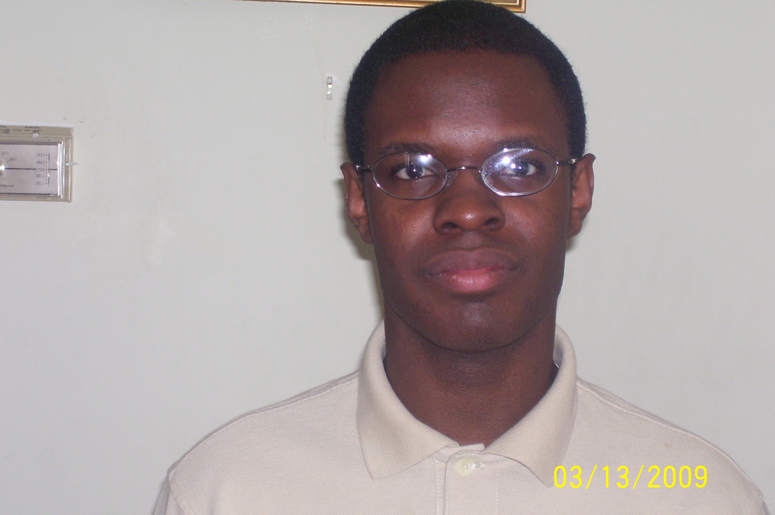
Bernard Thomas
1929Teddington Dr • Charlotte • N.C. • 28214-2454 • USA
Email: bernard.thomas@live.com • Mobile/Cell: (704)241-3463

Birthday • October, 24, 1985
Marital Status • Single
Nationality • American

Objective

Young recent university graduate who loves kids eager for the opportunity to learn how to teach E.S.L. in the Republic of Korea.

Education

2003-2008
North Carolina State University, Raleigh, North Carolina
Bachelor of Arts
•Major in Communication

Teaching Related Experience

May, 2007 – present
North Carolina State University Office of International Services, Volunteer Small Group Leader
• Answered questions of incoming new international students to the University
• Organized morning activities for students
• Counseled students during stay at University

Work Experience

September, 2008 – December, 2009
JC Raulston Arboretum, Agricultural Support
• Set up facilities for public and private events
• Cleaned and closed on weekends
• Assist patrons with finding plants in the garden

Language Skills

• Intermediate Spanish

Travel Experience

•The Bahamas, 1 week

References

Available upon request

