Jinok Kang
85-14 Broadway Apt #3A Elmhurst, NY 11373
Cell : (347)658-6787
Marykang1031@hotmail.com 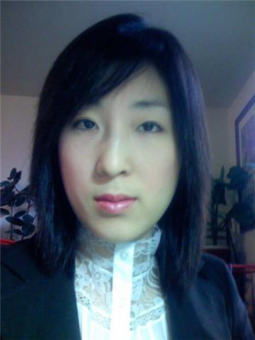

OBJECTIVE: A position as a teacher
EDUCATION: Hunter College, City University of New York
Bachelor of Arts in Psychology
Minor: Sociology
Related coursework: General Psychology, Statistical Methods in Psychology, Experimental Psychology, Abnormal Psychology, Physiological Psychology, Cognitive Psychology, Developmental and Social Psychology, Personality Psychology.
SPECIAL SKILL: Microsoft Word, Excel, PowerPoint, Outlook, Internet Explorer, Netscape, Internet Research, TESOL Certificate, Business English Certificate, Teaching of English to Young Learner certificate. Awarded the Certificate of Participation of Becoming a Teacher.
LANGUAGE SKILLS: Bilingual (Korean and English)
EXPERIENCE:
04/2005-present The New York Physical Therapy and Acupuncture, Flushing, NY
Physical Assistant ( temp position )
Assist patients with exercises, massages, electrical stimulation, paraffin baths, hot and cold packs, and ultrasound. Assist patients in the lifting and transportation of disabled patients. Monitor and provide documentation of patient treatment and response. Process billing transactions and handle all internal and external calls.
5/2002-03/2004 Teacher and Tutor, Queens, NY
Taught elementary school students in English, bible, arts in Korean Church of Queens during summer, temporary part-time teacher assistant in P.S. 11 Kathryn Phelan School and Simon Baruch High school (Handed out assignments and corrected homework)

1999-4/2002 The Hanahreum Distribution, Queens, NY
Clerical worker
Perform data entry and operate computer (word processing, spreadsheet, database, presentation. Answer phone calls, perform numerical filing, make copies of printed matter using copying and fax machine when instructed, match, code and enter invoices into QuickBooks, prepare journal entries related to revenues and expenses
References Available Upon Request

