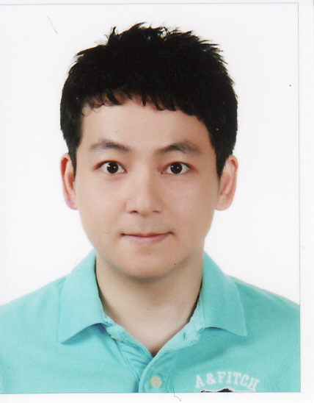
James Jung Yong Woo
Professional Skills
- Fluent in the languages of Korean and English.
- Strong leadership skills
- Ability to think strategically and work independently.
- Excellent team building, interpersonal and communication skills.
- Able to create curriculum for various English levels.
- Great knowledge of the Hangeul Program.
- Easy and outgoing, can relate to all kinds of students.
- Positive attitude and dedicated approach to work.
Work Experience

Soosuk Language Institute, Apgu, Seoul, South Korea March 2012-July 2013
Main Speaking and Writing Instructor
Team Leader

- Managed the entire speaking and writing program.
- Help develop curriculum.
- Taught various levels of conversational English.
- Managed speaking and writing programs for the academy.
ADGiS Language Institute, Daechi, Seoul, South Korea June 2008-March 2012
Team Leader

- Managed the entire elementary team.
- Help assist and build curriculum.
- Quality Assurance and Control of Korean and foreign instructors.
- Handled training of all new elementary instructors.
- Proposed and implemented new ideas for critical thinking.
- Managed American Textbook program.
- Managed speaking program for the academy.
- Consultation with parents.

Served in the Korean military May 2006-May 2008

English Channel, Jongro, Seoul, South Korea Jan 2006-May 2006
English Instructor

- Taught various levels of conversational English and business English.
- Was responsible for managing the business curriculum.
- Mainly dealing with speaking and business classes.

R.K.L.Y Legal Group, Toronto, Ontario, Canada April 2004- Nov 2005
Manager

- Managed the employees to work well in a business environment.
- Simultaneous translation. (Korean to English, English to Korean)
- Was responsible for making sure the office runs well.

Worked various private lessons and corporate classes throughout my time in Korea.
Accomplishments
- Plaque from the Toronto Police for helping out with the Korean Business Association as the main translator. (Toronto)
- Valedictorian– R.J.Lang Middle School. (Toronto)
- Valedictorian – McKee Public School. (Toronto)
- TESOL certificate

Education
The Cyber University of Korea
Practical Foreign Languages

Seneca College, Toronto
Business Administration

Northview Secondary School, Toronto
References Available upon request

