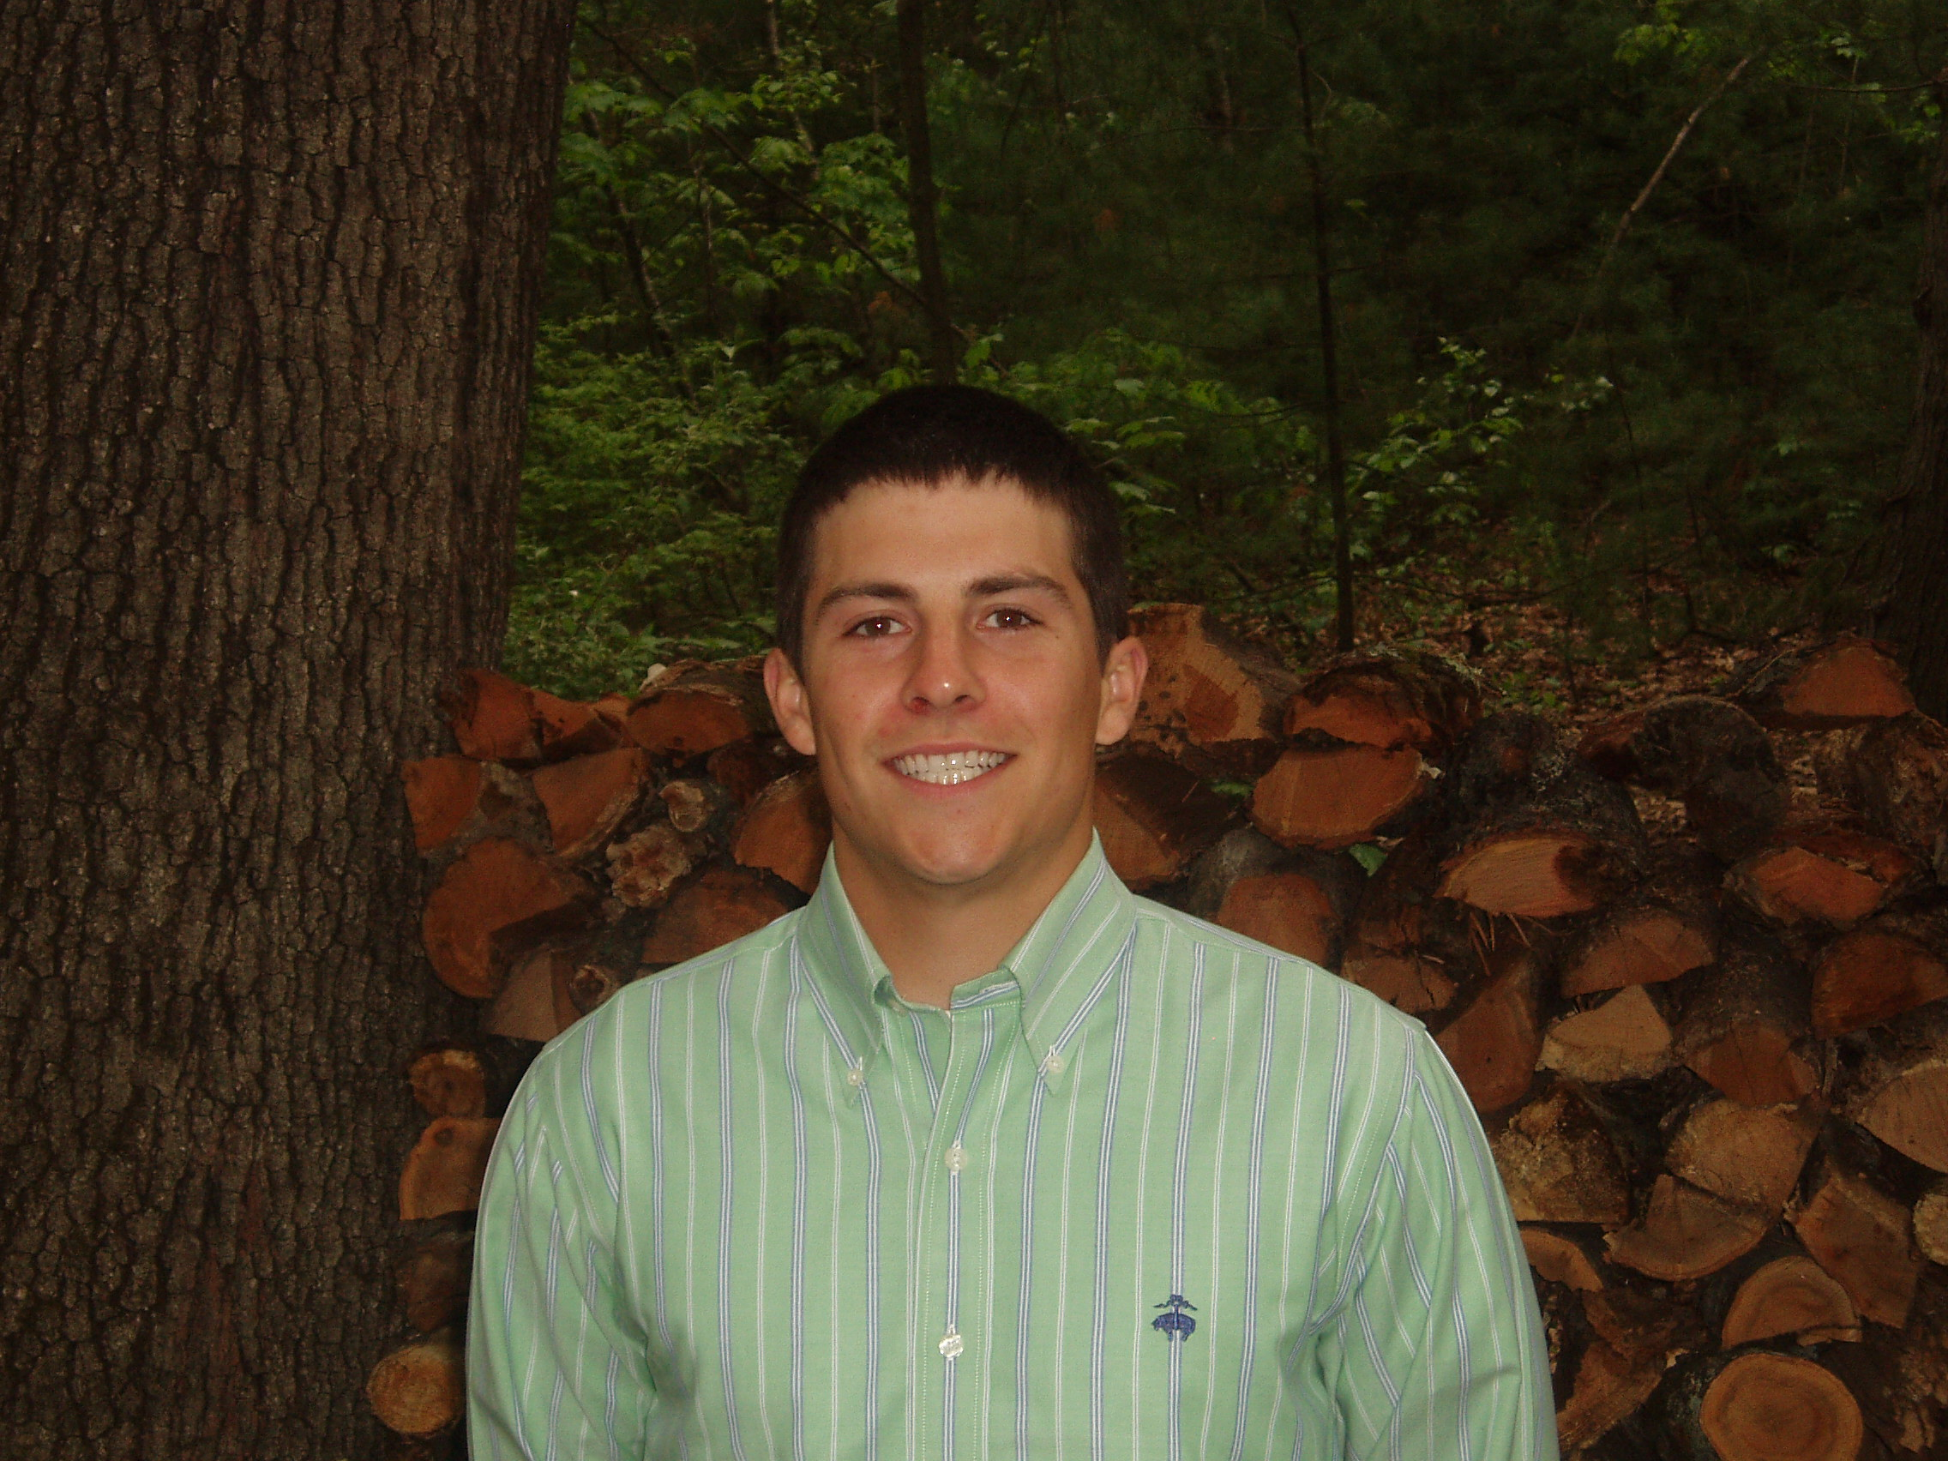

Jamie Chevalier
U.S.A.

Education
Keene State College Keene, New Hampshire
Bachelor of Arts in English Literature, May 2009 Sept. ’05 - May ’09 Concentration in Postcolonial studies
Minor in History
Graduated Cum Laude - 3.5 GPA

Teaching Experience

Pine Tree Academy Seoul, South Korea
English kindergarten and elementary teacher Jan. ’12 -- March ‘13

Taught an American curriculum to students aged 7-14. Also led field trips, taught gym

classes, wrote and produced plays, and helped the school recruit new teachers.

Foxcroft Academy Dover-Foxcroft, Maine

Special Education teacher Dec. ’10 – July ’11
Taught autistic high school students English and History at Foxcroft Academy, an international private school. Most of the teaching was of high school literature one-on-one. Also coached baseball and worked daily with the filmmaking department after school.

BCM Language Centers Seoul, South Korea

English conversation teacher Sept. ’09 – August ‘10
Taught Korean students of all ages conversational English. Led discussions on many topics
while maintaining a focus on building communication skills such as vocabulary, intonation, listening, and confidence.

Keene State College
Worked as a teacher’s assistant for my college advisor, Dr. Brinda Charry.
Notable accomplishments included my contribution to a seminar entitled “A History of Race
in the Renaissance”, as well as the leading of lectures on topics such as Postcolonial Theory
and “intertextuality” for Dr. Charry’s Literary Analysis class at Keene State College.

Activities
Varsity High School Baseball Coach: assistant Head Coach at Foxcroft Academy in 2011
Varsity College Baseball: four-year starter and recipient of three All-Conference awards
Volunteer Baseball Instructor: all four years at college I instructed local ballplayers ages 5-14
Private Tutor: helped college classmates with writing and editing of their essays
Broadcaster: announced high school basketball games for Internet radio

