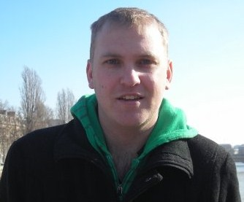

Jamie Plunkett
Flat 2 Rutland Court, Cossack Street, Rochester, Kent, ME1 2EF, England
Email: plunkettj84@googlemail.com Mobile: +447949780486

DOB: 26/10/1984
Marital Status: Single
Nationality: British

Objective

I am an experienced teacher looking to teach elementary and/or middle school aged students in South Korea. I am relishing the opportunity to continue teaching in another culture to explore the differences and expand my skills to enhance my career.

Availability – I am available from August 9th 2010 and can commit to a contract for a full year.

Education

University of Brighton, England (2007-2008)
PGCE (Teaching qualification in the UK)
- Original university certificate dated 15th July available on request.
Fully qualified teacher as of 31st August 2009.
- Certificate from the GTC (General Teaching Council for England) available on request.

University of Brighton, England (2003-2006)
Degree of Bachelor of Science in Computing
- Original university certificate dated 13th September 2006 available on request.

Teaching Related Experience

Fully qualified teacher with two years teaching experience:

Oakmeeds Community College Sept 2008 – Sept 2009
•Teacher of ICT and Business Studies.
• Secondary education in England, ages 11-16 mixed education.

University of Brighton teacher training Sept 2007 – Sept 2008
Two school placements lasting four months each:
- St Wilfrid’s Catholic School
- Eastbourne Technology College

Work Experience

Two full years’s teaching experience as mentioned above.

The Daily Telegraph newspaper Sept 2006 – Sept 2007
- Working in Sales and Market research for one of the UK’s leading media group.

Travel Experience

- Have spent the last 6 months travelling around the UK and Europe.
- Have had holiday’s in Thailand, Cuba, America and many destinations in Europe

References

Available upon request.

Travel Information

- Will be travelling alone
- Single person accommodation preferable
- Would ideally like to be located in either Seoul or Busan or any major cities in South Korea.
- Passport in hand and original University Degree certificates.

If any other information is required please do not hesitate to contact me.

