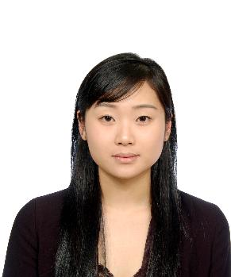
Jeeye Han

Seoul Eunpeung Gu Shinsa 2Dong Hyundai 1Cha APT 104-606
Home: (02) 305-3070 Cell: (010) 5673-8777
Marsden0718@hotmail.com
82 10 5673 8777

Education
2003-2007 Dongduk Womans University, Seoul, Korea (4years)
Major: English Language and Literature
Bachelor’s degree, February 2007
Courses included: Business Communication in English, Public Speech in English, International Conference Communication, Mass Communication & Society

Work Experience
March 2008 Advanced Materials & Intergration CO.,LTD, Pyeongteak, Korea
Translation, Interpretation, Personal Assistant of CEO
Handled various inquiries from foreign related to market practices, market announcement.
Translate bussiness documents, simultaneous interpretation, communicated with the foreign participant companies and associations.
Filed and organized documents. Provide needed documents to the participating board of director

August 2007- Pagoda Academy, Seoul, Korea
August 2008 English instructor
Implemented curriculum given by the school. Found and incorporated materials and resources to core curriculum for all ages and skill levels
Monthly grading and evaluate students.(RC, LC)
Taught English for various grades and helped students prepare for middle school. Also helped test prep for CAT testing.

March 2003- YBM Education / GNB English Seoul, Korea
July 2007 Head Teacher and manager of Program
Instruct classes from Elementary to Adult (TOEIC beginner – advanced class, RC, LC, Newspaper script reading, Business Class etc)
Recruit and train new teachers
Designed and implemented new entry strategies and worked as a Team leader for marketing plans, progress and correct accordingly

Leadership Roles
2003-2005 HSBC Sports and Social Club, Seoul, Korea
Staff
Managed monthly cultural events for colleagues which have been chosen as the best program of HSBC SSC 2003

2005-2007 Campus Fellowship Seoul, Korea
Head officer
Organized summer and winter conferences for Korean students
Edited monthly newsletter

Skills and Other Information
Language Fluent in Korean and English
Computer Skills Efficient in MS-Office
Others Driver’s license /
TOEIC Score 940
3 years of private teaching experience (mostly executive directors or board members of enterprises)

