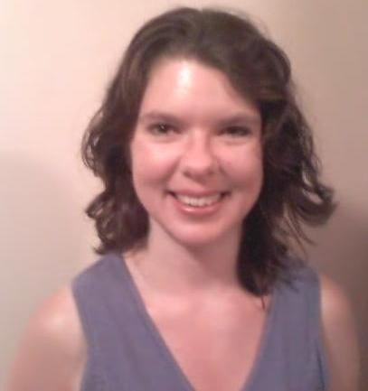
Jane Whiteing
612 S. 16th St. #15
Ames, IA 50010
Phone @ Korea: 010-7233-5113
Summary of Qualifications
-
Communicate effectively and diplomatically in stressful situations
- Maintain Calm and Collective demeanor in tense and demanding times
- Multi-tasked over 5 years: fulltime work in Social Services and undergraduate studies.
- Two years apartment managing: solving facility and tenant problems n tribulations

- Extensive perception and understanding people using problem solving & critical thinking skills.
Education
- Human Services, B.A. Grand View College, Des Moines, Iowa. Summer 2007
- Human Development and Family Studies, Iowa State University, Fall 1998 - 2002
- Early Childhood Education, Iowa Lakes Community College, Fall 1995 - Spring 1998
Jane Whiteing
612 S. 16th St. #15
Ames, IA 50010
Phone @ Korea: 010-7233-5113
Experience
MBT @ Ulsan South Korea Sept. 08 to Aug. 09
ESL Teacher: preparing daily lesson plans, evaluating students, effectively teaching adolescents.

ECC @ Ulsan South Korea Sept. 07 to May 08
ESL Teacher: preparing daily lesson plans and effectively teaching children to adults
Mainstream Living Inc., Ames Iowa. 1998 - August 2007
-Supported Living Technician:

Train, teach and monitor persons with disabilities, independently or in group home settings.

Guided consumers in daily living and achieving personal goals.

Worked as a team player and team leader as necessitated.

Arranged, organized and took groups of consumers on weekend tournaments and trips.

Pheasant Run Apartments, Ames, Iowa. Spring 2005 - Spring 2007
-Apartment manager:

Supervised residential grounds, and building maintenance. Did purchasing, ordering of supplies and equipment. Maintained excellent customer service with tenants. Resolved problems with tenants, utility providers, vendors, and political entities.

