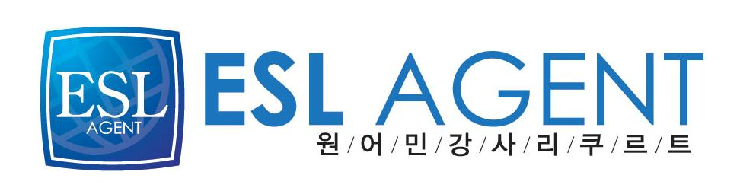
이에스엘 에이전트
최진영(Cassie)
02-2675-0582

Jasmin Quinn Rice
Seoul, South Korea



EDUCATION:

Wellesley College, Wellesley, Ma, 2006-2011
Bachelor of Arts, Classical Civilizations: May, 2011.
- Courses: Roman Law, Dead Sea Scrolls, Drawing, Gender in Antiquity, Sculpture I, Fundamentals of Chemistry, Conservation Studies.
- Member of Wellesley V-Day Campaign.

Intercollegiate Center for Classical Studies Sicily, Catania, Italy, 2008-2009
Study Abroad, Fall semester, Academic credit from Duke University.
- Courses: Mediterranean Cultures, Intermediate Latin; Ovid, Advanced Greek; Pindar, Beginning Italian.
- Analyzed material culture to gain a better understanding of ancient civilizations.

Thornton Academy, Saco, Me, 2002-2006
- Graduated fifth in a class of 284, National Honor Society, Academic Decathlon, Amnesty International, Interact, Student Advisory Board.

EXPERIENCE:

English Instructor at NGLOW Kids, Gwangmyeong, South Korea, February 28, 2013-June 28,2013
- Primary English instructor for one advanced kindergarten class, one preschool class, and several elementary and kindergarten after school classes. Prepare materials for and lead classes in various subjects such as phonics, language, science, math, music, grammar, and geography. Create a stimulating English curriculum for a preschool level class. Produce detailed reports for kindergarten students on a biweekly, monthly, and quarterly basis. Complete detailed reports for after school students on a monthly basis. Work closely with each student to ensure the growth of their English language skills.

English Instructor at Poly School, Mokdong, Seoul, October 4, 2012-February 27, 2013
- Activity Director and music instructor for three preschool classes. Organize special activities for holiday celebrations. Lead the creation and direction of a Christmas play. Primary English instructor four elementary level classes. Prepare for and lead various classes focusing on phonics, reading, speaking, grammar, math, social studies, and writing. Complete detailed reports for elementary students on a monthly basis. Create a productive learning environment for gifted students using books utilized in North American curriculums.

English Instructor at YBM ECC, Ssangmun, Seoul, February 23, 2012-September 27, 2012
- Primary English instructor for two kindergarten classes and five elementary level classes. Prepare for and lead various classes focusing on phonics, reading, speaking, and grammar skills. Complete detailed reports for all students on a monthly basis. Successfully guide students to a higher degree of English language comprehension.

Teavana Team Leader, South Portland, Me, September 1, 2010-September 20, 2011
- Organize co-workers and facilitate improvements in store environment and business practices. Advise customers on purchases of tea and tea accessories. Train and coach employees.

Academic Tutoring, Wellesley, Ma, 2008-2010
- Tutored student in SAT testing skills. Utilized diverse pedagogical tools in order to accommodate student's learning style. Focused on identifying accurate grammatical structures and expanding vocabulary. Taught strategies to improve reading comprehension.

Computer Skills; Microsoft Word, Excel.
Latin: Two years of college level Latin, Translated Ovid, Catullus, and Vergil
Greek: Five semesters of college level Ancient Greek, Translated Pindar, Plato, Homer

