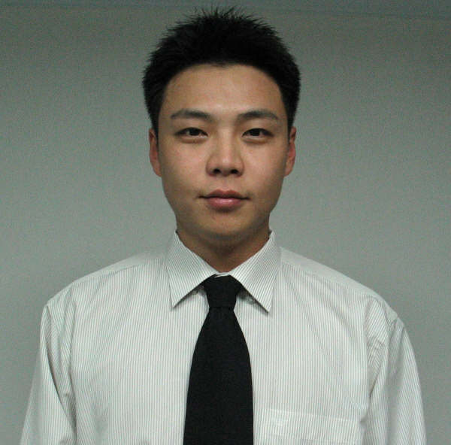
Resume
Jason(Jae Yong) Jung
Work Experience

March 2012 – August 2012
Full-Time Manager at Pressync (Marketing&PR Company)
Clients – Calvin Klein, Prada, Chanel, National Museum of Art, JTI
Translated official Press Release
Marketed various events in Seoul
Promoted campaigns for various Companies

November 2010 – February 2012
Full -Time Head Instructor/Consulting Manager at CDI Suncheon Branch
Organized Instructor meetings/ trained Instructors
Organized seminars and parent teacher meetings

November 2009 – September 2010
Part-Time Substitute Instructor for various branches of CDI,
Including Secho, Yeongtong, Dongtan, Shinlim

June 2008 - October 2009
Full-Time English Instructor for CDI (Chungdahm Institute) Bangbae Branch
Taught from lower levels (English Chip) up to Intermediate levels (Interactive English, Eagle)
Monitored and trained Instructors as a Head Instructor
Organized instructor meetings/ trained new instructors

January 2006 - January 2008
Full Time English Instructor for KookJeong E-School(Jamsil, Korea)
Organized curriculum for over 100 students(advanced class)
Classes mostly focused on reading American Textbooks and written skill improvement
Prepared students for overseas study.

September 2004 - January 2006
Full time English Instructor for 이보영’s English Talking Club.(Ansan, Korea)
Organized curriculum for over 50 students (beginner to advanced)
Prepared 6th graders for Middle school English Education, Middle school students to High school

January 2004 - August 2004
Recruiter for ParkEnglish Recruitment Agency(Seoul, Korea)
Interviewed and Organized necessary documents for English Instructors to teach in Korea
(Also worked as a Part-time instructor for Adult’s business classes)

November 2001 - January 2004
Served Korean Military in 철원, 강원도
Honorably discharged as a Sergeant

August 2000 - November 2001
Worked in Sales and Marketing Department for J&B Korea co.ltd.
Translated English Documents, Faxes for the company
Interpreted for Company’s buyers and visitors.
Organized English Documents and Fax.

Education

1999 - 2000
University of Washington (Seattle, Washington USA)
Majored in Business and Administration
1996 - 1999
Graduated from Shorewood High school (Shoreline, Washington USA)

