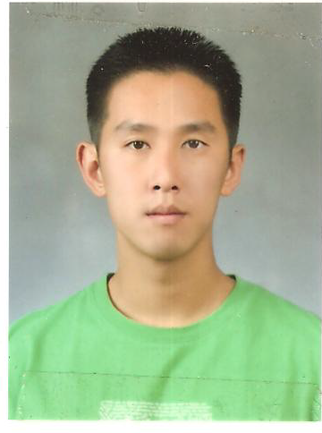

Eung Jay Kim
Seoul Gangnam Gu, Yeoksam Dong
HP: 010-9207-3455 EMAIL: ejaye27@hotmail.com

OBJECTIVE
Seeking position utilizing Korean and English language skills; special interests in teaching conversation and TOEIC/TOEFL

PROFESSIONAL EXPERIENCE
Republic Of Korea Army, Daejeon, Korea 2007 ~ 2009
Interpreter / translator, Republic of Korea Army Headquarters (32nd Infantry division, Ministry of Defense, ROK Army HQ)
- Interpret documents and translate conversations.
- Responsible for teaching over 50 students English conversation and pronunciation, during which students were presented with modified assignments at different levels provided with research. Helped students improve grammar and mechanical skills on an individual basis through tutoring.
- Received "Award of Excellence" for numerous temporary leave of assignments. Assigned as English Instructor and lead interpreter in Switzerland for the Annual International Military Tattoo Festival.

Gardena Academy, Gardena, CA. USA 2005 ~ 2006
ESL teacher, tutor
- Provide assistance to ESL students; teach fundamentals of basic grammar, practice conversation in English, and correct homework.
- Small group and individual tutoring; teaching basic conversation skills, and assigning homework.
- Provide transportation to/from the academy and home.

Rimtech International Transport, Gardena, CA. USA 2004~ 2005
Inbound / outbound documentation, order processing, customs validation
- Responsible for documenting all incoming and outgoing cargo information and notices in the South Korea and Southeast Asia Operation.
- Process all shipment orders in the distribution department.
- Responsible for getting all vehicles validated from U.S Customs.

EDUCATION
California State University, Long Beach
Bachelor of Science in Business Administration

SKILLS
Written and oral fluency in Korean
TOEIC 990
Microsoft Word, Excel

