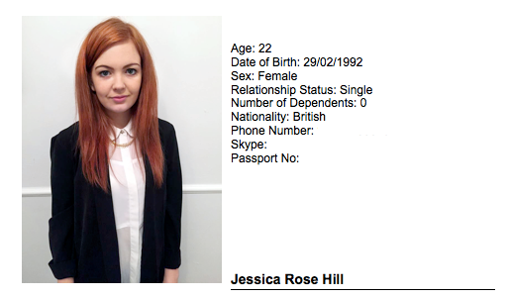
Profile

I am a recently qualified English Foreign Language Instructor, native to England. I believe myself to be both outgoing and hard working with a strong desire to succeed within the English Foreign Language, and teaching profession in general. It has been my goal to become an EFL instructor prior to me attending university, with South Korea being my first location of choice to practice and further develop my teaching skills. The South Korean culture appeals to me mostly for it’s its fusion of rich history with technological innovation in which I would love to live and work within for at least a year of my life. However, I am of course moving to South Korea primarily to succeed within a well-developed and competitive EFL industry to further develop the skills to grow as a professional teacher.

Academic Achievements and Qualifications

BA (Bachelor of Arts) Fine Art, University of Bolton (2011- 2014)

I am a recent graduate of The University of Bolton attaining a 2:1 Bachelor of Arts in the subject of Fine Art. Throughout the course of my degree I developed many transferable skills for the teaching profession. These skills include: independent project management, completing high-quality work within strict time frames and much practice in presenting ideas and concepts within the classroom environment. Such skills in planning and presenting give me confidence in leading successful lessons of my own.

Teach English Foreign Language Certificate 120 Hours (2014)

After graduation I laid the foundations for working as EFL Instructor by completing a ‘120-hour TEFL qualification’ (100 hours online, 20 hours class room experience), with: 'TEFL.org.uk,' the UK's biggest TEFL Company of which is accredited by numerous independent bodies to maintain a high standard of teaching. Not only did the course cover all the skills essential for teaching EFL, it also specified in how to manage and teach a variety of ages; from young children to adults.

Teaching Experience

My prime teaching experience comes from my TEFL qualifications 20-hour classroom experience. This entailed PPP lesson planning, and teaching small groups, of which we were graded upon to guarantee we could deliver successful lessons. Beyond instruction we would also practice the monitoring of other teachers lessons and students.

I have attained further teaching experience by volunteering art and craft lessons to children at local libraries and galleries. I have on a number of occasions led workshops independently with small children to help them enhance a variety of arts and craft skills. Finally 30% of my degree grade came from the presenting of my work and concepts to my tutors and peers giving me further practice delivering ideas and lessons. My collective experience gives me confidence in teaching both young children to adults and anything in between.

Hobbies and Interests

I regularly visit art galleries and museums, as I am very interested in world culture, especially in the form of art of which transcends language barriers. My main area of interest is contemporary art. Additionally I am interested in craft and vintage fairs. I often attend and work at such events and sell handmade merchandise.

Additional Work Experience

As well as running workshops I have worked in several other areas of an art gallery. I have previously set up exhibition spaces, and invigilated during exhibitions. I have also led groups around the gallery spaces as a volunteer docent. This has given me experience of working with a range of age groups and relaying knowledge on the gallery collections, which again is further experience in leading groups and teaching information similar to the role of an instructor in a classroom.

Referees

Academic Referee:
Alan Buckingham, A.Buckingham@bolton.ac.uk, 01204 903378

TEFL Course Referee:

Caroline Tattersal, carolinatattersal@gmail.com

