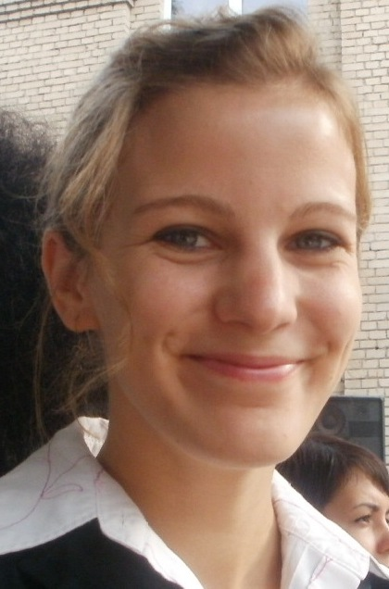
Jessica Ruch

Qualifications Summary
International Experience and training in Lesson Planning, Teaching ESL, and Youth Development. College coursework emphasized international perspectives and development. Proficient in German and conversational in Russian. Skilled in spreadsheet, database, and word-processing programs.

Education
University of Oregon, Eugene OR
      - Bachelor of Arts, German and International Studies July, 2008
      - GPA 3.91, Magna Cum Laude, Dean’s List
      - Study Abroad: University of Heidelberg, Germany August, 2006 – June, 2007

ICAL TEFL Certificate August, 2012
      - Completed 120 hours of practical, comprehensive coursework on teaching ESL

Experience
EPIK English Teacher, South Korea September, 2012- August 2013
      - Taught ESL to K-6th grade at Beomeo Elementary School, Yangsan
      - Developed Curriculum, Lesson Plans, and taught extra-curricular English Classes
      - Developed and taught Winter and Summer English Camps

Peace Corps Volunteer, Ukraine March, 2010- June, 2012
      - Taught ESL to 1st-11th grade at public village school in collaboration with local teachers
      - Developed Lesson Plans and new English Resources for teachers and students
      - Created, initiated and directed five popular English Clubs attended by more than 100 students
      - Organized and Facilitated youth Summer camps for 100 youth emphasizing conversational English

Start Making A Reader Today Volunteer, Eugene OR April, 2009 – February, 2010
      - Worked closely with K-3 Students who needed literacy support
      - Encouraged students to read on own with self-confidence and comfort

Relevant Skills
      - Proficient in Microsoft Word, Excel, PowerPoint, and Smart Board
      - German - proficient in reading, writing, and speaking
      - Russian- Certified Intermediate level, speaking and reading
      - Flexible and adaptable in international setting

