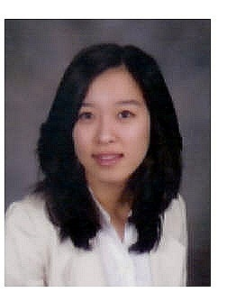
Jiha Kim
Woosung Apt 14-905
Daechi-dong Gaepo 2cha
Gangnam-gu
Seoul, Korea
Tel. (82)10-7149-1838
kimjiha@msu.edu

PERSONAL DETAILS
Birth: Korea, 1985
Citizenship: Korean
Mother Tongue: Korean
Martial Status: Single
Health: Excellent
EDUCATION
2000-2001: Townsville Grammar High School Queensland, Australia
2001: East Lansing High School Michigan, USA
2002-2004: Williamston High School Michigan, USA
2004-2009: Bachelor of Arts Michigan, USA
School of Hospitality Business, Michigan State University
2009: TESOL/TESL Certification Michigan, USA
Oxford Seminars

WORK EXPERIENCE
2008 Manager Assistant, Holiday Inn Atlanta, USA
Front Office
- Guest check-in/out procedures
- Concierge
- Assisted manager
Housekeeping
- Room inspection
Bar
- Served drinks
- Cashier
2007 English Teacher, Mommy & Me (Language Institution) Seoul, Korea
- Taught kindergarten and elementary students
- Arranged course schedule prepared course materials.
- Also assisted other teacher
2006 Food & Beverage, The Tuxedo Club New York, USA
- Served food and beverage for guests
- Set-up and clean-up for events and meals.

ACTIVITIES/INVOLVEMENT
2007 Volunteer, Hospitality Business Auction
2007 Server, Hospitality Les Gourmets hospitality Black tie Dinner

SKILLS&EXPERIENCE
Foreign Languages: English (fluent), Japanese (basic)
Travel: United States, UK, Greece, Turkey, Italy, France, Australia, Japan, Mexico.
Interests: sports, music, cooking, movies, travel.

