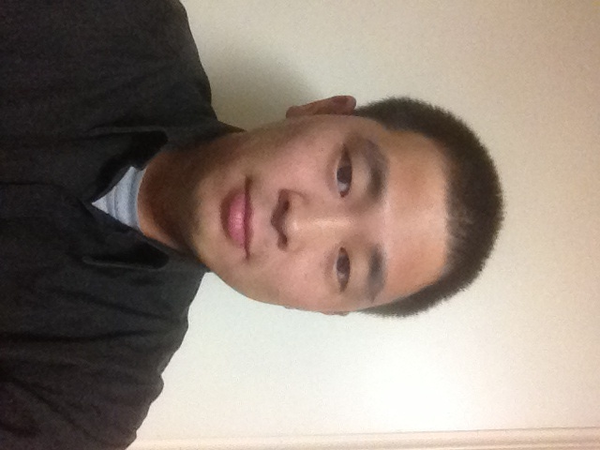

JiHun Busa
Email: Busa2020@gmail.com
Phone: 010-9173-2872
Current Location: Goyang/Ilsan
Desired Location: Goyang/Ilsan/Seoul

English Tutor Goyang/ Ilsan

* Native English speaker from Atlanta, Georgia tutors other Korean residents with grammar and conversational English.
* Proofreads and edits English written by native Koreans.
* Assist with pronunciation and correct word selection.

Legacy Chevrolet Sales Training

* Promotes store brands to create sales and profit goals
* Conducted skills training, guest service and new product knowledge training for all department associates.

Aflac American Family Life and Insurance Company (AFLAC Inc.) Senior Specialist/Trainer

* Subject Matter Product and Administration Expert to assist all internal and external clients.
* Review contracts and compliance for Agents Licensing, Verified commissions and fees for Agents Accounting
* Reviewed underwriting requirements for New Business department, Assisted External Payroll departments with benefit payments, Serviced Claims for customers.
* Responsible for leadership tasks including team member questions and inquiries, service levels, productivity and compliance.
* Review inquiries, documents and account information to research and resolve while relying on judgment and experience to resolve non-routine issues
* Work with other appropriate departments when customer requests and discrepancies need to be escalated for resolution

TSYS Total Systems Credit Card Services Service Representative

* Assisted customers with giving and clarifying account information and performed maintenance by entering customer data into database.
* Performed calculations and research to resolve issues customers had concerning payment discrepancies and subsequent fees.
* Submitted requests through appropriate channels for account maintenance.

Education
2012 Member of Society of Manufacturing Engineers for Lean Manufacturing
2012 Masters Business Administration MBA Troy State University (Apostilled)
2007 Finance BBA Columbus State University (Apostilled)
2004 Certified Life and Health Insurance Specialist Columbus Technical College

