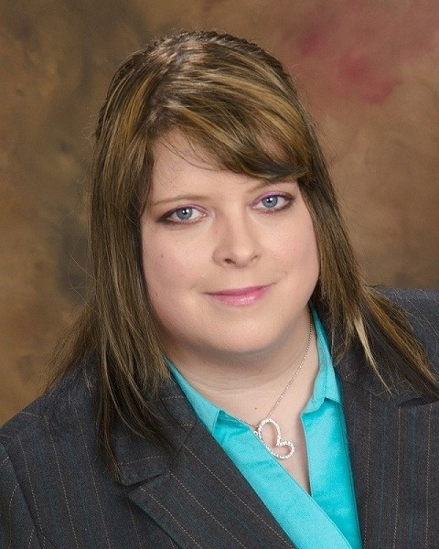
Joanna Thomas

Objective:
My goals are to help promote and build English skills and abilities for Non-native speakers. To share cultures and experiences to promote culture awareness.

Education:
May 1994 High school diploma, Andover High School 1744 N Andover Rd. Andover Ks
67002
May 1997 Associate, Butler County Community College 901 S Haverhill Rd. El Dorado, Ks 67042
May 2001 BA in Art, Friends University 2100 W. University. Wichita, Ks 67212

December 2001 BGS in Criminal Justice. Wichita State University 1845 N. Fairmont Wichita, Ks 67260

Current Education: TEFL Certification: Completed December 8, 2011. TEFLOnline.com
120 hour Master Diploma course with Business English and Young Learners Endorsements. Through BridgeTEFL (ACCET accredited-Accrediting Council of Continuing Education and Training US Department of Education Recognized Agency ).

Qualifications and Work related experience:

June 2012-June 2013: Teaching English at Pullo Elementary School 1 50 gil seogu bullo dong Incheon South Korea. I taught grades 3-6.
August 2011 to May 2012: Teaching English as a second language to Vietnamese Buddhist Monks at Phap Hoa Temple 4706 N. Arkansas Ave. Wichita, KS 67204-2924
June 2011 to June 2012: Offering English lessons online via skype to students from Japan, S. Korea and Vietnam.
April 2011 to June 2012: Correcting English submissions on Lang-8, including explanations of English Grammar and structure.

February 2012 to June 2012: Tutoring two Korean students online through .ComEnglish Seoul, S. Korea

References:

Yu Eun Kyoung Co-teacher at Pullo Elementary school
565 1094 ext: 720

Song Jung Hee Co-teacher 3-4th grade at Pullo Elementary
School. 565-1094 ext: 742

Dr. Ahn Tran, PhD, Associate Professor. Wichita State University. Department of
Curriculum & Instruction. 1845 Fairmount Street. Wichita, Kansas 67260-0028
email: anh.tran@wichita.edu
telephone: 316-978-6934 *will also provide letter of recommendation*

Danna Hatchett, Adjunct Instructor. Butler Community College. Advanced Technology
Center. 715 E. 13th st. Andover, Ks 67002. email: dhatchett@butlercc.edu
telephone: 316-218-6348 *will also provide letter of recommendation*

Adam Von Cannon 1509 Oneida Wichita, Ks 67217 316-269-2223

TEFL Certified Teacher

Dear Sir/Madam,

Please consider me an applicant for your English teaching position that your school has available. Since August of 2011 I have been voluntarily teaching Buddhist Monks English as a second language at a local Vietnamese temple. In 2012 I started working at an Elementary public School in South Korea and will finish my contract this June, 2013. I am eager for an opportunity to expand my teaching abilities and make this a career. I thoroughly enjoy teaching English to non-native speakers and learning about my student's cultures as well.

*I have a good ability to manage a classroom with students at different language levels, all of my current students are at a different level from beginner to intermediate- advanced. I am always on time, and well organized.

*As a teacher, I believe it is essential to not only teach the curriculum but also to build a structured, nurturing environment that not only will allow the students to grow individually but also as productive members of society.

*I have a strong ability to individualize the curriculum to suit the needs of students at all levels in the same classroom.

A major strength that I would bring to your school system is a creative, positive outlook on life, a mind-set to work very hard towards the goals one sets, generosity and kindness towards others, patience, and to be a positive role model to my students. I want to inspire my students to be the best they can be and to keep an optimistic view towards the future and build positive self-esteem. I believe that all children can learn and do well given the opportunity and the right mind-set.

I would welcome an opportunity to work with you and your school system and I look forward to hearing from you in the near future. Thank you for your time and consideration.
Sincerely, Joanna Thomas

