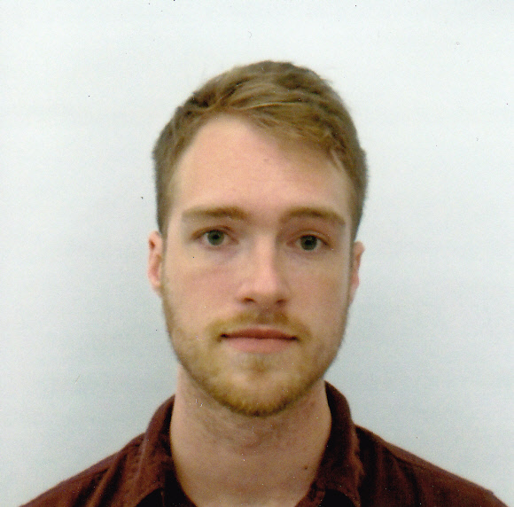
Objective
To obtain a teaching position in a professional school,
private school, or university in Korea teaching ESL grammar
and conversational English.

Education
University of Central Florida
4000 Central Florida Blvd.
Orlando, FL 32816
Graduated August 2013
- B.A. History (Focus in Asian and U.S. Studies), GPA 3.3
- TEFL Certificate (180-hour). In-class teaching practice, training in curriculum development, course planning, ESL grammar, conversation English, contrastive language issues, current teaching/employment conditions, current methods of teaching foreign languages at the secondary level within a communicative framework and classroom experiences. Also led 10 hours of conversation practice for international students at the Center for Multilingual Multicultural Studies.

Daytona State College

1200 West International Speedway Blvd.

Daytona Beach, FL 32114

Graduated December 2010

A.S. Environmental Science (Focus on Ecology), GPA 3.0

Spruce Creek High School

801 Taylor Road

Port Orange, FL 32127

Graduated 2009, Magna Cum Laude, 3.9 GPA, finished a semester of college early via AP classes.

Work Experience
Bubba Gump Shrimp Co.
250 North Atlantic Avenue #120
Daytona Beach, FL 32118
(386) 947-8433
[January 2013- present]
Marshall's & Homegoods
5505 S. Williamson Blvd.
Port Orange, FL 32128
(386) 763-4681
[August 2012- January 2013]
Wildside Bar & Grille
2305 Edgewater Drive
Orlando, FL 32804

(407) 730-7963
[June 2011- May 2012]

Hollywood Theaters

5547 South Williamson Blvd.

Port Orange, FL 32128

(386) 523-9400

[November 2009-January 2011]

Aunt Catfish's Restaurant on the River

4009 Halifax Drive

Port Orange, FL 32128

(386) 767-4768

[February 2008-April 2009]

Language Ability
- Native speaker of English.
- Three years of German language and culture study.
- Two semesters of French language and culture study at UCF.

References
- Dr. Keith Folse, TEFL professor, UCF - keith.folse@ucf.edu - 823-4555
- Dr. Karen Verkler, Education Professor, UCF - karen.verkler@ucf.edu - 407-823-5235
- Professor Christina Torres, Linguistics, UCF

