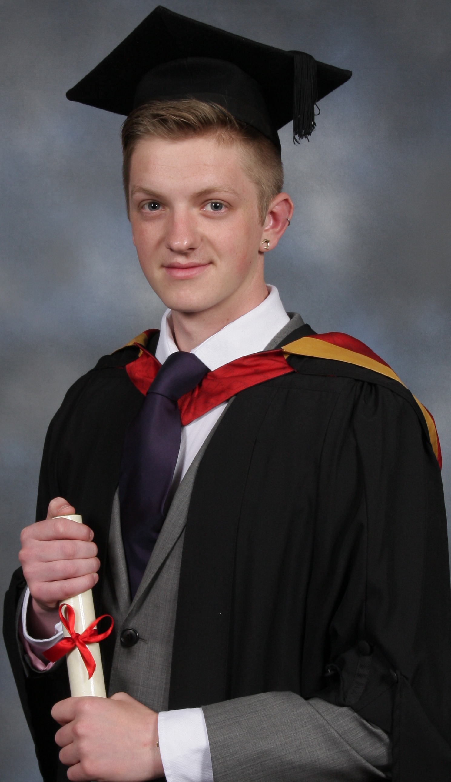
John Lee Taggart
15 Fernedene Court, Gosforth, Newcastle, United Kingdom, NE31NN
(0191 447 4882 / 07855460424) – JohnT360@hotmail.com
I am a dynamic and creative graduate with a proven work ethic – I have lived and worked in the USA, China, Finland and the United Kingdom respectively; I feel this gives me an international perspective and demonstrates I have the ability to adapt to diverse and often difficult workplaces.
I am looking to secure a teaching position in a challenging post, where I can bring my self motivated ambition to every classroom and in turn develop my current skill set further.
Education History and Qualifications:

TEFL in China  (2012) | Awarded the certificate of ‘Teaching English as a Foreign Language’ by the TEFL in China programme. (Secured position to teach English at Jianghan University in Wuhan, China).
Northumbria University  (2009-2012 | Graduated with a BA (hons) in English Literature from Northumbria University, completed dissertation on the novel American Psycho entitled ‘Transgressional Fiction as a Barometer of Cultural Boundaries’.
Georgia State University  (2010-2011) | Second year of university spent in the USA (Atlanta, Georgia) on an exchange to Georgia State University, I was enrolled on a variety of classes including; Southern Literature, Art, Psychology, Acting for Performance, English Writing, Film Analysis and English vs. American Culture.
St. Aidan’s Sixth Form  (2007-2009) | Achieved good A-levels in English Literature (A), General Studies (A), Double Award Applied Business (BC), Government & Politics (C).  Awarded the ‘St. John Fisher Cup for Outstanding Performance in General Studies’.
St. Aidan’s RC Secondary School  (2002-2007) | Achieved GCSEs in English Literature (A), English Language (A), Art (A), Double Award Science (BB), ICT (B), Religious Studies (B), Mathematics (C), Spanish (C), Economics (C).

Work History - (Have worked solidly since I was 16 – below are my relevant roles in education):
- Jianghan University (China) – Foreign Expert Teacher (TEFL)- (August 2012-January 2013)
- Wuhan Love Kids Education Institute (China) – English Teacher – (September 2012 – January 2013)
- Shunyi No. 5 Middle School (China) – Summer School English Teacher – (August 2012)
- Georgia State University (USA) – English Department Student Assistant (August 2010- July2011)

