John Paul Deacon
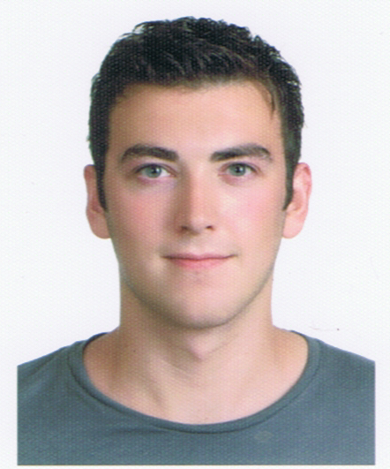
E-mail correspondence: Johndeacon4@hotmail.co.uk
Nationality: British Date of Birth: 1985/11/06
Telephone Number: +44 1455 844509 Mobile Number: 010 8685 3261
Education:
- 2005-2008: Upper second class BSc Degree, The University of Hull, England.
- 2003-2005: Triple distinction (equivalent of 3 A’s at “A level”) BTEC National Diploma, Brooksby College, England.
- 2000-2002: 10 GCSE’s at grades A*- C, William Bradford Community College.
Work Experience:
- KNC Hyunjae Language Institute, Mokdong branch, Seoul. Teacher of English Reading, Speaking and Listening to elementary and middle school students (November 3rd, 2008 – October 31st, 2009).
- UK Environment Agency – Utilizing physical practical skills, academic knowledge, problem solving, computer literacy, presentation and data entry skills and dealing with the general public.
- Losehill House Hotel – Utilizing communication and inter-personal skills with clientele along with public speaking, hosting and events organization management.
Miscellaneous:
- Certificate in Emergency (First) Aid.
- Certificates in Health and Safety and Manual Handling from the Health and Safety Executive.
- Best practical student of the year (2005), Brooksby Melton College, England.
- Best English student of the year (2002), William Bradford Community College, England.

Motivation for teaching:
I first visited South Korea in August 2008 after graduating from university in England. I spent a very enjoyable fortnight visiting the main tourist attractions of Seoul whilst on vacation to visit my sister who has lived in Korea now for almost ten years. During this vacation, I decided to return to Seoul as an ESL teacher and succeeded in working for KNC Hyunjae Language Institute in Mokdong where I fulfilled a one year contract. At this academy, I was responsible for teaching English reading, speaking and listening to approximately 90 students each month. I thoroughly enjoyed teaching and interacting with the students and I achieved a great level of personal satisfaction in teaching students whilst visibly noticing continuing improvements in their English abilities.
During my first year in South Korea, I developed a great interest and appreciation for Korean culture, history, language and food! I am therefore keen to further extend these interests with my one years teaching experience and previous experiences of assisting elementary and middle school students in community based projects in the UK such as the Hull University Big Brother programme and the Environment Agency and Leicestershire County Council initiative “Get hooked on fishing, not drugs and crime”. In November 2009, I visited Cambodia for a vacation and volunteered to teach English at an orphanage and also, a Buddhist monastery in Siem Reap. In addition to this, in the summer of 2007, I volunteered for Operation Wallacea, in Indonesia, an environmental conservation organisation which also involved teaching English to schoolchildren in the local villages and at the local school.
I am a highly motivated, confident, independent and highly literate self reliant individual with competent public speaking, presentation and computer skills. I take great pride in my punctuality and organization and also relish new challenges. I work very well on my own and also as part of a team and consider myself to be adaptable to all work conditions and take great satisfaction from assisting others, completing assignments and meeting deadlines to the best of my abilities.

I look forward to hearing from you
Kind regards,
John Paul Deacon

