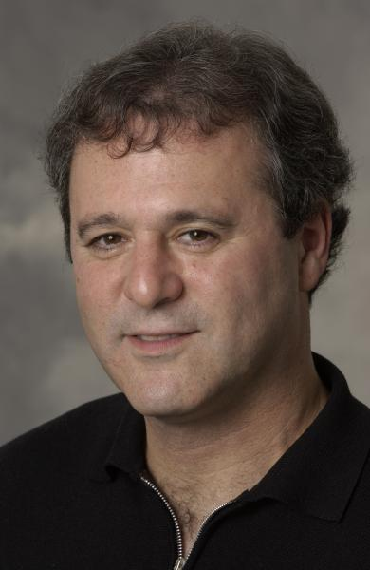
Jon Warner

PERSONAL DETAILS CONTACT INFO
BIRTH: Mt Vernon, New York PHONE: 011 415 668 9015
MARITAL STATUS: Single Email: jswarner07@comcast.net
Citizenship: U.S.A. Website: jonswarner.com
Mother Tongue: English
Professional Profile:
_________________________________________________________________________________________________
Principal and founder of J.S.Warner Tax and Financial Services. I am an Enrolled Agent, IRS e-file provider and member of the California Society of Enrolled Agents (CSEA). J.S.Warner Tax and Financial Services is a Registered Investment Advisory firm. In addition to Tax Preparation, Tax Planning and IRS representation, J.S.Warner Tax and Financial Advisory Services provides: Retirement Planning, Portfolio Design and Estate Planning.
Tutor for college and graduate ESL students for essay paper writing, grammar structure and content development in the areas of Health Sciences, Biology, Business Management and sample Business Development Plan writing.
Previously, I worked at the Royal Bank of Canada and Merrill Lynch as a Financial Advisor/Planner in the San Francisco Bay Area. I have also worked in various Sales and Marketing roles at AT&T, Qwest and Sprint and at number of high tech start-up companies with clients such as Apple, Cisco, AMD, 3Com, Applied Materials, Oracle, Acer and Sun Microsystems.
Education, Registrations and Licenses
_________________________________________________________________________________________________
100-Hour TESOL LCC, Santa Barbara CA,
Enrolled Agent - US Treasury Department, enabled to practice before the IRS
MS, Marketing, Golden Gate University, San Francisco, CA,
BA, Biology, Long Island University, Southampton, NY
AS, Information Systems, Coleman College, San Diego, CA
Registered Investment Advisor, State of California
_________________________________________________________________________________________________
My entire career has required me to work as an educator. This included educating companies MIS staffs to enable them to understand and implement new technologies, educating individuals and businessmen about tax, financial products and services, writing business plans for start-up companies and tutoring university students for descriptive writing assignments and public speaking. Some of my most significant accomplishments have been successful sales campaigns to acquire new business from clients such as Apple, Cisco, 3Com, AMD, Applied Materials, Sun Micro, Netscape, Oracle and Acer. Critical to this is my ability to communicate both verbally and through writing. As a TESL instructor, I can provide invaluable insight to businessmen who will be working offshore within English speaking environments and will need to master English “business jargon.”

Work Summary
J.S. Tax and Financial Services and TESL tutor, 2008- Present, Sole Proprietor, San Francisco, CA
Tax Preparation, Tax Planning and Investment Advisory Services. Tutoring for students for essay paper writing, grammar, content, Harvard business case reviews, descriptive business writing and public speaking.
Merrill Lynch, 2006-2008, Financial Advisor/Planner, Private Client Group, Oakland, CA

Financial Planner for capital creation, preservation, portfolio diversification, growth and income strategies, estate planning, wealth transfer, trusts, life insurance, tax efficiency and college funding.

Royal Bank of Canada/Dain Rauscher, 2004-2006, Financial Consultant, Private Client Group, San Francisco, CA

Wealth Management services consultant for capital preservation, portfolio diversification, growth and income strategies, estate planning, wealth transfer, trusts, life insurance, and college funding planning for high net worth individuals and families.

MS Marketing, 2002-2004, Golden Gate University, San Francisco, CA

Adero, 2000-2001, Western Regional Sales Manager, San Francisco, CA

Led sales efforts, executed marketing programs, negotiated channel sales agreements with large multinational hosting companies, ISPs and telecommunications companies as well as managed the Content Bridge Alliance Program.

Qwest Communications, 1998 - 2000, Strategic National Account Manager, San Jose, CA

Top performer and Strategic Account Manager for Qwest in Silicon Valley. Negotiated new contracts with Sun Microsystems and Covad Communications. Led contract negotiations for Cisco’s Broadband win and Oracle Business On-Line win. Account Manager for Netscape and team member of wins at Kaiser Permanente and General Magic. Developed support staff and sales staff in all aspects of pre and post sales support in transition from acquisition to Account Management role.

AT&T, 1994 – 1998, Global Data Account Manager, Santa Clara, CA

Account Management responsibility for 3Com, Clorox, AMD, Applied Materials and ACER Inc. Sold, designed and implemented forty-country data network to 3Com. Sold, designed and implemented ATM Service to AMD. Sales, design and operational responsibility for Global Frame Relay Services, International Private Line Services, ATM, Remote Access and Internet/Intranet services. AT&T Gold Club 1995, 1996, 1997
RELEVANT SKILLS
_______________________________________________________________________
Leadership, Management and Organizational Skills: Business Manager, which requires me to work with clients to understand their needs and help them to excel in their roles. Complete understanding of the entire business cycle from both the client’s and vendor’s perspective and the business communications process involved from initial sales contact to contract negotiation closure. Matrix management of account teams with as many as twenty members.
Research and Planning Skills: Working in technology, tax, finance and tutoring students has exposed me to many situations in which I was required to perform extensive research and planning on subject matter which I was not previously exposed to. This has provided me with the skill necessary to quickly assimilate new information and implements solutions while proactively preparing contingency plans in case changes occur resulting in potential problems.
Human Relations Skills: As a business manager and tutor I have acquired the insight to working with people of varying personalities and skill sets. This has allowed me to draw from both people’s strengths and weaknesses to motivate and gain maximum rapport for the project at hand.
Language Skills: I have studied Spanish and Portuguese at the Berlitz School in San Francisco, USA and have frequently traveled to Mexico, Costa Rica and Brazil.
Professional References
Contact information for phone and Email for references provided per request
_______________________________________________________________________
Ada Hunter | AT&T | Account Executive |
Jerry Cacacho | KDD | Director of Sales |
Personal References
Casey Cheng | Wells Fargo Bank | Banker |
Rob Caldwell | President Caldwells |

