Resume

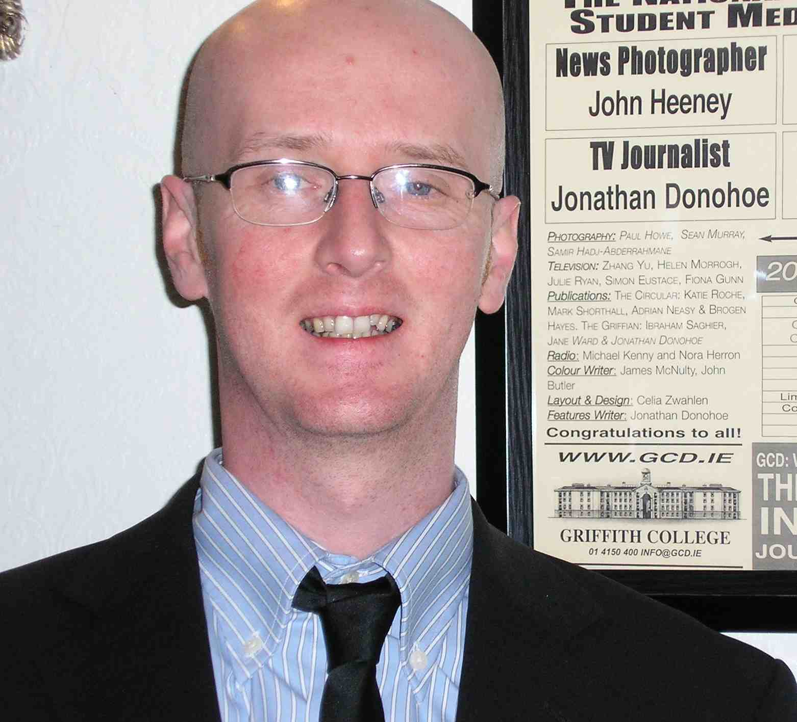

Name: Jonathan Donohoe

Address: Coolevin, Portmanna, Clonee, Co. Meath, Ireland.

Mobile Tel: +353 086 240 9001
Land Tel: +353 01 82 55 097
E-mail: donohoej2000@yahoo.ie

DOB: 08/02/1976

Education: 1994 - Leaving Certificate
- Castleknock College, Dublin 15.

Further Education:
- 1997 - Certificate in Marketing, Advertising and Management
- Ballsbridge College of Business Studies.

- 2007 – Batchelor of Arts Degree in Journalism and Media Communications - Griffith College Dublin.

- 2009 – ACELS/CELT TEFL Certificate
- Atlantic Language Galway

Most recent Employment:

July 2009 – Present: I have been giving private tuition to adults here in Ireland, some of whom are
preparing for their IELTS Exam while others need to improve their English
for work purposes.

June/July 2009: During the summer, I worked for a Summer Camp based in Ireland called Native Speaker.
I taught two morning classes of 15 young students each day and helped organize and
supervise them in the afternoons and evenings.
Duties:
- Guiding, encouraging and facilitating students use of English inside
and outside of the classroom.
- Stimulating student interest through use of personalization, class projects
and suitable activities.
- Eliciting and re-enforcing previous knowledge.
- Partaking in and supervision of activities and guided tours.
- Overseeing class leaders and liaising with Management.
- Placement test grading, class exercise and error correction.
- Continuous research for original and enjoyable class activities.
- Pronunciation, enunciation and clarification of common re-occurring errors

Skills: Strong Communication skills, very well organized, Listening skills, Patience, Sense of
humor, very computer literate, TEFL Teaching, Music arrangement, Guitar, singing.
*I believe that my background and acquired skills are conducive to giving clear, concise
and interesting lessons. I’ve also found that students react very positively to the musical
element that I can bring to the classroom.
Aside from teaching English, I have also taught guitar for over 5 years to all age groups
from 4 to 40 years. I always encourage my students and I make a point of only re-enforcing
the positives rather than discouraging them.

Achievements: WINNER - SMEDIA Awards March 2007*

I won an award for the category; ‘TV Journalist of The Year’ in the Student Media
Awards 2007 for a documentary film I produced at the time.

Previous Employment:

March 2007 - February ‘09: I was working for Associated Newspapers on their national titles, The Irish Daily Mail
and The Irish Mail on Sunday where my role from sub-editing to the production and layout
of pages. This called for continuous communication in a high-pressure environment.

2004 - November ‘07: November of 2007: I graduated from Griffith College Dublin with distinction
on my Bachelor of Arts Degree in Journalism and Media Communications.

2001 - February ‘04: I worked as a Customer Service Rep for Kingram Communications Group Ltd., a design
house and commercial digital printers. My duties involved, communicating with clients
designers, printers and management while overseeing projects from beginning to the final
installation.

1996 - June ‘01: I was head of Quality Assurance at Litho Studios Ltd, a printing company.
My position meant I managed production in the Q.A. Department and a small team.
Although I had many duties, the day-to-day work involved constant communication,
proofreading and checking files whilst maintaining and archiving a database.

General Interests: I enjoy teaching, reading, writing, music, travel, culture, film, cooking, socializing,
landscape gardening, playing guitar, classic car restoration, cycling and rowing.

Referees: Mr. John Joe Callaghan Director Native Speaker, Sligo
Tel: +353 71 9147728
Mail: info@nativespeaker.ie
Mr. Ciaran O’Tuama Editorial Systems Editor Associated Newspapers Ltd.
Tel: +353 01 6375800
Mail: ciaran.otuama@mailonsunday.ie

Mr. Martin Ryan Managing Director Kingram Communications
Tel: +353 01 660 13 69
Mail: martin@kingram.ie

