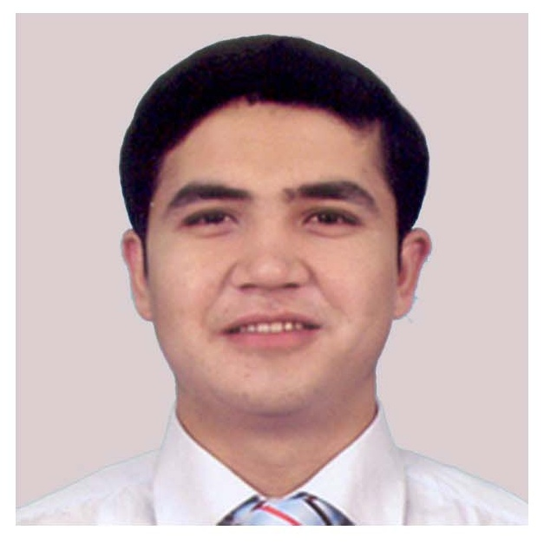
Joseph Usman

Current address:  Republic of Korea, Dae-Gu  Dalsei-Gu, Chukjeon-Dong  (010) 8694-6646  Joseph.jordan1771@gmail.com | Permanent address:  Central square 112  Stone City, Commonwealth  of Independent States, Cenral Asia

Objective | To secure a job as an English teacher with my education and experience, to build up a career by joining a staff that gives importance to it's employees and believes that in order to become a good school it needs people who are driven by good relationship with the students.
Education | Masters Diploma in MBA, expected in 2010  Keimyung University, Dae-Gu, Republic of Korea  Specialization: Business Administration  Bachelors Diploma in Economics, June 2007  Stone City State University, CA  Specialization: Macroeconomics  Overall GPA: 3.6/4.0
Work experience | Dates | 9 November 2007 →1 July 2008
Work experience | Occupation or position held | English teacher
Work experience | Type of job | Part time
Work experience | Main activities and responsibilities | To provide an efficient, personal, friendly and satisfying education for the students of Talking Club.  To provide fun, humour, and entertainment.
Work experience | Name and address of work place | Eboyong Talking club, Dae-gu (SK).
Work experience | Dates | 27 December→ 3 March
Work experience | Occupation or position held | English teacher
Work experience | Type of job | Part time
Work experience | Main activities and responsibilities | To provide fun, humour, and entertainment
Work experience | Name and address of work place | English Junior Camp, Dae-gu (SK).
Work experience | Dates | 5 October 2006 – 18 June 2007
Work experience | Occupation or position held | Airport Services Agent
Work experience | Type of job | Full time
Work experience | Main activities and responsibilities | To provide an efficient, personal, friendly and satisfying experience for our customers who are checking in, transferring or boarding their aircraft or collecting their baggage in Dubai.
Work experience | Name and address of work place | Emirates Airlines, Dubai, United Arab Emirates
 | Dates | 1 June 2006 – 30 October 2006
 | Occupation or position held | Receptionist
 | Type of job | Full time
 | Main activities and responsibilities | Checking in and checking out guests as per the five-star hotel standards, taking room service orders, and so on.
 | Name and address of work place | Aspen Meadows Hotel and SPA, Aspen, CO, USA
Personal Skills | Computer Skills:  - Microsoft Word  - Microsoft Excel  - Microsoft PowerPoint | Language Skills:  - English (Mother Tongue)  - Turkish (Mother Tongue)  - Korean (Beginner)
Additional  information | Hobbies: cooking, swimming and playing chess. Good in table tennis.

