Jon-Paul (JP) Coetzee
Personal | Age: 24  Date of birth: 03/05/1984  Nationality: South African  Native language: English | 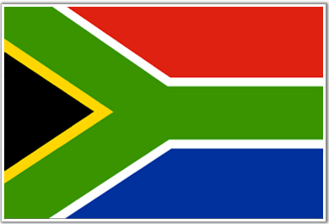
Contact | Email: jpc.xxx@gmail.com  Telephone: +60 12 699 3975 (Malaysia)
Experience |   English Teacher GnB English Academy March 2007 – December 2008 Anyang, South Korea  - I have been working for nearly 2 years as a Native English ESL teacher at an English academy in Korea. My students' ages range from kindergarten, elementary to middle school students.  - planning the curriculum and study materials  - responsible for creating and grading test and examination papers.
Experience | 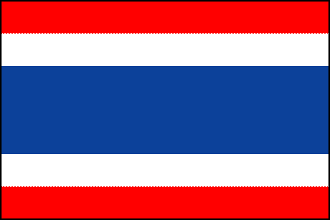  Marketing Manager Samui Property Management Aug 2006 – December 2006 Koh Samui, Thailand  - Developed and maintained a catalogue website, as well as Internet promotion and marketing.  - Developed and maintained documentation, eg. Contracts, receipts, quotes and schedules.  - Designed Advertising for both print, as well online, media.
Experience | Restaurant Manager Pickles Restaurant Mar 2006 – July 2006 Koh Samui, Thailand  - Managed a busy restaurant in a Popular tourist area.  - Hired, recruited and trained staff  - Taught English to Thai and Burmese staff  - Produced brochures, menus and designed print advertising media.
Experience | Sales Executive: Webmail (Interface Media) Oct 2005 – Jan 2006 Cape Town, South Africa  - Sold advertising space on the largest email facility in South Africa  - Sold websites, website hosting and internet marketing solutions
Experience | Tour Guide – Part Time  Explore the Garden Route  Nov 2003 – Sept 2005 Knysna, South Africa  - Performed guided day-tours in and around Cape Town, South Africa  - Performed guided tours around the South and South Eastern region of South Africa, including safari’s, whale watching and forest tours.
Education |   University of South Africa (UNISA)  - BComm (Bachelor Of Commerce)  - Majoring in Business Management.  - 2002 - 2005
Skills | - Excellent ability in all MS Office software applications  (MS Word, Excel, Powerpoint, etc) as well as basic web design  - Languages:  - English Native  - Dutch / Afrikaans Business  - Korean / Hangul Conversational  - Thai Basic  - Bahasa Malaysian Basic  6. Xhosa Basic
Attributes | I have an international drivers license,  A full health certificate, including disease and drug test.  A criminal background check.

