Jon-Paul (JP) Coetzee
Personal | Age: 25  Date of birth: 03/05/1984  Nationality: South African  Native language: English | 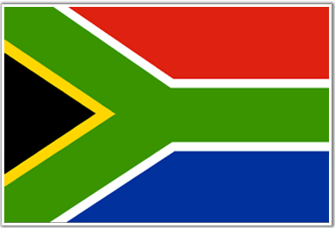
Contact | Email: jpc.xxx@gmail.com  Telephone: +81 80 3680 3540 (Japan)

English Teacher Camp Korea – Winter Camp 2010
January 2010 – February 2010 Jochiwon, South Korea
- Teaching elementary and middle school students at a winter camp near Seoul.
- Also instructed university students the Oral Proficiency Interview program (OPiC) in the Korea University campus in Jochiwon.
Experience | 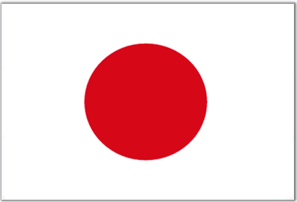  English Teacher Public Elementary and Junior High Schools  February 2009 – December 2009 Toyohashi, Japan  - Taught at elementary schools and junior high schools  - I was responsible for creating lesson plans, curriculum, as well as grading test and examination papers.
English Teacher GnB English Academy March 2007 – December 2008 Anyang, South Korea
- I taught for 2 years as a Native English ESL teacher at an English academy in Korea. My students' ages range from kindergarten, elementary to middle school students.
- planning the curriculum and study materials
- responsible for creating and grading test and examination papers
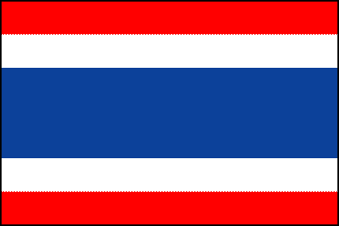
Marketing Manager Samui Property Management Aug 2006 – December 2006 Koh Samui, Thailand
- Developed and maintained a catalogue website, as well as Internet promotion and marketing.
- Developed and maintained documentation, eg. Contracts, receipts, quotes and schedules.
- Designed Advertising for both print, as well online, media.
Experience | Sales Executive: Webmail (Interface Media) Oct 2005 – Jan 2006 Cape Town, South Africa  - Sold advertising space on the largest email facility in South Africa  - Sold websites, website hosting and internet marketing solutions
Education |   University of South Africa (UNISA)  - BComm (Bachelor Of Commerce)  - Majoring in Business Management.  - 2002 - 2005
Skills | - Excellent ability in all MS Office software applications  (MS Word, Excel, Powerpoint, etc) as well as basic web design  - Languages:  - English Native  - Dutch / Afrikaans Business  - Korean / Hangul Conversational  - Japanese Conversational  - Thai Basic  6. Xhosa Basic
Attributes | I have a Japanese drivers license, a clear criminal background check  and excellent referral letters as well as all the documents needed for the E2 visa.

