Juan Erik Garza
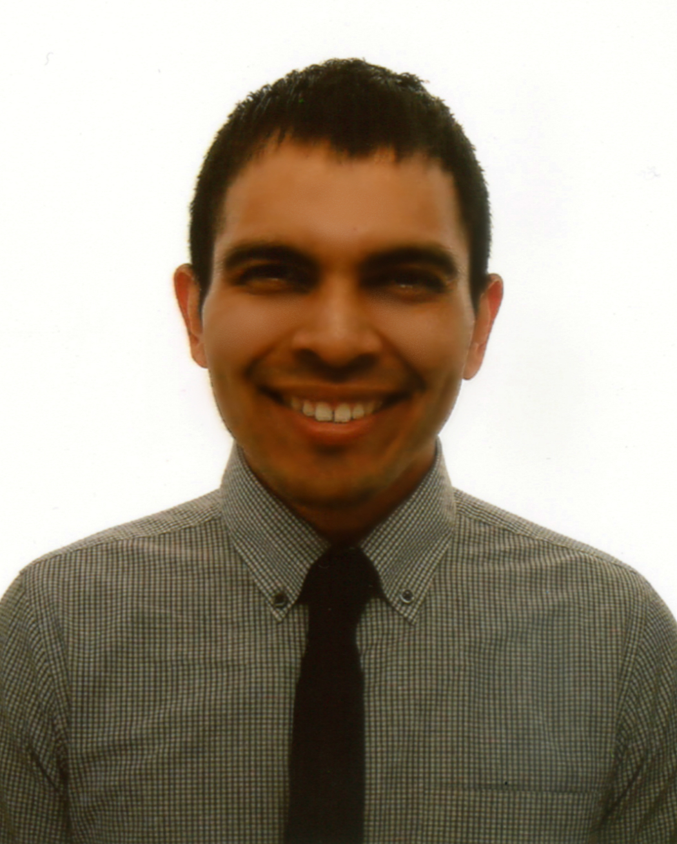
Personal
Birth: U.S.A., April 27, 1987
Citizenship: American
Mother Tongue: English

Education
  - The University of Texas at Austin: Bachelor of Arts
Major: English - Minor: Government
2009 TESOL/TEFL Certification - Oxford Seminars

Teaching Experience
2010 - 2013 One Week Program Teacher Paju English Village
- Taught language and media classes to Korean elementary and middle school students. Developed language and media lessons. Taught English classes to high school, university, military and international students (Japanese, Russian and Thai) during special programs throughout the year. Taught elementary students at a local elementary after school program.

2012 - 2013 Volunteer English Teacher Seoul, South Korea
- Volunteered with community service organizations teaching English to kindergarten and elementary students at orphanages and community centers in Seoul.

2010 Substitute Teacher - Austin Independent School District Austin, Texas
- Implemented teacher lesson plans, assigned students class work and homework and maintained classroom control and discipline. Completed a daily report to communicate important information to the teacher.

2009 Volunteer Adult ESL Teacher Casa Marianella Immigrant Shelter, Austin, Texas, U.S.A.
- Taught a weekly beginner level English class to Spanish-speaking immigrants.

2008 Reading Program Tutor Zavala Elementary, Austin, Texas, U.S.A.
- Tutored elementary school students whose reading levels were below their grade level. Helped increase their comprehension, reading and spelling abilities.

Career Related Experience
Nov. 2012 - Mar. 2013: One Week Program Coordinator Paju English Village
- Led research and development of homeroom and language lessons, staff trainings for new lessons, and the program’s lesson development committee. Assigned development tasks to team members, collected lesson feedback from staff, and implemented necessary changes. Assembled and edited program books, attended weekly leader meetings, supported the One Week Program head teacher and ensured smooth program operations.

2006 - 2007 UTeach Program Student The University of Texas at Austin, Austin, Texas, U.S.A.
- Studied a variety of teaching methods, lesson planning and implementation. Observed local public elementary and middle school classes. Prepared and taught science lessons for elementary and middle school students.

References
Park Hyun Goo - Paju English Village Head Teacher
Email: hyungoo.park.gev@gmail.com - Phone: 010.6744.2251

Kim Young Hwan - Former Paju English Village Head Teacher
Email: hans.k.gev@gmail.com - Phone: 010.5339.4166

Transcripts Available upon request

