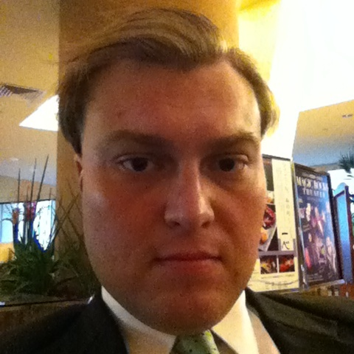
Julian C. Janssen
PMB 435 Ste. 101
1270 N. Marine Corps Dr.
Tamuning, GU 96913
(h): 671-646-2510 (c): 671-488-2510
(e): julian.c.janssen@gmail.com

Academic Experience
Bachelor's of Arts in Political Science, University of Guam (2008)
Member, National Political Science Honor Society
Graduate, John F. Kennedy High School (2002)
Member, National Honor Society

Professional Experience
Research Assistant, Guam Procurement Assessment Report, University of Guam (2012-2013)
Researcher/Policy Analyst, Guam Legislature (2010-2012)
Resident Manager, Tumon View Phase II (2005-2009)
Legal Assistant, Melinda C. Swavely (2008)
Teaching Assistant, Dr. Thomas Iverson (2007)
Legislative Intern, Guam Legislature (2006)
Legislative Aide, Guam Legislature (2005)
Freelance Copy Editor, Pacific Daily News (2004)

Work-Related Skills
Able to work well with elementary-age children and teens.
Microsoft Word, Excel, Powerpoint, Outlook.

Personal Characteristics
Responsible
Innovative
Self-motivated
References

Professional
Vanessa Ji, Esq. (w): 671-969-8920
Carlo Branch (c): 671-687-7567
Melinda C. Swavely, Esq. (w): 671-646-1222

Personal
Dr. Robert Underwood (w): 671-735-2990/5
(h): 646-7418
Dr. Jeff Johnson, DDS (h): 477-1620
(w): 646-7982

