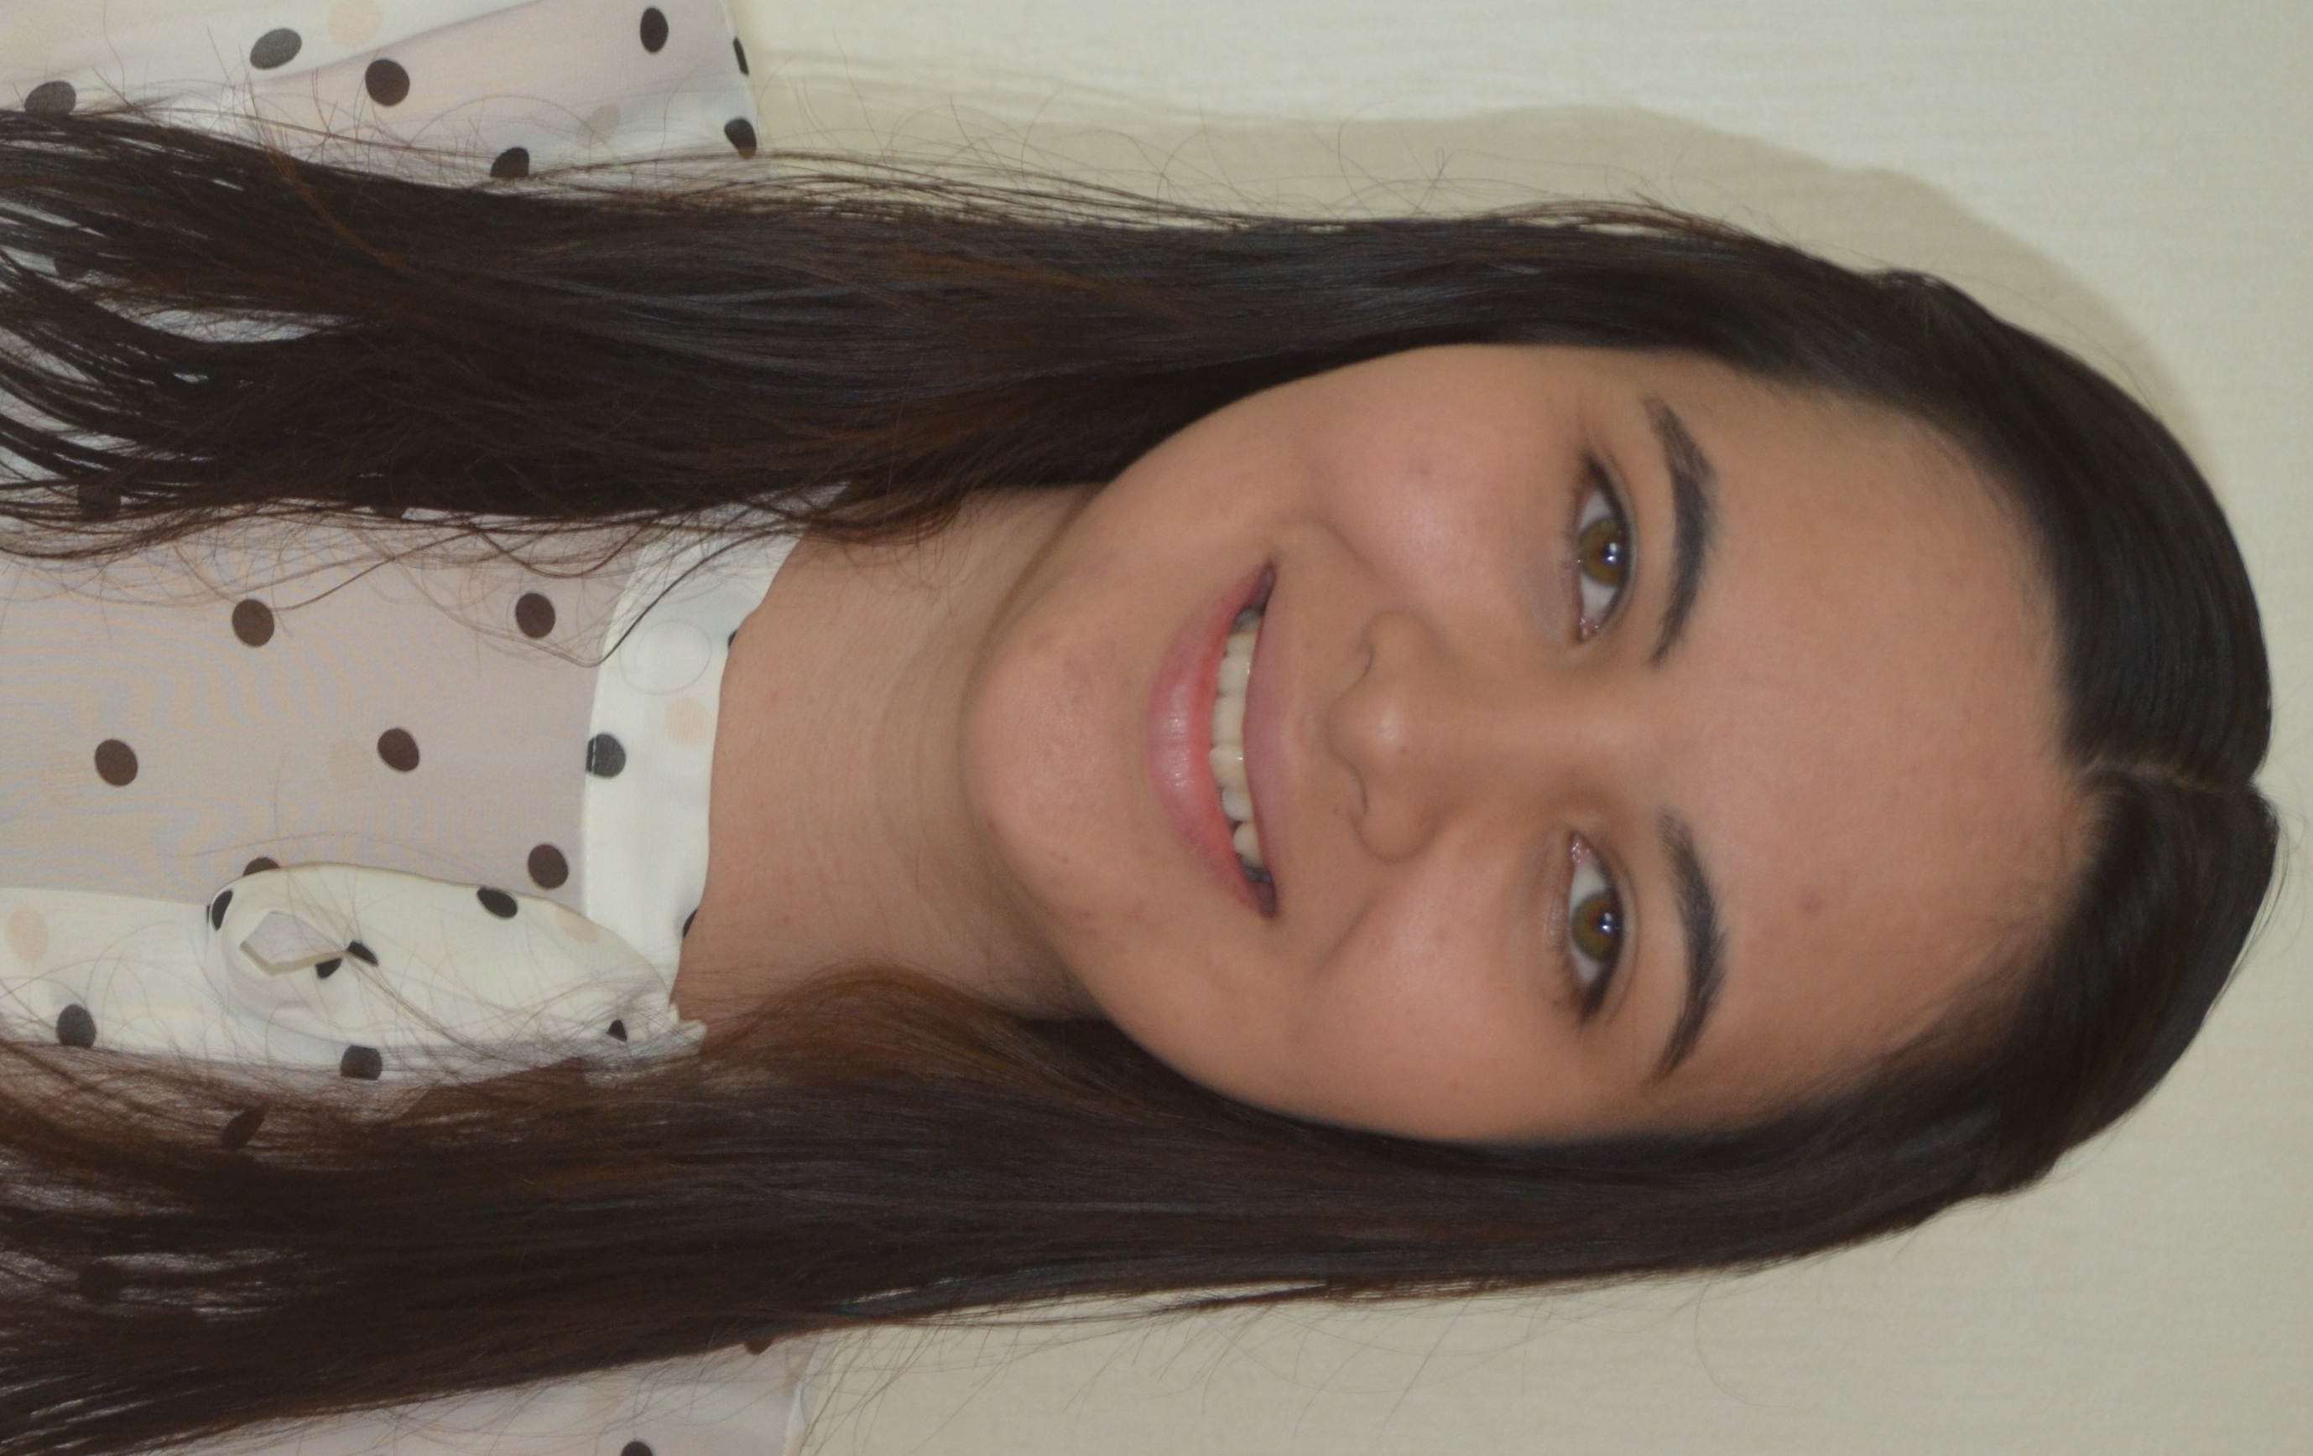

JUNE CHRISTENSEN

Education

TESOL Certificate III, Teach International, Brisbane, Australia
Bachelor of Business - Events Management Major, Griffith University, Brisbane, Australia
Graduate of Kedron State High School, Brisbane, Australia

Experience

TEFL Teacher: I currently work at ECC in Jinju, South Korea. During my time I have taught students from Kindergarten to Middle School level. I have developed good classroom management skills and always come into my classes prepared. I use the teaching materials provided to me and try to make the most interesting and fun lessons for my students. Some of my duties include checking student’s work, preparing and conducting speaking tests and writing monthly evaluations. During my time here I have developed good relations with both my co-workers and students.

Student Event Coordinator: At Griffith University I coordinated trivia events for Student Linx, an organisation that hosted events for local and international students. This role developed my leadership and communication skills especially with students whose first language wasn’t English. I can use these skills in a TESOL environment because I can supervise classes independently and communicate with students and staff where language might be a barrier.

Concierge Consultant: At Smart Service Queensland, I worked in a contact centre where I received calls for the State Government and directed the callers to the best department. This position required me to listen and provide callers with the best referral. I have learnt how to paraphrase to understand my callers, and I believe this will be a useful with my students and provide them with a clear understanding when I am teaching. I can listen carefully to students needs and provide them with great assistance in English.

Data Entry Officer: At Energex, a major Queensland electricity company, I processed solar applications where I read and reviewed applications before entering the data into the system. I developed reading and reviewing skills which can transfer to a TESOL environment where I can review and assess the work of the students to assist them in their development in English.

Retail Assistant: At Sunglass Clearance Warehouse I worked as a retail assistant, I dealt with customers from all ages and nationalities providing excellent customer service and assisting with their needs. I learnt to be well mannered, patient and knowledgeable in my field. I can transfer these skills and can learn quickly so my knowledge in TESOL will expand with the more experience I have.

References

Trinity Jeong
ECC Academy – Head Teacher
Email: jbrimsuk@hanmail.net Number: 055-763-0509

Seuyon Chung
ECC Kindergarten – Co-Teacher
Email: seuyon@hotmail.co.kr Number: 010-8595-3330

