Kimberly M Talamahina
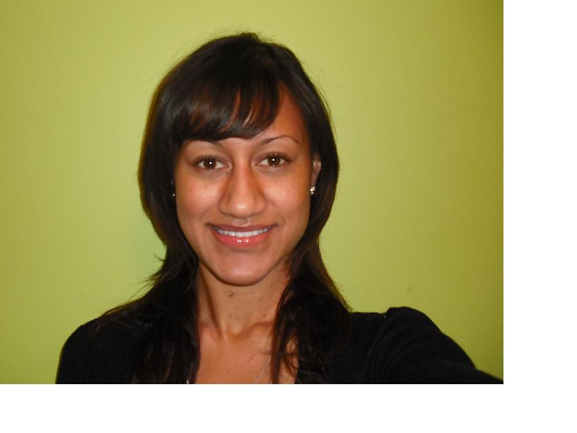

Jangandong
Seoul
South Korea
Cell:010-4991-7233
kimmtal@hotmail.com

“I plan to use my experiences and educational backgrounds in ways that will encourage my students too strive to reach their goals.”

EDUCATION

2009- Certified Chronic Care workshop facilitator: Auckland District Health Board NZ.

2004 – 2008 University of Otago
Bachelor of Arts in Psychology and Politics, Minor: Social work and PI Studies
Also completed; Laws- Legal history, Case Analysis, Anthropology.

2003- Qualified PSSP Counsellor for Secondary Schools

1999 – 2003 Auckland Girls Grammar School (Prestigious NZ High School)
A Bursary, University entrance at the highest level
Business scholarship for law
Acceptance in to Pre-Medicine
Sixth form certificate
Fifth Form Certificate

RELEVANT SKILLS

Interpersonal Skills
- Appreciation and interest in many cultures, developed through overseas travel and having participated in many international competitions for athletics
- Proven negotiation and conflict resolution skills and experience, in dealing with clients when enforcing company policy as a psychologist/ health professional and in past customer service roles
- Proven active listening skills demonstrated as a psychologist, counsellor, mentor and tutor.

Communication
- Able to communicate effectively with a broad range of people(s) from a diverse range of ethnic and social circumstances through past employment and voluntary activities
- Effective and strong written, verbal and presentation skills developed primarily through tutoring/counselling and as a health representative in psychology and chronic health care.
- Confident speaker in front of a large audience having conducted workshops in front of prestigious health professionals in New Zealand. Including Doctors, Nurses, health nutritionists and clinical psychologists.
- Basic knowledge of Korean commands, which may help create cohesion throughout teaching lessons.
- Fluent speaker of the Niuean language, and a good understanding of Samoan and Te Reo Maori.

Planning and Organising
- Prepared and assisted with teaching materials as a University tutor, creating action plans for students to reach their learning goals
- Prepared and completed assignments and reports within specified timeframes
- Aptitude in organisation and time management skills through managing university work, part-time employment and sporting activities
- Liaising with health professionals and developing strong working relationships with key personnel

Summary of Work Skills

Personal and Business Relationship Management – capable of developing and maintaining durable relationships. Able to effectively network to establish relationships and links, with community groups, and business associates. Evidenced by the many community initiatives I have been involved in.

Problem Solving – able to collate and analyse data, filter irrelevant and unnecessary data, to produce a report evaluating finds, and make recommendations. Evidenced by my involvement in task groups at University.

Technical Knowledge – at this point, confined to University Studies. My BA Double Major in Psychology and Politics leans towards having a theoretical knowledge, which I have practised in part, through my vast community group involvement. I am ready to utilise and impart this knowledge in the field.

Self Management / Time Management and Planning Skills - Combining study, with part time work and being involved in both University and Community projects requires discipline, effective planning and time management skills. I have a developed an effective methodology for these attributes, to ensure I maintain a personal state of equilibrium, which enables consistency in my performance.

Teamwork – while happy to work independent, I thrive on working within a team environment. The collaborative sharing of ideas and groups working together to achieve a common goal is very rewarding.

EMPLOYMENT HISTORY

2009- Current- Kindergarten/ Elementary English teaching
- Planning lessons, home work preparation and marking
- General administration
- Teaching English, grammar, phonics, spelling, punctuation, general conversation
- Phone interviews with each child and comments to and from parents

2004- 2008- Tutor (student teacher) for University students. University of Otago NZ.
- Goal planning towards exams, essay writing and presentations.
- Tutorial planning, brainstorming, action plans to reach target grades
- Law, psychology, politics, case analysis, legal history, PI studies

2008-2009- Chronic Care Workshop facilitator, Auckland/ NZ
- Presentations, workshops in front of health care professionals and patients
- Presenting self care health plans to people with chronic illness
- Planning and initiation of Action plans, goals over a 6 week intensive programme.
- Telephone contact through a buddy system, regular checkups
- Help with diagnosis, and advice on medical prescriptions.

2004- 2008- ACC Accident Compensation Corporation (Offices in Auckland, Henderson & Dunedin, NZ)
Position: University assistant to Case Managers and Injury Prevention departments
Duties included:
- General administration duties, including, reception work, filing, handling customer enquiries and providing solutions/options to remedy.
- Injury Prevention Projects – Event support, information services, providing first hand information to customers.
- Truck Fatigue Stops – provided advice and general information to truck drivers regarding fatigue. Also completed questionnaire forms for statistical analysis.
- Pacific in the Park (West Auckland) – Community event sponsored by ACC. Here I provided safety advice and injury prevention information to interested parties.

INTERESTS

- Athletics: Represented Niue Island in the 100m and 200m at the Mini games 2007, Oceania Games.
- Netball: Represented Niue Island in netball at the Oceania games
- Basketball: Represented Otago University at basketball, 2004-2007
- NZ radio: Niu fm 103.8 youth radio presenter
- Television: Hosted a cultural show, ‘Tagata Pasifika’- NZ, 2003
- Hip hop: Hip hop dancing competitor, Unitec NZ
- Volunteer work: Started up famous, ‘Raise the level’ talent quests around West Auckland, NZ.
- Pacific Island Community work: Involved in various cultural shows, youth groups.

Referees

Dr Vili Nosa Lecturer, Pacific Health
The University of Auckland
+64 9 3737599 ext 86906
v.nosa@auckland.ac.nz

Nina Kirifi-Alai Pacific Island Manager University of
Otago
nina.kirifi-alai@otago.ac.nz

