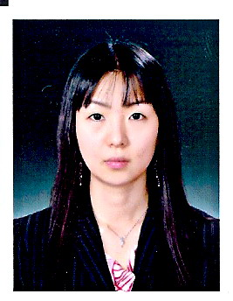

Kaitlin Haeyeon Yoo
khy_219@hotmail.com
Current location: Gwangjin-gu,
Gangdong-gu, Seoul
Cell: 010-9234-0753

Experience Unisense One on One English / 2008-current
-Full time conversational English instructor for adults

E. Bo Young Talking Club (Gimpo location) / 2008
-Full time instructor for students in various levels

E. Bo Young Talking Club (Seoul location) / 2007
-Part time instructor for second to fourth graders for 2 months
American City (Gwang Myung KTX) / 2007
-Part time instructor for carious ages for 2 months
------------------------------------------------------------

AdWin Advertising Agency Inc. / 2003-2007
-Translated ad copies from English to Korean.
-Prepared presentations for American clients as a team.
-Communicated with various clients regarding the ad and schedules.

Bilingual Special Education Itinerant Teachers / 2005
-Managed student profiles as an administrative staff.
-Scheduled the testing for students.
-Translated during the testing.
Yonsei Academy in NY (Not affiliated with the university) / 2002-2003
-Managed and helped students in various grades after school.
-Taught reading for a fifth grade student privately.
Bansuk Summer School / 2002
-Managed and taught a kindergarten class

Education Konkuk University / 2009
Y-TESOL

Touro-Graduate School of Education and Psychology/CITE
2006 to 2007
Major: special education
-Completed 12 credits attending part time each semester.
-Observed the classroom settings in public and private schools for 100 hrs.
Pratt Institute / 1998 to 2002
Major: Graphic Design

Activities -Mission trip to Switzerland 1997
-Mission trip to Trinidad 1995

