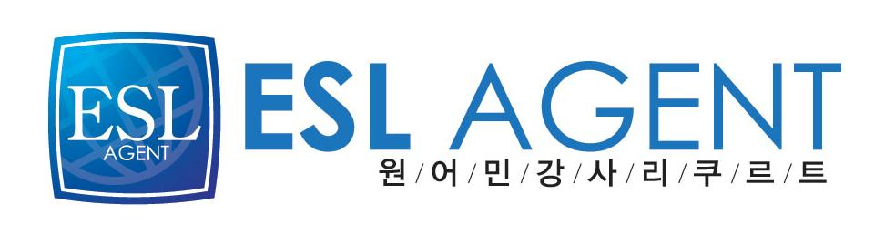
이에스엘 에이전트
최진영(Cassie)
02-2675-0582



Kaitlyn D. Gibson

Citizenship: USA
D.O.B. June 1, 1984
Marital Status: Married

OBJECTIVE
Experienced teacher looking for the opportunity to begin a TESOL career while exploring a culture that values education, loyalty, and courtesy for others.
EDUCATIONAL BACKGROUND
Hiram College (Hiram, Ohio): (August 2002-May 2006)
- Bachelor of Arts Degree in Integrated Language Arts with GPA 3.85
- Received Ohio Teaching Cert. in Int. Lang. Arts, Grades 7-12.
- Passed required Ohio Praxis Teaching Examinations.
Academic Honors and Awards:
- Graduated Magna Cum Laude, Dean’s List, Phi Beta Kappa Honors Society

TEACHING EXPERIENCE
Copley-Fairlawn Middle School (Copley, Ohio): August 2006-Present
- Spent seven years teaching a variety of courses for grades 5-7, including Technical Literacy, Reading and Math Intervention, Literacy Enrichment, Writing Intervention, Writing Workshop, and Fundamentals.
- Spent the past five years tutoring students in both English and Math.
- Designed lessons that focused primarily on improving students’ writing, reading, and oral presentation skills.
- Conducted parent/teacher conferences and coached Power of the Pen.
Crestwood High School (Mantua, Ohio): Hiram College (Spring 2006)
- Completed ten weeks of student teaching at grade 10.
- Developed standards-based lesson plans for both General English and Honors English.
- Worked closely with both cooperating teacher and with parents to promote student success.
Cardinal High School (Middlefield, Ohio): Hiram College (Fall 2004)
- Completed five weeks of methods field experience at grade 9.
- Helped students who had not passed the state proficiency test to improve their reading and writing skills.

RELATED EXPERIENCE
Freelance Writer: Trogdon Publishing, Rittman OH (2005-06)
- Wrote news articles and editorials for the local newspaper, The Norton Trading Post.

INTERESTS
- Fiction Writing and Outdoor Excursions

