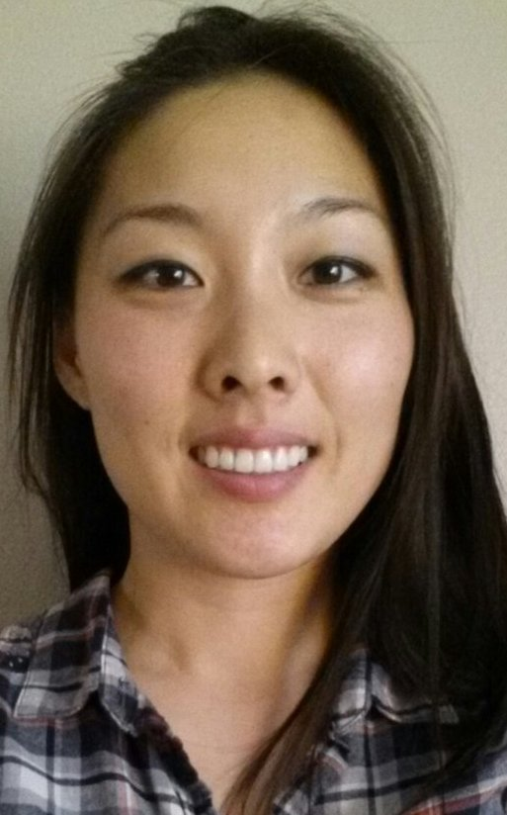

Katherine Park

Objective | To obtain a position as a hardworking teacher that would allow me to be productive in an energetic work environment where educational system and student learning abilities are top priority.
Experience | January 2013-Present  SigmaGraft, Inc  Research and Development, Researcher  Manufacturing dental bone graft material, design and develop new products, improve  current products, develop innovative dental products in the dental industry.  May 2011-Present  United States Army Reserve  92A Automated Logistics Specialist  Proficient in the principles of warehouse functions, which include applied techniques: stock control, issue, receipt, and storage procedures.  February 2010- December 2012  Phillip S. Min D.D.S., M.S, Limited in Endodontics  Dental Assistant/ X-ray Technician  Chair-side assisting, take digital x-rays, take vital signs for patients, cleaning and packaging instruments, setting up and cleaning treatment rooms, pick up phone calls and make appointments.  June 2009-February 2010  Holy Gate Montessori School / Holy Gate After School Program  Classroom teacher for 8 students (Grade 1). Help with homework, teach students to phonics, grammar, math, and reading as a group and individually.  June 2008-September 2010  Private Tutoring  Private tutoring for students in grades 2-7 with English, math, science, and social studies; check homework, and do subject exercises with extra materials.  June 2007-September 2007 / June 2008-June 2009  Smart Educational Center, Summer School Program  Teach 6 students in a class (grades 2-3) with English grammar, reading, and math for two seasons of ummer.
Skills | Four hand coordination (Dentistry)  Proficient in Microsoft Word, Excel and PowerPoint.  Organized, responsible, and multi-tasking.  Good communication and hand/eye coordination skills.  Control classroom students  Teach individual study, and group study (K-8)
Education | 2013  Currently in progress of obtaining TESOL certificate.  2011  United States Army Basic Combat Training, Fort Jackson, SC  United States Army Quartermaster School, Fort Lee, VA, Graduate  2005-2009  University of California San Diego, Revelle College, Graduate  B.S in Human Biology, Minor in Psychology  2000-2004  Benjamin Franklin High School Graduate
Reference | AVAILABLE UPON REQUEST.

Whom it may concern,

I am submitting an application and a resume for the English teaching position in Seoul. I am currently residing in Los Angeles, California USA. I was born in Seoul, Korea but immigrated to New Zealand when I was 3 years old. I spent my whole childhood and moved to United States at the age of 12 with my family. I graduated my middle, high school and obtained a university degree in California. I have spent my whole life speaking English and living outside of Korea in foreign countries. I have also joined the United States Army and currently in my third year in service as a reservist.

I am currently in progress of obtaining TESOL certification. It will be finished at the end of November. I want to teach English in Korea because one of my colleagues spent one year in Korea teaching elementary students and enjoyed the experience. I have some teaching experience back when I was in college. I was also a supervisor/teacher for Sunday school at church for about 3 years. I have experience with working with kindergarten and elementary students in teaching. I would like to open my opportunities and continue to experience teaching students and expand my experience and go in the field of education. I believe that grammar and punctuation is very important just like the Korean education system emphasizes at school, but I also think conversation is very important also in terms of linguistics. I want to give my knowledge and ability to the students to help them grow not only in grammar but also in the ability to have a conversation between students as a natural habit.

I look forward in discussing my qualifications further for teaching position in Korea. Please reach me at parkatherine@gmail.com

Thank you so much for your time.

Sincerely,
Katherine Park

