Kathryn Salmon Resume  Address:  Kestrel Cottage  Crown East Lane  Lower Broadheath  Worcester  WR2 6RH  Phone: +447541 209959 or +441905 333209  Email: kksalmon@hotmail.com  Reference Francesca Fairhurst (Manager)  Reference number +441095 855010 |  | Application to teach English in South Korea  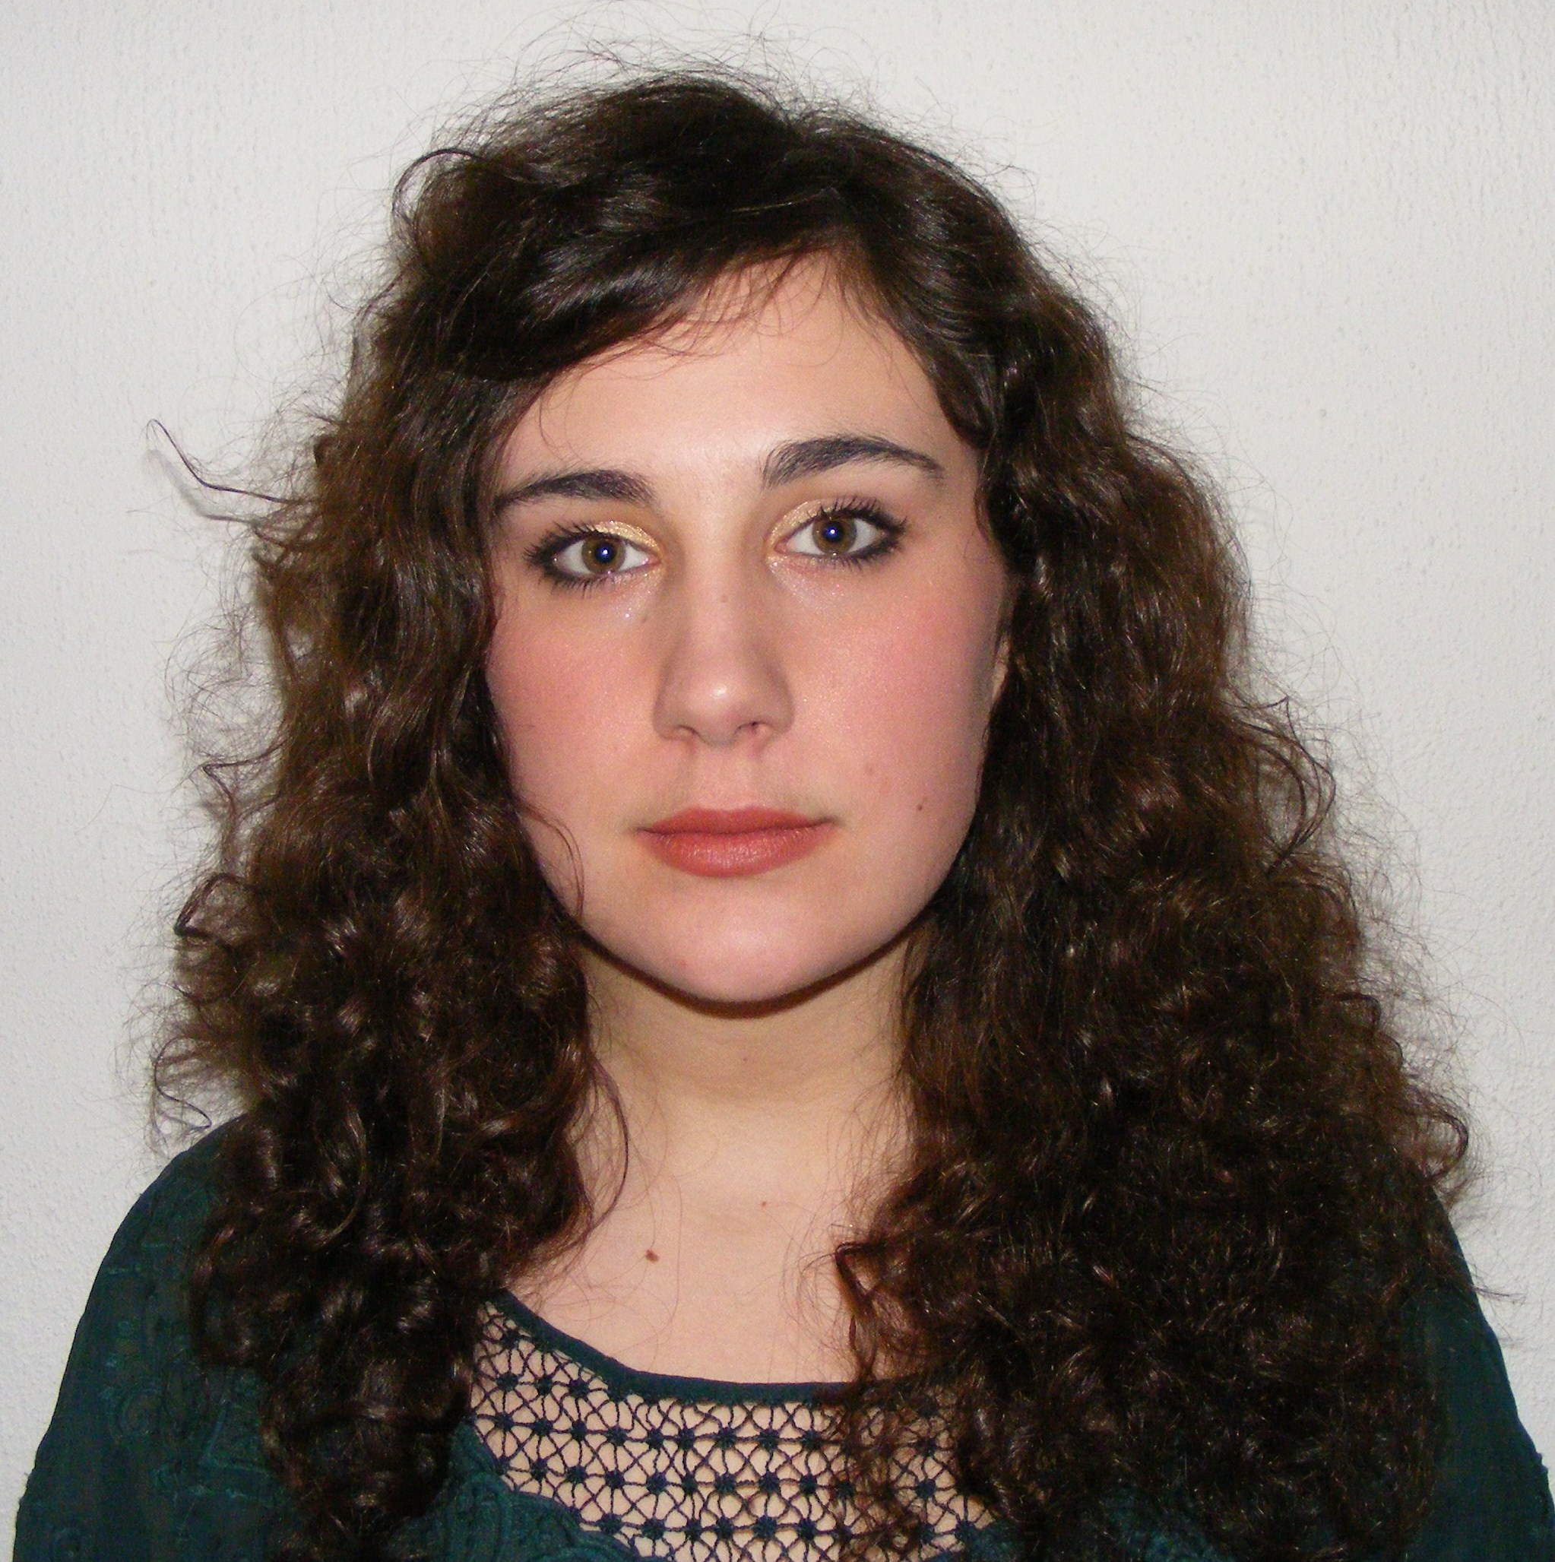
Objective | To work in a stimulating and rewarding environment, teaching English as a foreign language in South Korea
Summary | - I worked at Little Hoots Day Nursery as part of a work placement over the summer. Here I helped care for children between the ages of one and five while their parents were at work. This involved helping to supervise play time whilst also taking an active part in basic educational classes where we used songs and activities to help the children learn basic skills and knowledge.  - I have worked as a child minder for two different families over the past eight years. Both of these positions have taught me a great deal and I have gained valuable experience, learning how to interact with young children of different ages whilst balancing the need for professionalism as an employee. I faced different challenges working with each family, particularly as the son of my first employer has a learning difficulty called autism which can make him extremely difficult to handle. I also had to show a great level of responsibility and maturity when Mrs. White, my second employer gave birth and I was honored to be given the responsibility of looking after her second son from a very young age.  - I am a confident, capable and adaptable individual with excellent verbal communication skills. These skills have been developed through various jobs within the public sector, where a confident and friendly manor is essential. Through my various work experiences, I have demonstrated an enthusiasm to continually learn new skills and am always looking for an opportunity to put my skills to good use, within new and challenging environments. I am an extremely dedicated and reliable employee and can be counted on to put the maximum amount of effort into each job I do. Furthermore, eight years working for Mrs. Gough and a further five years in the employ of Mr. and Mrs. White, along with extensive time periods at other positions, demonstrates devotion to both my role and my employer.  - I have developed high quality written communication skills during both my time at University and during the administrative positions I have held since graduating. I produced high quality and in depth reports, presentations and essays whilst at University, including a five thousand word independent study and fully comprehensive archaeological site report, following a six week excavation project. This demonstrated an ability to work outside the academic environment, working with independent piers from the archaeological profession, as an effective member of a team. Since graduating, I have developed excellent administrative skills within two different roles. Here it is essential to provide clear and concise written work on a daily basis, working with people on many different levels and to tight deadlines.
Education | BA Archaeology  Cardiff University, Wales, United Kingdom  Graduated in 2008 with 2:2 (Hons) |  | 2005-2008
 | A-Levels  Worcester Sixth Form College, United Kingdom  Classical Civilisations: C Geology: B Geography: D  AS Level  Worcester Sixth Form College, United Kingdom  Biology : C |  | 2003-2005  2003-2004
 | 9 GCSE’S  The Chantry High School, Worcester, United Kingdom  (A-C Grade- including Maths, English and Science) |  | 1998-2003
Employment | Graduate Intern in Admissions  University of Worcester, United Kingdom  - Working within the Admissions department of the University, I am dealing with applications to the University from both UK and international students. An extremely high level of organisation is vital as I am dealing with hundreds of applications a day and often need to be aware of what stage specific applications to the University are in.  - I am dealing with students on a daily basis, via telephone, email and in a face to face capacity. It is therefore essential that my communication skills are impeccable as I am dealing with many complex queries.  - I am responsible for organising Selection Days at the University, ensuring that up to fifty students attend and have provided all relevant paper work before the interview process, requiring exceptional organisational skills. I was also involved in helping to organise the graduation ceremony for 2009 graduates. This involved many complex tasks, run by different teams, which needed to run smoothly along side each other, requiring exceptional team work.  - I am also studying several Business Management modules as part of the Internship scheme. These are taken from the Universities MBA program, and include Leadership Concepts, Project Management, Operational Strategy and Finance.  Child Caring  Mr and Mrs White, Worcester, United Kingdom  - During and since my time at University, I have been entrusted with the care of Mr. and Mrs. White’s children, James (eight) and Harry (one), during evenings and weekends. I started caring for James, but once Mrs. White gave birth to her second son, I was trusted with the care of their baby as well, demonstrating a great level of responsibility and maturity.  - My relationship with the White family has developed over the past five years and due to the close proximity of our houses, I am able to look after the boys at short notice. This has meant that I have been lucky enough to not only watch, but to take an active part in their learning and development.  - As Mrs. White is an IT teacher at the high school I once attended, I have been able to gain valuable experience from her, learning the basics of lesson planning and how she manages the teaching and development of her classes at the Chantry High School.  Child Caring  Mr and Mrs Gough, Worcester, United Kingdom  - Since the age of fifteen, I have regularly helped Mrs Gough care for her children Carter (ten) and Maddy (five).  - As carter has severe learning difficulties, he can be disruptive and difficult to communicate with. I have learnt many techniques through working regularly with Carter, alongside Mrs Gough where by I am able to calm his behaviour.  - I have also learnt how to ensure that both children are looked after effectively when one child is more demanding of your attention. I have found it important to ensure that a more well behaved or quiet child is not forgotten about or ignored in the face of such difficulties.  Financial Administrator  Park Row Associates, Cardiff, United Kingdom  - This role was focused around providing highly efficient administrative support to a team of sixteen financial advisors, as well as to the Regional Sales Executive.  - A complete understanding of ‘new business administrative procedures’ was essential, along with a highly developed knowledge of the Windows package and the in-house computer program.  - I carried out monitoring of all pipeline business within very strict service standards, ensuring that I was always working within the rules and guidelines set down by the financial services industry.  Nursery Assistant  Little Hoots Day Nursery, Kempsy, United Kingdom  - Assisted in any way possible within the nursery environment. Working with children from the ages of one to five, I helped to monitor play time and took an active role in basic educational lessons.  - This involved themed art sessions, using song as a method of learning and conducting group reading sessions with the children.  - I learnt how to work with a large group of children at one time and the importance of co-operation with colleagues to ensure the safety and well being of the children. |  | Sept 2009- Present  2005- Present  2002- 2009  Oct 2008- March 2009  (Redundancy)  Summer 2005
Personal Interests | - I am a keen cyclist, an activity that I pursue on an almost daily basis. I also enjoy walking and regularly take advantage of the beautiful countryside and hills in my local area for walking.  - As an archaeologist and historian, I particularly enjoy visiting sites of archaeological and historical note around the UK, such as the many castles and prehistoric monuments spread throughout England and Wales.  - I particularly enjoy artistic projects in my spare time and regularly create jewellery, cards and prints. I am also an extremely keen cook and love to experiment with new ideas and flavours in the kitchen.  - I love to travel and am motivated by the belief that experiencing other cultures enriches ones life and creates a much greater understanding and therefore toleration of the world. I have so far visited several European and Eastern European countries. I have also travelled to Tunisia, Singapore and Brunei

Why am I the right type of person to teach overseas?
Having travelled to many different countries, I have a deep love for experiencing other cultures. I have always found myself wanting to stay for a longer period of time during previous travelling experiences, in order to more fully understand the culture that I had been living in. I am now ready to embrace living abroad for a long period of time in order to achieve this. I believe that teaching in South Korea will enable me to experience a totally different culture whilst also experiencing teaching, my ideal future career.

What qualities do I believe necessary to be a good teacher?
To be a good teacher, I believe that patience and empathy are essential qualities. An ability to interpret your pupil’s behaviour is key, along with an ability to provide fun and stimulating lessons, ensuring that they will truly understand and absorb the learning experience. This will require a high level of motivation and therefore maturity, in order to keep the pupils entertained and interested. A teacher who is clearly motivated and interested themselves will always encourage enthusiasm to learn in their pupils.

- How I would deal with a work place dispute with another co-worker or supervisor
A work-place dispute is always unpleasant for both parties involved. I would therefore aim to rectify the situation in the most polite and friendly manner possible ensuring that I listened to my co-workers point of view. I would ensure that any such discussions were carried out at the end of the day so that they would be unlikely to affect either party during the working day.
If l found that I was still having difficulties, I would seek advice from Access South Korea, whilst consulting friends already working in the TESL sector to ask how they had dealt with similar situations.
- How I will tackle potential home sickness while in South Korea
I would lean on my boyfriend and friends already working in South Korea for support. I would also remain active, visiting areas of natural beauty and of historic interest throughout South Korea on my days off. As visiting such places is a particular passion I believe this will help take my mind off any home-sickness.

Other plans while in South Korea
I would like to visit as much of South Korea as possible during my time off from work. I am particularly interested in visiting South Korea’s many historic temples and walking in the beautiful countryside, so will be taking advantage of as many outdoor pursuits as possible. I am also very keen to learn as much Korean as I can. I hope to experience as much of the food culture as possible, not only eating but learning to cook as many traditional Korean dishes as I can as food and cooking is my other passion.

