Kay Chang
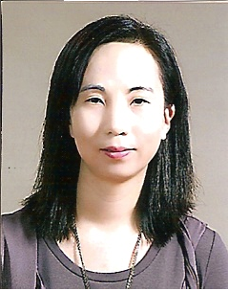

(e-mail: k2chang_2000@yahoo.com)
(C.P. 010-3106-0064)

Hanyang-Oregon TESOL certificate
University of California, San Diego:
Psychology (B.S.)
John Marshall High School, USA

Songwoon Elementary School
(May 07 - current)
Kwangduk Middle School
(afterschool instructor: current)

Songwoon afterschool program: 3rd & 4th grade [Jul. 2009 ~ Feb. 2010]
** I taught art, music, and language arts through an immersion class
Songwoon afterschool program: 1st & 2nd grade at winter session
[Jan. ~ Feb: 2009 & 2010]
** I taught art, music, and language arts through an immersion class
Songwoon afterschool program: 6th grade [Apr. 2008 – Dec. 2008)
** I taught Language Arts –writing, grammar, reading, etc.

Participated Siheung English Festival as an English Speech Contest Juror (2008)
Award: 경기도 교육장 표창장 수상 (2008)

[Other Teaching Experiences—grade school students]
I have teaching experience at few private institutions → reading, writing, speaking, listening, grammar, daily conversations and TOEFL etc.

[Teaching Experiences of adults]
I have teaching experience to the elementary school teachers and company workers for reading comprehension, daily conversations, and TEPS etc.

