Kay Chang

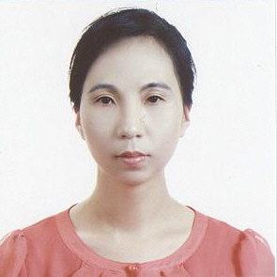 | E-Mail: k2chang_2000@yahoo.com  CP: 010-3106-0064  Hanyang-Oregon TESOL certificate  University of California, San Diego: Psychology (B.S.)

Gusung Middle School in Yongin: (May 07, 2010 ~ May 06, 2011)
Songwoon Elementary School in Siheung: (May 07, 2007 ~ May 06, 2010)

[afterschool program]
Kwangduk Middle School: [March ~ June 2010]
Songwoon Elementary School: 3rd & 4th grade [Jul. 2009 ~ Feb. 2010]
** I taught art, music, and language arts through an immersion class
Songwoon Elementary School: 1st & 2nd grade [Jan. 2009 ~ Feb & 2010]
** I taught art, music, and language arts through an immersion class
Songwoon afterschool program: 6th grade [Apr. 2008 – Dec. 2008]
** I taught Language Arts –writing, grammar, reading, etc.

[English Festival]
Participated Siheung English Festival as an English Speech Contest Juror (2008)
Award: 경기도 교육장 표창장 수상 (2008)

[Other Teaching Experiences—grade school students]
I have experienced teaching at few private institutions: 정철어학원, 이보영 Talking Club, 쎄스어학원 for reading, writing, speaking, listening, grammar, daily conversations and TOEFL.

