Kay Chang

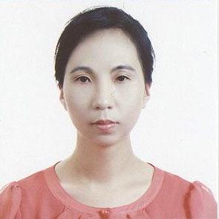 | Hanyang-Oregon TESOL Certificate  University of California, San Diego: Psychology (B.S.)  Salamanca, Spain: Study Abroad  Citrus College: Child Development  E-Mail: k2chang_2000@yahoo.com  C.P.: 010-3106-0064

Gusung Middle School in Yongin: (May 07, 2010 ~ May 06, 2011)
Songwoon Elementary School in Siheung: (May 07, 2007 ~ May 06, 2010)
[afterschool program]
Kwangduk Middle School
Songwoon Elementary School: 3rd & 4th grade
Songwoon Elementary School: 1st & 2nd grade
Songwoon afterschool program: 6th grade
[English Festival]
Participated Siheung English Festival as an English Speech Contest Juror (2008)
Award: 경기도 교육장 표창장 수상 (2008)

[Other Part-Time Teaching Experiences—grade school students]
I have experienced teaching at few private institutions: 정철어학원, 이보영 Talking Club, 쎄스어학원 for reading, writing, speaking, listening, grammar, daily conversations and TOEFL.

About Kay
I love travelling and experiencing different languages and cultures. To effectively develop the English communication skills to EFL students are often challenging but when I accomplish it, I feel rewarded.

