Keith Allan Herl
Sangdanggu Yongamdong
1092-2 Hayan Building 4F
Chungcheongbukdo, Cheongju City, South Korea
Vis_a_vis_0@yahoo.com
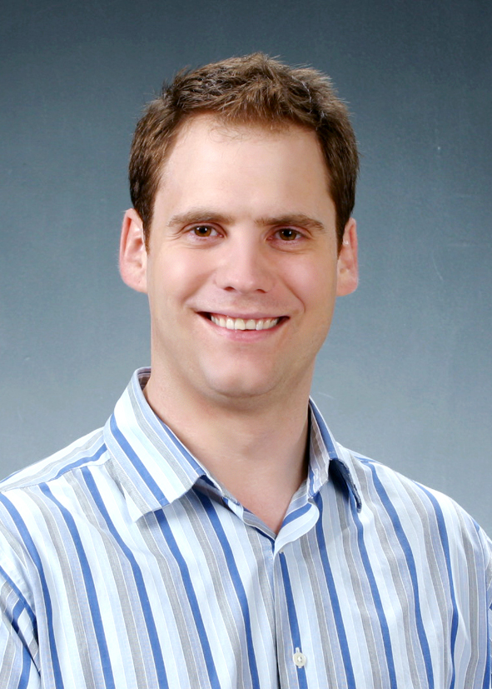
March 2007
To Whom It May Concern:
My name is Keith Herl and I am a master’s educated teacher is interested in a position at your institution. I am looking for a professional school who can utilize my skill and a professional work environment.
I believe that I have many strengths that make me an excellent candidate for an ESL teaching position at your institution. One important quality is my experience. I have taught, very successfully, for one year at an English academy. The experienced I gained there gives me assurance in my competence as an English teacher. Most importantly, this last year has taught me that I am capable of doing much more. Previously, for more than four years I have worked with children in a diverse array of settings with a diverse population of individuals, which has been a tremendous source of learning for me. I have leaned much about what it is to be a teacher and a fine professional from an excellent practicum advisor and exceptional educators at Lincoln Elementary and Felten Middle School. My experience coupled with my education has provided me with an immeasurable amount of knowledge about children and education

My experience, knowledge, and desire to help students makes me a highly qualified candidate for your teaching position. I would welcome the opportunity to meet with you and discuss how my skills can contribute to student success at your school.

My current contract and visa expires on March 20th of 2007. I need to return to America for the beginning of the summer but I plan to return around the middle of July. I can start employment around the time of July 16th . I can be flexible somewhat about the starting date for the right situation. I can be reached by email at vis_a_vis_0@yahoo.com or by phone at 010-8692-0221. I look forward to hearing from you to schedule a personal interview at your convenience. Thank you for your consideration.

Sincerely,

Keith Allan Herl

Sangdanggu Yongamdong 1092-2 Hayan Building 4th Floor 010-8692-0221
Chungcheongbukdo, Cheongju City, South Korea vis_a_vis_0@yahoo.com

EDUCATION
Education Specialist, Ed.S, May 2006 (incomplete thesis)
Fort Hays State University, Hays, KS

Master of Science in School Psychology, MS, July 2005
Fort Hays State University, Hays, KS

Bachelor of Arts in Psychology, BA, May 2004
Tabor College, Hillsboro, KS

EXPERIENCE

ESL Private School English Teacher May 2006- May 20th, 2007
Herald School, Cheongju, Republic of South Korea
- English instructor for Korean students at a large private English Academy
- Taught students ranging in age from kindergarten to early high school
- Gained experience teaching TOEFL IBT curriculum to middle and high school students, focusing particularly on the writing and listening sections
- Instructed English in a variety of subjects and settings including music, ORDA, science, math, and others
- Organized and accompanied students on various field trips, parties and celebrations, as well as other events
- Wrote evaluations of student performance using rating scales and written narrative passages
- Developed and created exams as well as other instructional materials and methods to supplement existing curriculum
- Collaborated with the Director, managers, Korean teachers, and other foreign teachers to deliver the best instruction possible to the academy’s students

School Psychology Practicum, August 2005-May 2006
Lincoln Elementary School, Hays, KS
• Performed assessment and observation on early childhood though high school
students
• Collaborated with school facility to create behavior plans and interventions for
students
• Counseled elementary and middle school students
• Collaborated with parents and staff for IEP development

Keith A. Herl Page 2

Special Education Para-Educator, January 2006-Present
Felten Middle School, Hays, KS
• Worked together with Special Education teachers, para-educators, and others provide educational services to students with moderate-to-severe mental
handicaps in a self-contained resource room

Attendant Care Worker, August 2004-March 2005
High Plains Mental Health Center, Hays, KS
• Worked with children in psychosocial group and one-on-one settings
• Worked in Respite Care Center with adult and youth clients

Attendant Care Worker, February 2002-August 2004
PrairieView Mental Health Center, Marion, KS
• Worked with children and adolescents ages 3-17 in elementary, middle, and
high schools
• Worked, led, and organized psychosocial treatment groups and group leader
for summer camps
• Gained experience in administration and paperwork
• Observed and closely worked in conjunction with PrairieView staff, received
exemplary evaluation marks

OTHER RELEVANT EXPERIENCE/COMMUNITY SERVICES ACTIVITIES
Assistant Track and Field Coach, March 2004-May 2004
Victoria High/Middle Schools, Victoria, KS
• Coached athletes in jumping and sprinting events
• Achieved successful relationships and outcomes with athletes

Volunteer
Big Brothers, Big Sisters of Marion County, KS, January 2002-December 2005
• Volunteered with a young boy who has been diagnosed with a mood disorder
and lived in a single parent home

REFERENCES
Available upon request

Keith Allan Herl

010-8692-0221
충북 청주시 상당구 용암동 1092-2 하얀 빌딩 4층 vis_a_vis_0@yahoo.com

학력사항
교육학 전문가 과정, 2006.05 (논문미제출)
Fort Hays State University, Hays, KS

교육 심리학 석사학위, 2005.07
Fort Hays State University, Hays, KS

심리학 전공 졸업 학위, May 2004
Tabor College, Hillsboro, KS

경력사항
사설 ESL보습학원 영어교사, 2006.05- 2007.현재
Herald School
- 규모가 큰 영어 사설 학원에서 한국 학생들을 지도하고 있음
- 유치원 학생에서 고등학교 1학년까지의 학생들을 지도하고 있음
- 특목고나 대학을 준비하고 있는 중,고등학생들을 위해 Writing과 Listening위주의 TOEFL IBT를 가르치고 있음
- 다양한 과목의 영어를 가르치고 있으며 그에 따른 도구와 수업에 필요한 자료들을 준비하여 교육 함(예를 들어 ORDA-유치원생을 위한 영어 공부 자료,수학,과학적인 현상들의 이해를 돕기 위한 실험 준비 등)
- 수업을 제외한 현장학습,이벤트 및 축하 파티 등 학원생을 위한 여러가지 다양한 활동을 하는데 있어서 스케줄을 계획하고 준비함
- 시험을 통한 학생들의 수행 평가 능력을 객관적 입장에서 관찰하여 장점,부족한 점 등을 고려하여 편지 형식의 평가서를 씀
- 본래 교육 과정에 있는 자료들 외에 수업지도에 필요한 도구와 자료들을 만들고 시험문제를 독창적으로 만들어서 과제 수행에 도움이 될 수 있게 함
- 상관인 원장,교수부장,그 외 한국 선생들 및 외국인 선생들과 협동하여 학원생들에게 최고의 교육을 제공할 수 있도록 협조하여 일함

교육 심리학 실습 교육 현장 학습, 2005.08- 2006.05
Lincoln Elementary School, Hays, KS
- 초년생의 어린이들부터 고등학생들과 같이 생활하고 관찰 하면서 평가서 작성
- 학교의 교직원과 협동하여 행동계획안을 만들고 학생들을 위한 중재자의 역할
- 초등학생부터 중학생에게 심리학적 교육 카운셀링을하여 도움을 줌
- 학부모 및 관련 직원들과 개인맞춤교육플랜 개발을 위해 협력하여 일함

Keith A. Herl Page 2

장애 및 신체 결함을 가진 아동을 위한 교육, 2006.01-2006.05
Felten Middle School, Hays, KS
- 특수교육 선생님,장애아동전문교육가 외 다른 조력자들과 함께 경증 및 중증심신장애아동을 교육함

활동보조치료 수행인, 2004.08- 2005.03
High Plains Mental Health Center, Hays, KS
- 정신지체 아동들과 그룹 및 일대일 상담
- Respite Care Center 에서 청소년 및 성인대상으로 일함

활동보조치료 수행인, 2002.02- 2004.08
PrairieView Mental Health Center, Marion, KS
- 3세에서 17세에 이르는 아동 및 청소년들을 상담 및 치료 보조
- 정신지체 활동 그룹 상담 치료 및 여름캠프 리더로 활동계획표 정리 및 지도
- 행정관리과에서 문서업무 담당 경험
- PrairieView staff들의 업무를 주의깊게 관찰하며 일하여 모범적인 평가서를 받음

기타 관련된 경험 및 사회봉사 활동
육상코치 보조 활동, 2004.03- 2004.05
Victoria High/Middle Schools, Victoria, KS
- 도약점핑 및 단거리 경주 선수들을 보조 코치함
- 선수들과 같이 지내는데 있어서 좋은 관계를 유지하고 좋은 성과를 이룸

자원봉사활동
Big Brothers, Big Sisters of Marion County, KS, 2002.01- 2005.12
- 감정조절장애가 있는 어린이들과 배우자 없는 부모를 가진 학생들을 상대로 자원봉사 활동

근무가능일시
상시 가능 함

