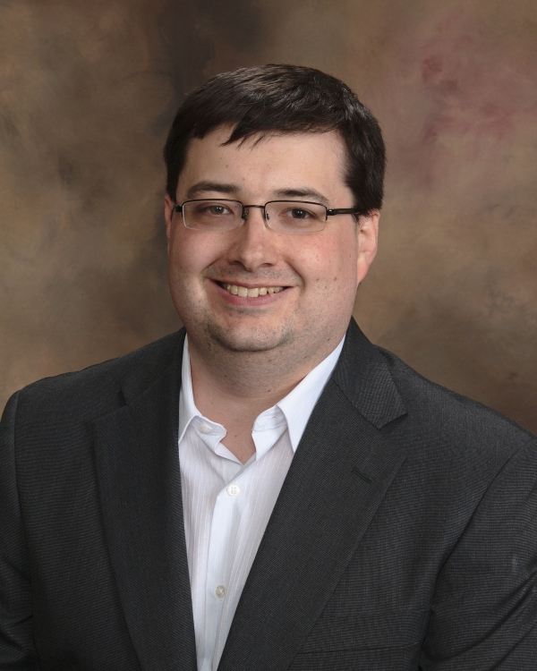

KEVIN P. YANCEY
EDUCATION

TEFL Certification (100 Hours)
University of Toronto May 2013

B.S. Computer Science
Kansas State University 3.9 GPA Sept. 2000 – Dec. 2004

WORK RELATED EXPERIENCES

Youth Event Adult Sponsor/Supervisor June 2006 – Dec. 2011
Presbytery of Northern Kansas Youth Council

- Served on the council that plans and leads regional youth programs for 6th through 12th grade, including lock-ins and leadership training programs for youth.

Young Adult Leader/Board Member Sept. 2000 – Dec. 2006
Ecumenical Campus Ministries

- Attended three missions trips (Mexico, Chicago, IL, and Port Arthur, TX), two of which involved tutoring and socializing with children.
- Worked on the council to plan and lead programs for college students, including mission trips, weekly social gatherings, discussion groups, and learning opportunities.

EMPLOYMENT HISTORY

Lead Software Developer/IT Manager Oct. 2008 – Present
Personalized Brokerage Services, LLC

- Awarded Employee of the Year in 2011.
- Worked with senior management to establish requirements for a project to migrate Customer Relationship Management (CRM) software to a more modern platform.
- Lead the IT team implementing the CRM migration project.
- Designed numerous reporting tools to present business metrics to the senior management team.

Software Development Consultant May 2001 – Oct. 2008
Balance Wheel Technologies, Inc. – Kansas Bureau of Investigation, KDOC, JC Court, SC Court

- Worked with Kansas Bureau of Investigation Records department to define requirements for a consolidated Criminal History Background Reporting system.
- Submitted recommendations for the National RAP Sheet XML Standard.

Lead Software Developer Jan. 2007 – Jun. 2007
Zeratec Inc.

- Presented a software prototype to the AFSG in Washington, DC.
- Lead a development team on a 1.2 million dollar contract with the Air Force Surgeon General (AFSG).

Software Engineer Feb. 2005 – Dec. 2006
Fundamental Technologies Inc.

KEVIN P. YANCEY
References

Jerry Manweiler - Fundamental Technologies Inc.
Former Manager
1-785-840-0800
manweiler@ftecs.com

Ray Zweiner - Zeratec Inc.
Former Manager
1-785-331-3200
ray@zeratec.com

Blake Courtney – Balance Wheel Technologies, Inc.
Former Manager
1-785-969-8991
blake.courtney@gmail.com

