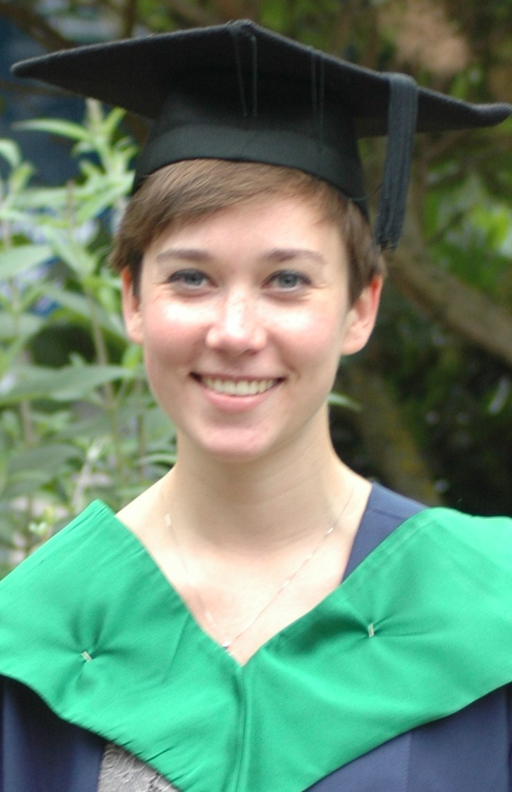
Kirstie Daniell: Curriculum Vitae

A recent Psychology Graduate and soon to be qualified Premium 140-hour TEFL-qualified teacher. Two years professional experience in Community Healthcare and Education and a keen worldwide traveller in Asia, America and Europe.

I am a reliable, engaging and confident teacher with excellent organisational and communication skills. I am approachable and enthusiastic teacher who has excellent classroom management skills. I have excellent presentation skills, both written and physical.

Can use initiative and creativity to solve problems in the classroom and has a proven ability to creatively stimulate learners with creative techniques.

Professional Experience

2012 Community Healthcare Assistant. Buckinghamshire NHS

- In the Reablement Team I am involved in the rehabilitation process of patients in their home; through psychological, physical and practical techniques.

2011 Volunteering Programme India

- I worked one to one with children teaching different skills appropriate to their level of abilities in each subject (e.g. Maths, English, Art). As a teacher I had to find creative and stimulating ways of engaging the children in learning and playing.

References available on request.
Education

2008-2011 BSc Psychology (hons) (2:1), University of East Anglia, Norwich.

140-hour Premier TEFL England Course. To be completed in April 2013.
- 20-hour Classroom TEFL course
- 30-hour Grammar Course
- 50-hour TEFL Course
- 20-hour Video Course
- 10-hour Teaching Large Classes Course
- 10-hour Telephone Teaching Course

2006-2008 A-Level: Psychology, Maths, Graphic Design, Longdean School, Hemel Hempstead.
2001-2005 GCSE: 12 achieved A*-C, LongdeanSchool, Hemel Hempstead.

Personal Information.

Address: 26 Fishery Road Email: kirstie_daniell@hotmail.co.uk
Hemel Hempstead, Hertfordshire Mobile: 07784048606 Tel: 01442 462596
HP1 1ND

